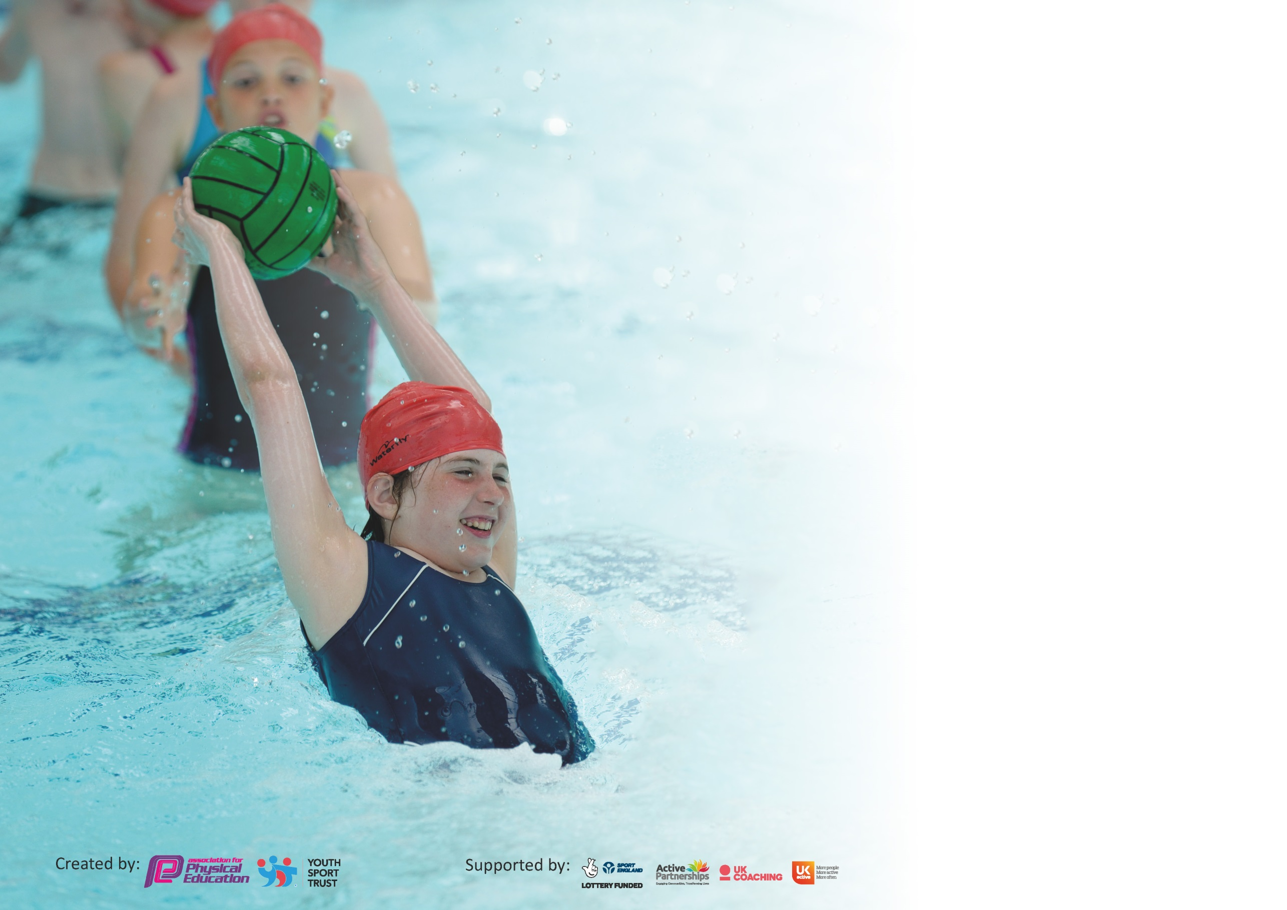

It is important that your grant is used effectively and based on school need. The Education Inspection Framework (Ofsted 2019 p64) makes clear there will be a focus on ‘whether leaders and those responsible for governors all understand their respective roles and perform these in a way that enhances the effectiveness of the school’.

Under the Quality of Education criteria (p41) inspectors consider the extent to which schools can articulate their curriculum (INTENT), construct their curriculum (IMPLEMENTATION) and demonstrate the outcomes which result (IMPACT).

To assist schools with common transferable language this template has been developed to utilise the same three headings which should make your plans easily transferable between working documents.

Schools must use the funding to make additional and sustainable improvements to the quality of Physical Education, School Sport and Physical Activity (PESSPA) they offer. This means that you should
use the Primary PE and Sport Premium to:

- Develop or add to the PESSPA activities that your school already offer
- Build capacity and capability within the school to ensure that improvements made now will benefit pupils joining the school in future years

Please visit gov.uk for the revised DfE guidance including the 5 key indicators across which schools should demonstrate an improvement. This document will help you to review your provision and to report your spend. DfE encourages schools to use this template as an effective way of meeting the reporting requirements of the Primary PE and Sport Premium.

We recommend you start by reflecting on the impact of current provision and reviewing the previous spend.

Schools are required to publish details of how they spend this funding as well as on the impact it has on pupils’ PE and sport participation and attainment by the end of the summer term or by 31st July 2020 at the latest.

We recommend regularly updating the table and publishing it on your website throughout the year. This evidences your ongoing self-evaluation of how you are using the funding to secure maximum, sustainable impact. Final copy must be posted on your website by the end of the academic year and no later than the 31st July 2020. To see an example of how to complete the table please click HERE.

Support for review and reflection - considering the 5 key indicators from DfE, what development needs are a priority for your setting and your pupils now and why? Use the space below to reflect on previous spend and key achievements and areas for development.

Key achievements to date until July 2019: | Areas for further improvement and baseline evidence of need:
- Achieved the Platinum School Games Mark 2018-2020 making us the first and only school in the locality to achieve this level.  - Provided all KS2 students with 2 hours of physical education p/w (within the curriculum only); and have extracurricular provision in addition to this;  - Offered talented young sports people specific support to help them to develop their sporting potential.  - Engaged at least 40% of students in leading, managing and officiating School Games activity (25% more than last year). | - A wider range of opportunities for Year 3 and 4. A lot of the competitions we entered last year were aimed at Y5 &6.  - Improving the quality of independent play with a particular focus on balance, strength and coordination.  - Introduce a daily mile to get all pupils undertaking at least 15 minutes of additional activity per day.

Meeting national curriculum requirements for swimming and water safety.
What percentage of your current Year 6 cohort swim competently, confidently and proficiently over a distance of at least 25 metres?  N.B. Even though your pupils may swim in another year please report on their attainment on leaving  primary school at the end of the summer term 2020. | %
What percentage of your current Year 6 cohort use a range of strokes effectively [for example, front crawl, backstroke and breaststroke]? | %
What percentage of your current Year 6 cohort perform safe self-rescue in different water-based situations? | %
Schools can choose to use the Primary PE and Sport Premium to provide additional provision for swimming but this must be for activity over and above the national curriculum requirements. Have you used it in this way? | Yes/No

Action Plan and Budget Tracking
Capture your intended annual spend against the 5 key indicators. Clarify the success criteria and evidence of impact that you intend to measure to evaluate for pupils today and for the future.

Academic Year: 2019/20 | Total fund allocated: £ 17440 | Date Updated: 11/06/20
Key indicator 1: The engagement of all pupils in regular physical activity – Chief Medical Officer guidelines recommend that primary school pupils undertake at least 30 minutes of physical activity a day in school |  |  |  | Percentage of total allocation:
 |  |  |  | %
Intent | Implementation |  | Impact
Your school focus should be clear what you want the pupils to know and be able to do and about  what they need to learn and to  consolidate through practice: | Make sure your actions to achieve are linked to your intentions: | Funding allocated: | Evidence of impact: what do pupils now know and what can they now do? What has changed?: | Sustainability and suggested next steps:
All children to be engaged in physical activity daily.  Children to have access to a range of sports which suit their interest and physical needs.  Raise awareness of importance of kick-starting healthy active lifestyles through Healthy Schools Week.  Improving the quality of independent play with a particular focus on balance, strength and coordination. | Update the school PE policy  Audit whole-school planning to ensure: evidences progression of P.E. skills across the school & sport mapping to accommodate fixtures ensuring suitable coaching prior to competitions.  Maintain the level of PE teaching within the school.  Children will be more aware of the importance of healthy, active lifestyles.  Replace playtime equipment inc. climbing wall for both KS1 and KS2. |  | Planning and timetabling shows a range of sporting activities offered to all pupils and includes competition dates.  - All KS2 children have been provided with 2 hours of physical education p/w (within the curriculum only); and have extracurricular provision in addition to this.  WIDER IMPACT AS A RESULT OF ABOVE  - Pupils are more active in PE lessons – take part without stopping to rest.  - Attitudes to learning improved – better concentration in lessons. | - This was successful although the dates change each year so this will need reviewing annually.  - Healthy Schools Week did not happen this year but will be re-scheduled.  New play time equipment has helped embed physical activity into the school day through active playgrounds and active teaching.

Key indicator 2: The profile of PESSPA being raised across the school as a tool for whole school improvement |  |  |  | Percentage of total allocation:
 |  |  |  | %
Intent | Implementation |  | Impact
Your school focus should be clear what you want the pupils to know and be able to do and about  what they need to learn and to  consolidate through practice: | Make sure your actions to achieve are linked to your intentions: | Funding allocated: | Evidence of impact: what do pupils now know and what can they now do? What has changed?: | Sustainability and suggested next steps:
Friday assembly every week ensuring the whole school is aware of the importance of PE and Sport and to encourage all pupils to aspire to be involved.  School games promoted to the parents and local community fortnightly.  Create a notice board in the corridor to raise the profile of PE and Sports for children, visitors and parents.  Developing links with Governors:  Discuss action plan, identify opportunities to monitor PE & report to Governors about PE and School Sport Premium.  Developing young Sports leaders within our school which allows us to introduce and extend competitive opportunities in our own school.  Role models – sporting personalities so pupils can identify with success and aspire to be a local sporting hero. | Achievements celebrated in assembly (match results and notable achievements in lessons etc.)  Regular updates sent to parents via Up to the Minute and the school website.  Maintain and update the notice boards regularly with sports reports, clubs, fixtures and photos.  Governor will have a clear understanding of PE within the school, be aware of areas for development including changes identified through the year & will be aware of how the funding has been spent.  Train Year 5s in Summer term so they can take over next year.  Encourage Sports Leaders to be used to organise Level 1 competitions.  Organise Sports for Champions to send in a sports personality. |  | A large proportion of children are recognised in assemblies throughout the year.  The notice board is full of information about fixtures, clubs, sports reports and pupils are keen to get involved.  Monitoring by the Governor is included in the whole-school monitoring plan.  Provided opportunities for children to work as a team in sports they might not always get a chance to try. Children have developed sportsmanship skills and collaboration.  Kimberley Renicks (Judo) took an assembly and then ran a session with each junior class.  WIDER IMPACT AS A RESULT OF ABOVE  - Pupils are very proud to be recognised in assemblies / photos on notice boards and website etc. which is impacting on confidence and self-esteem.  - Increased self-esteem / confidence are having an impact on learning across the curriculum. | The SMT have seen the benefits of the raised profile and is committed to funding these areas if the Primary PE and Sport Premium is discontinued.  Year 5 Sports Leader training could not take place. This will have to be completed in Autumn 2020.

Key indicator 3: Increased confidence, knowledge and skills of all staff in teaching PE and sport |  |  |  | Percentage of total allocation:
 |  |  |  | %
Intent | Implementation |  | Impact
Your school focus should be clear | Make sure your actions to | Funding | Evidence of impact: what do | Sustainability and suggested
what you want the pupils to know | achieve are linked to your | allocated: | pupils now know and what | next steps:
and be able to do and about | intentions: |  | can they now do? What has
what they need to learn and to |  |  | changed?:
consolidate through practice:
Up-skilling staff to improve progress and achievement of all pupils.  Sports coaches to support school sport (Mr Green, Fairways to Horsham & Alternative Sports Festival).  Coordinate staff members to attend Weald Family CPD. | Undertake all PL which is offered through the sports partnership/LA/  National Associations (afPE & YST)/ NGBs/ Awarding Organisations with an aim to get more staff up-skilled and involved.  Surveys for staff.  Identify the local centres who are running these courses & ensure all identified staff are enrolled. Establish dates when cover is required and appoint cover staff. |  | Staff meetings  Locality staff meetings with Mr Meaney (SSGO)  Discussions with staff.  Team teaching with Mr Green (a specialist PE teacher) has increased the quality of teaching and learning. He has also organised activities at lunch time and provided various after-school clubs. In coordination with the PE coordinator, he has supported the implementation of the “Learning to Lead’ initiative throughout the PE curriculum | Mr Green to continue working with the school in a similar capacity, ensuring he is covering different sports.  This will lead to sustainability as all staff will be supported to feel confident to deliver PE and Sport both within and outside the curriculum.

Key indicator 4: Broader experience of a range of sports and activities offered to all pupils |  |  |  | Percentage of total allocation:
 |  |  |  | %
Intent | Implementation |  | Impact
Your school focus should be clear | Make sure your actions to | Funding | Evidence of impact: what do | Sustainability and suggested
what you want the pupils to know | achieve are linked to your | allocated: | pupils now know and what | next steps:
and be able to do and about | intentions: |  | can they now do? What has
what they need to learn and to |  |  | changed?:
consolidate through practice:
Additional achievements:  Continue to offer a wider range of activities both within and outside the curriculum in order to get more pupils involved.  Focus particularly on those pupils who do not take up additional PE and Sport opportunities.  Healthy Schools Week promoting different sports that child may not have experienced previously.  Maintain the wide range of clubs on offer to the children.  Forest School  Residential | Ensure there are subsidised opportunities for all children to attend after-school sports clubs.  Arrange a pupil survey to ascertain what pupils would like.  Involve external coaches to work with staff in clubs. |  | A lot of the activities, events and clubs that had been organised were not able to run due to COVID-19. | Staff will work together and share good practice which will lead to better confidence all round and more staff keen to get involved thus ensuring the extra activities will not only continue but there will also be an expansion.  These areas will remain a priority for 2020-2021.

Key indicator 5: Increased participation in competitive sport |  |  |  | Percentage of total allocation:
 |  |  |  | %
Intent | Implementation |  | Impact
Your school focus should be clear | Make sure your actions to | Funding | Evidence of impact: what do | Sustainability and suggested
what you want the pupils to know | achieve are linked to your | allocated: | pupils now know and what | next steps:
and be able to do and about | intentions: |  | can they now do? What has
what they need to learn and to |  |  | changed?:
consolidate through practice:
Involve all children in competitive sports through PE lessons.  To introduce additional competitive sports identified by pupils in recent survey in order to engage more pupils.  Engage more girls in inter/intra school teams particularly those who are disaffected. | Ensure all children compete in Level 1 (House) competitions within school each term.  Coordinate fixtures, cover and teams for Level 2 (inter-school) competitions.  Ensure all children are given an opportunity throughout the year to represent their house or school. |  | All children throughout the school had competition built into their lessons whether it was personal competition, small groups or real game situations. All junior children participated in the  Autumn House matches.  All children have become more confident and are keen to take part in house competitions. | Although we entered and planned to attend more sport competitions than ever before, covering a wider range of sports, due to weather and COVID-19 a lot of these didn’t happen. Therefore this will remain a priority next year.

Signed off by
Head Teacher:
Date:
Subject Leader:
Date:
Governor:
Date:

