Loxwood Primary School

Starting School Booklet

September 2020

Starting School

The time for your child to start school is approaching and like most parents you will be keen to know what you can do to help your child’s start in school be as smooth and as happy as possible.

Within this booklet are some ideas and activities that you can do to help your child over the coming months. We hope you find it a useful resource on how you can positively and actively support your children in their readiness for “Big School”. Try to keep in mind that the more nervous you are the more nervous they will be. Practising the ideas below will be one of the best ways to put you both at ease and feel ready for this next chapter.

What can I do before September?

Every child is different and at a different place developmentally however, there are a few skills that they will all need and that you can practise over the summer together

1. Going to the toilet on their own.

We are always on hand to help with those little mishaps however, children do need to be able to independently cope with number 1’s and 2’s.

If your child has a medical issue please speak to us and be assured we will work with you to support your child.

2. Getting themselves dressed and undressed

It’s so tempting to help (it’s certainly quicker) but they do need to be able to do this themselves.

We understand it takes a bit of practice however, to make things easier pick uniform without buttons or zips at the back. Tights can be very difficult to do independently! Reception children are welcome to wear green jogging bottoms if it helps. We also highly recommend buying uniform a bit bigger - it makes dressing so much easier and it should last longer to!

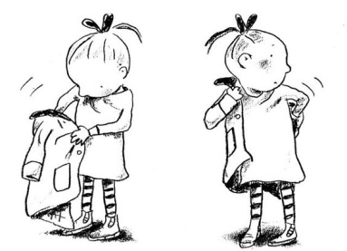
3. Putting on their coat and zipping it up

There are different techniques – but this can something
we carry on doing for our children without thinking about
it.

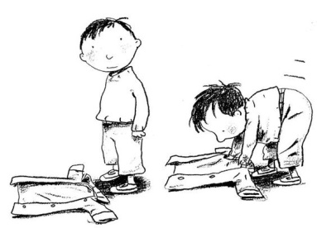
A teacher or member of staff will always help but won’t manage 30! So a little practise is wonderful.

Practising finding where their name is written on clothing is really helpful too and will give them more confidence. Please make sure you name everything!
Activities you can do with your child

You may already being doing these and if you are that’s great.

All these activities support a child developmentally in areas such as speaking and listening (essential for reading and writing) , social interaction (making friends) and pattern (the route of number and maths).

These are optional but should be fun for you and all the family.

- Sing lots of nursery rhymes and rhyming songs
- Have a go at pointing out and recognising numbers
- Talk about the world around you – notice seasons, weather, plants and animals
- Read lots of lovely stories – this will inspire a love of books at young age
- Show them their name written down and let them have a go (please model their name with a capital letter at the beginning, early habits are hard to break!). Mark making is the very first skill in writing and just picking up a pencil and making marks on the paper is great.
- Maybe your child can already write their name; can they write their second name?

When children start school they are all unique and at a different stages. Try not to worry what they can or can’t do in comparison to other children. We will ensure that our planning is adapted to support the children at every level of development.

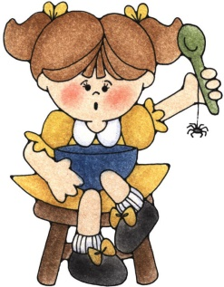
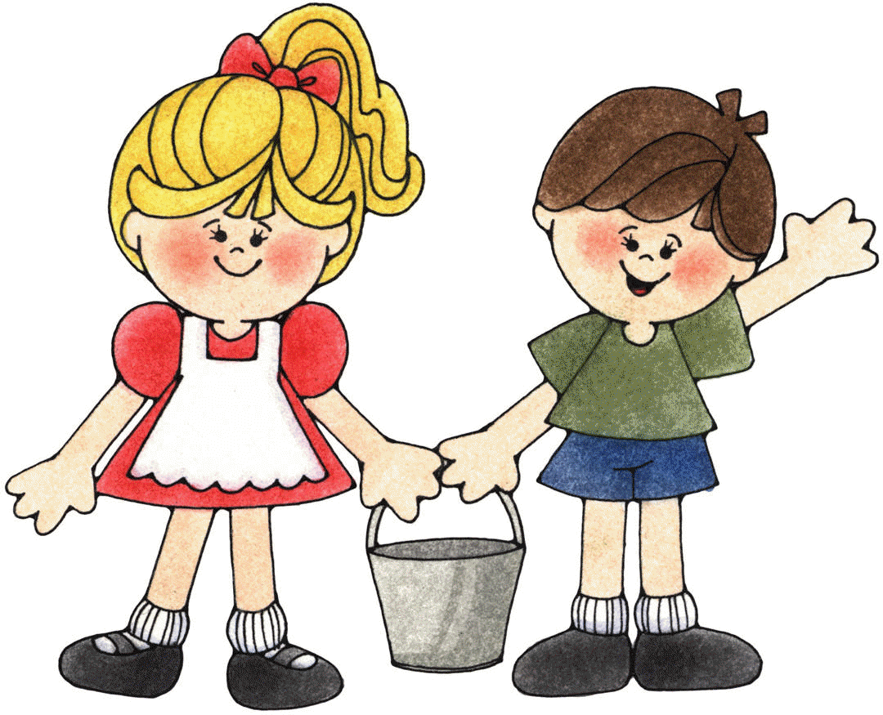
And finally….

Some hints and tips to help you as parents;

- We have all had different experience ourselves with school life, some good and perhaps some that weren’t so good; so is important to be as positive as possible with your child. This is their new start.

- If you are sharing your concerns with friends and family try to ensure that they are not in ear shot – little ears hear all sorts of things!

- Try to engage with as many of the Starting School activities as you can, the more time you spend practising them the more confident you will both be.

- Take some time for yourself after you have dropped them off – arrange to meet up with a friend or another mum or dad.

- Try to hold those emotions in until you have gone around the corner, very difficult I know but they are as worried about you as you are about them.

And finally please do always come in and talk to us. We do understand how emotional this can be and the more we can help and reassure you the better the starting school process will be for your child.

