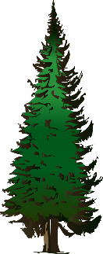
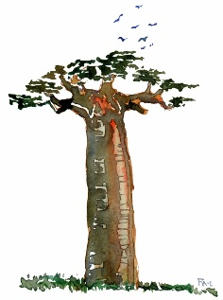
Fantastic Forests
Spring Term Home Learning Projects Year 2
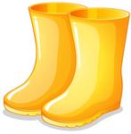
These activities are designed to get your creative juices flowing and to be a great opportunity to develop your skills with support from someone at home. You can do as many of them as you like, but we would like everyone to do one or two activities each half term. To share your learning please post onto Tapestry. If you want to email it, please address it to office@loxwoodschool.com for the attention of Mrs Rolland. If you have any queries or need further support please pop in and ask.
Perform a poem  Choose a favourite poem to perform to the class. Try to learn it by heart and add some actions to help you. You can either perform it live or send in a video of your performance! You might want to choose a poem with a nature theme to fit in with out topic? | 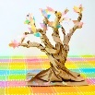  Super Sculpture!  Create a forest sculpture!  Use whatever material you like to create a sculpture of a plant, a tree or an entire forest! If it is too large or delicate to bring in then why not  email a photo of you and your creation? | Forest Adventure  Go on a forest or woodland walk with your family and try to identify some of the plants and animals that you see.  You could make a map of your walk using your geographical skills or produce your own plant and animal identification guide! You might even complete a tally of things that you find and go on to create a bar chart or pictogram.
Marvellous Measuring!  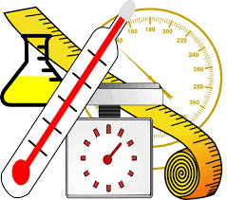  Have a go at measuring things at home in standard units (either length/ height in cm/m, mass in kg/g, temperature in °C; or capacity in litres/ml). Record what you have measured – you could even make a simple table or bar chart to show us your findings? | Techy Tour Guide  Imagine that you are a forest tour guide. Choose a forest anywhere in the world to research using the internet (with adult supervision), non-fiction books or by asking a grown up. Make a PowerPoint presentation all about it. (Include a map to show us where in the world it is.) or video yourself telling us all about your chosen forest. | Go green!  Make a difference to the planet by doing something eco-friendly. You could encourage your family to recycle more/use less energy/ use less plastic, go on a litter pick (with adult supervision), think of ways to encourage more wildlife into your garden or even write a letter to encourage someone else to help the planet!

…or get creative and amaze us with some of your own choice topic related learning!
We will endeavour to share each piece of Home Learning as soon as we can during our snack time.
Don’t forget to read as often as possible at home and practice reading and spelling the Year 2 Common Exception words (found on our Class Page)! Please record your child’s reading on Tapestry. House points awarded to children who are busy practicing their reading skills at home.

