3rd, 10th & 17th December 2018

**In Personal, Social and Emotional**

**Development we are learning to…**

Be confident to try new activities

Sing in front of an audience

Say when they do or don’t need help

Activities

KS1 Nativity performance

Pantomime visit

Christmas lunch

**In Communication and Language we are**

**learning to…..**

Listen to and follow instructions

Explain own knowledge and understanding and ask appropriate questions of others

Activities:

Discuss their Christmas traditions

with a talk partner

Compare similarities and differences

**In physical development we are**

**learning to….**

change into PE kit (PE shirt, PE shorts, joggers, jumper or cardigan, plimsolls, socks – gloves if cold)

understand what happens to our bodies when we exercise

move in different ways e.g. marching, skipping

Activity

Session run by Mr Green on Wednesday morning (you may want to send your child to school in joggers)

**1 week YE Plan**

**planner**



**Ask me about…**

 

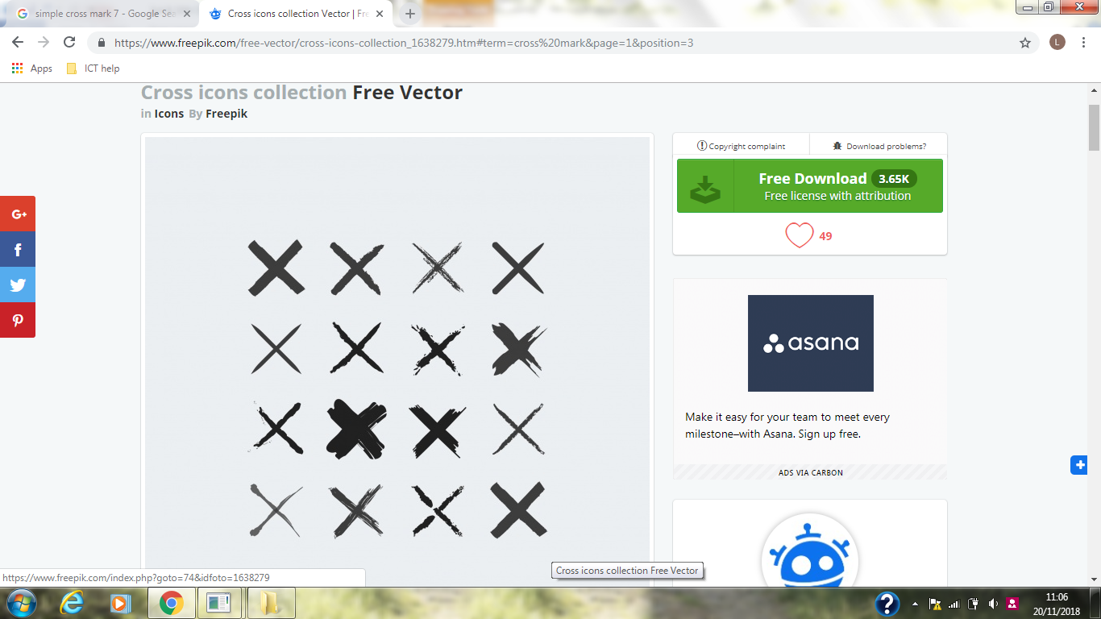





**In Mathematics we are learning to**

Represent numbers using fingers, marks on paper or pictures.

Compare two groups of objects saying when they have the same number.

Separate a group or objects in different ways and beginning to recognise that the total is just the same.

Use the language of ‘more’ or ‘less’ to compare two sets of objects.

**In Literacy we will are learning to..**

Give meaning to marks as they write and draw.

To use story language and full sentences when reading

To write the letter using the RWI letter patter

Begin to identify and record (write) the initial phoneme (first sound in a word) or dominant phonemes

**To label our pictures**

Activities

Word Time RWI

Repeat Fred Talk e.g.

p-i-g/pig

Begin to select correct

grapheme in simple words

Make a Christmas book and label our pictures

**In Understanding the world we are learning..**

about some of the traditions around Christmas

about the meaning of Christmas to Christians

about different ways to celebrate Christmas

Activities

Share a range of Christmas stories and texts

Make a Christmas Book

Take part in Christmas activities in school

**In Creative Arts and Design we are learning to…**

Act out a narrative with other children

Use a range of resources e.g. paint, construction, role play props, junk modelling, music and singing

Activities

Christmas craft day and activities

Christmas themed role play area

In Early Years we plan across the 7 areas of learning and

make links with our topic. We also follow the ideas and

interests generated by the children. In Reception

children spend time each day self-initiating, this is their

‘Learning time’. Adults will be observing, engaging and

moving their learning on during these times.