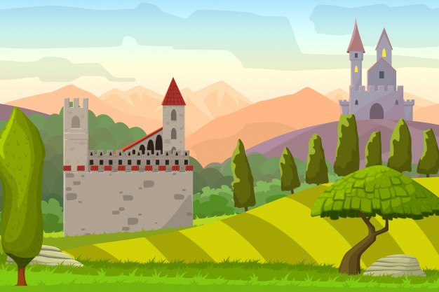

**English**

Write captions and labels for posters and guidebooks.

Retell simple stories.

Learn poems and write shared poems.

Spell days of the week.

Begin to write simple sentences.

**RE/RHE**

Jonah and the Whale story.

Friendships.

Understanding the concept of privacy.

Keeping safe online.

**Music**

Sing and improvise using voices.

Add percussion to a song.

Perform composition.

**Science**

Identify and name materials.

Compare material’s properties and group them.

Find out about the characteristics of autumn.

**Maths**

Count and understand place value to 20.

Counting in steps of 2.

Addition and subtraction within 10.

Recognise 2D and 3D shapes.

**Computing**

Log on and open program.

Click and drag objects.

Close down safely.

**History/ Geography**

Investigate castles.

Draw simple time lines.

Compare buildings past and present.

Basic geography of the UK.

**PE**

Multi skills/ Ball Skills.

Dance.

**Art/DT**

Mix paints.

Make collages.

Look at portraits and paint own.

Design and make a structure.

Castles in the Sky

Year 1 Autumn Term 2021