2nd and 9h November 2020

**In physical development we are**

**learning to….**

change into PE kit (PE shirt, PE shorts/joggers, jumper or cardigan, plimsolls, socks – gloves if cold)

understand what happens to our bodies when we exercise

move in different ways e.g. marching, skipping

Activity

Session run by Mr Green on Wednesday morning (you may want to send your child to school in joggers but put spare joggers/

school trousers in their

PE bag in case of accidents)

**In Personal, Social and Emotional**

**Development we are learning to…**

Take part in new activities

Be more outgoing towards unfamiliar people

Be more confident in new social situations.

Activities

PE with Mr Green on Wednesdays.

Daily phonics sessions (including handwriting, Fred Talk)

**In Communication and Language we are**

**learning to…..**



listen carefully to instructions

respond to instructions (some involving a two-part

sequence)

**2 week YE Plan**

**planner**

Full, empty or half full?



We will have a simple assembly about Remembrance Day

**In Understanding the world we are learning..**

about firework safety

about the role of a firefighter

about the tradition of Bonfire Night

Activities

Listen to non-fiction books about firefighters/bonfire night. Learn the fire safety song.

Watch educational clips/videos of firefighters at work/bonfire night

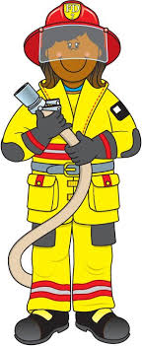

These are our good sitting rules





**In Mathematics we are learning to…order quantities (capacity) and to count accurately**

To recognise the need for re-counting after making a mistake.

To order two items by capacity

To order up to 5 items by capacity

To use the language of measures e.g. full, empty, half-full, in the middle, half-empty, less than, more than.



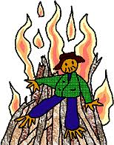



**Ask me about…**

**In Literacy we will are learning**

**to..**

Give meaning to marks as they

write and draw.

To use story language and full sentences

To learn to recall the phoneme of the day taught in Read, Write Inc lessons (see Sound Book)

To write the letter using the

RWI letter patter – see

sheet sent home

Activities

Take part in phonics lessons

Repeat Fred Talk e.g. m-u-m,

m-u-d, d-a-d, m-a-n etc

RWI Word Time

Listen to a range of texts

**In Creative Arts and Design we are learning to..**

Use a range of media, such as music, dance, role-play, paint and other materials to capture experiences e.g. fireworks and bonfire night

Activities Bonfire or Firework pictures

Access to resources e.g. musical instruments, role play props, painting easel, construction.

In Early Years we plan across the 7 areas of learning and

make links with our topic. We also follow the ideas and

interests generated by the children. In Reception

children spend time each day self-initiating, this is their

‘Learning time’. Adults will be observing, engaging and

moving their learning on during these times.