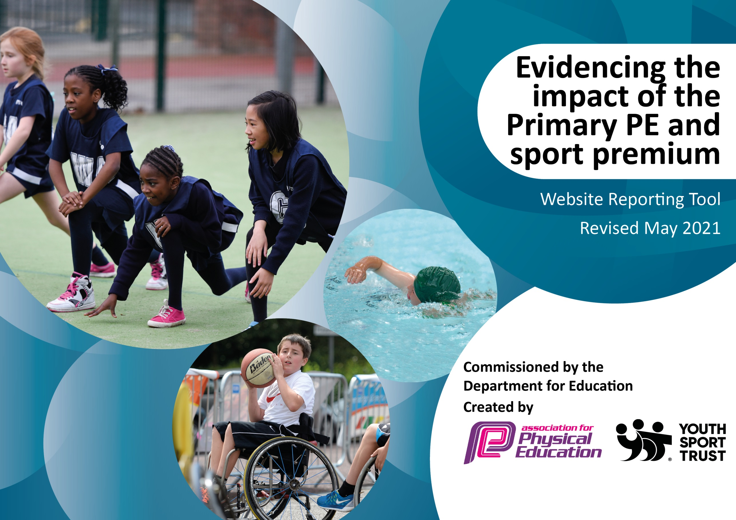

It is important that your grant is used effectively and based on school need. The Education Inspection Framework (Ofsted 2019 p64) makes clear there will be a focus on ‘whether leaders and those responsible for governors all understand their respective roles and perform these in a way that enhances the effectiveness of the school’.

Under the Quality of Education criteria (p41) inspectors consider the extent to which schools can articulate their curriculum (INTENT), construct their curriculum (IMPLEMENTATION) and demonstrate the outcomes which result (IMPACT).

To assist schools with common transferable language this template has been developed to utilise the same three headings which should make your plans easily transferable between working documents.

Schools must use the funding to make additional and sustainable improvements to the quality of Physical Education, School Sport and Physical Activity (PESSPA) they offer. This means that you should use the Primary PE and sport premium to:

- Develop or add to the PESSPA activities that your school already offer
- Build capacity and capability within the school to ensure that improvements made now will benefit pupils joining the school in future years
- The Primary PE and sport premium should not be used to fund capital spend projects; the school’s budget should fund these.
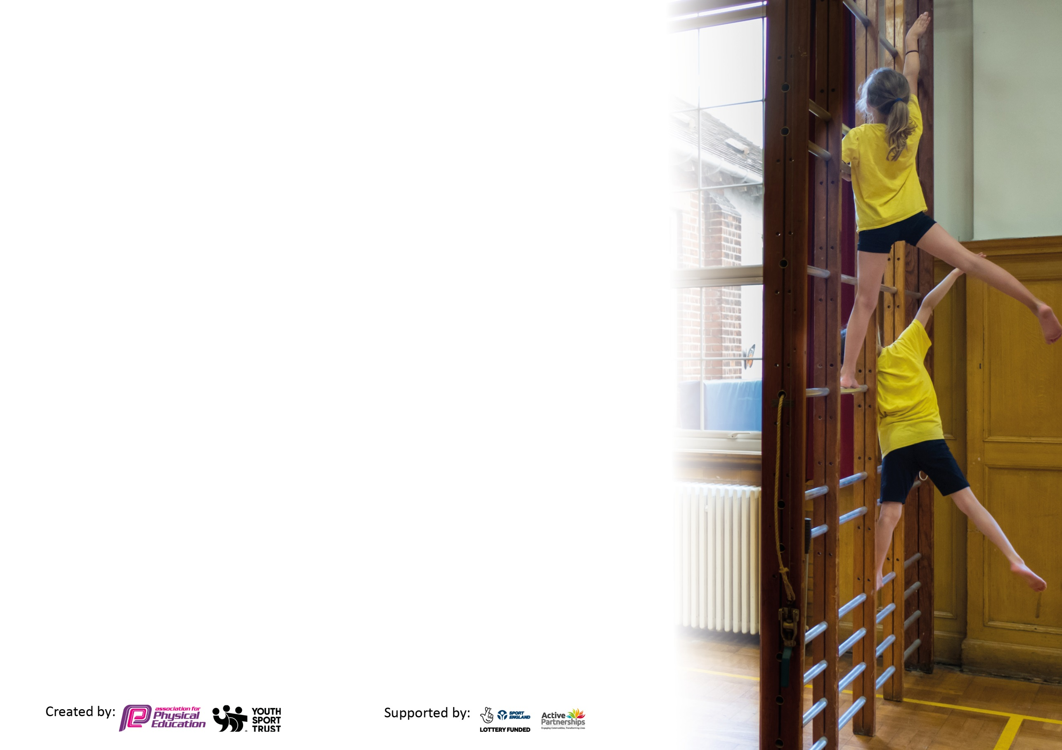
Please visit gov.uk for the revised DfE guidance including the 5 key indicators across which schools should demonstrate an improvement. This document will help you to review your provision and to report your spend. DfE encourages schools to use this template as an effective way of meeting the reporting requirements of the Primary PE and sport premium.

We recommend you start by reflecting on the impact of current provision and reviewing the previous spend.

Schools are required to publish details of how they spend this funding, including any under-spend from 2019/2020, as well as on the impact it has on pupils’ PE and sport participation and attainment by the end of the summer term or by 31st July 2021 at the latest.

We recommend regularly updating the table and publishing it on your website throughout the year. This evidences your ongoing self-evaluation of how you are using the funding to secure maximum, sustainable impact. Final copy must be posted on your website by the end of the academic year and no later than the 31st July 2021. To see an example of how to complete the table please click HERE.

Please note: Although there has been considerable disruption in 2020 it is important that you publish details on your website of how you spend the funding - this is a legal requirement.
Support for review and reflection - considering the 5 key indicators from DfE, what development needs are a priority for your setting and your pupils now and why? Use the space below to reflect on previous spend and key achievements and areas for development.

N.B. In this section you should refer to any adjustments you might have made due to Covid-19 and how these will influence further improvement.
Key achievements to date until July 2020: | Areas for further improvement and baseline evidence of need:
- Achieved the Platinum School Games Mark 2018-2021 making us the first and only school in the locality to achieve this level.  - Provided all KS2 students with 2 hours of physical education p/w (within the curriculum only); and have extracurricular provision in addition to this;  - Engaged at least 40% of students in leading, managing and officiating School Games activity (25% more than last year).  - 95.7% of Year 6 can swim competently, confidently and proficiently over a distance of at least 25m.  - All KS2 children competed in 2 Inter-school competitions (hockey and rounders).  - All children participated in a Sports Day (trailing new sports and participating in races).  - Extra-curricular clubs were reintroduced in the Summer Term (as soon as COVID restrictions allowed). | - A wider range of opportunities for Year 3 and 4. A lot of the competitions we entered last year were aimed at Y5 &6.  - Improving the quality of independent play with a particular focus on balance, strength and coordination.  - Introduce a daily mile to get all pupils undertaking at least 15 minutes of additional activity per day.  - Continue to promote healthy living and eating throughout the school.  - Swimming lessons for 2021

Did you carry forward an underspend from 2019-20 academic year into the current academic year? YES
Total amount carried forward from 2019/2020 £6838
+ Total amount for this academic year 2020/2021 £17510
= Total to be spent by 31st July 2021 £24348

Meeting national curriculum requirements for swimming and water safety.

N.B Complete this section to your best ability. For example you might have practised safe self-rescue techniques on dry land which you can transfer to the pool when school swimming restarts.
Due to exceptional circumstances priority should be given to ensuring that pupils can perform safe self rescue even
if they do not fully meet the first two requirements of the NC programme of study.
What percentage of your current Year 6 cohort swim competently, confidently and proficiently over a distance of at least 25 metres?  N.B. Even though your pupils may swim in another year please report on their attainment on leaving primary school at the end of the summer term 2021.  Please see note above. | 95.7%
What percentage of your current Year 6 cohort use a range of strokes effectively [for example, front crawl, backstroke and breaststroke]?  Please see note above. | 91.3%
What percentage of your current Year 6 cohort perform safe self-rescue in different water-based situations? | 60.9%
Schools can choose to use the Primary PE and sport premium to provide additional provision for swimming but this must be for activity over and above the national curriculum requirements. Have you used it in this way? | Yes/No

Action Plan and Budget Tracking
Capture your intended annual spend against the 5 key indicators. Clarify the success criteria and evidence of impact that you intend to measure to evaluate for pupils today and for the future.

Academic Year: 2020/21 | Total fund allocated: £1744 | Date Updated: 19/05/2021
Key indicator 1: The engagement of all pupils in regular physical activity – Chief Medical Officers guidelines recommend that primary school pupils undertake at least 30 minutes of physical activity a day in school |  |  |  | Percentage of total allocation:
 |  |  |  | 33%
Intent | Implementation |  | Impact
Your school focus should be clear what you want the pupils to know and be able to do and about  what they need to learn and to  consolidate through practice: | Make sure your actions to achieve are linked to your intentions: | Funding allocated: | Evidence of impact: what do pupils now know and what can they now do? What has changed?: | Sustainability and suggested next steps:
All children to be engaged in physical activity daily.  Children to have access to a range of sports which suit their interest and physical needs.  Raise awareness of importance of kick-starting healthy active lifestyles through Healthy Schools Week.  Improving the quality of independent play with a particular focus on balance, strength and coordination. | Update the school PE policy  Year 5 to trail the daily mile.  Audit whole-school planning to ensure: evidences progression of P.E. skills across the school & sport mapping to accommodate fixtures ensuring suitable coaching prior to competitions.  Maintain the level of PE teaching within the school.  Children will be more aware of the importance of healthy, active lifestyles.  Replace playtime equipment inc. climbing wall for both KS1 and KS2.  Train Year 5s in Summer term as Sports Leaders so they are ready for Year 6 and can encourage active play at break times. | £8146.92 | Planning and timetabling shows a range of sporting activities offered to all pupils.  New LTP ustalising Get Set 4 PE covering a wider range of sports and better whole-school progression.  All KS2 children have been provided with 2 hours of physical education p/w (within the curriculum only); and have had extracurricular provision in addition to this.  n/a  The children are more active at playtimes and behaviour improved as they were playing more structured games.  WIDER IMPACT AS A RESULT OF ABOVE  - While pupils are more active in PE lessons and we have been working hard in the Summer Term, fitness levels and stamina had decreased in Autumn and Spring Term due to Lockdowns.  - Attitudes to learning improved – better concentration in lessons. | This was successful but the dates change each year so this will need reviewing annually.  Healthy Schools Week was unable to go ahead due to COVID but has already been pencilled in for next year.  While this improved activity levels at playtimes in the short term, it will need renewing regularly as the equipment doesn’t last.  Sports Leaders have been unable to support playtimes due to COVID restrictions and separate bubbles.
Key indicator 2: The profile of PESSPA being raised across the school as a tool for whole school improvement |  |  |  | Percentage of total allocation:
 |  |  |  | 13%
Intent | Implementation |  | Impact
Your school focus should be clear what you want the pupils to know and be able to do and about  what they need to learn and to  consolidate through practice: | Make sure your actions to achieve are linked to your intentions: | Funding allocated: | Evidence of impact: what do pupils now know and what can they now do? What has changed?: | Sustainability and suggested next steps:
Friday assembly every week ensuring the whole school is aware of the importance of PE and Sport and to encourage all pupils to aspire to be involved.  School games promoted to the parents and local community fortnightly.  Create a notice board in the corridor to raise the profile of PE and Sports for children, visitors and parents.  Developing links with Governors:  Discuss action plan, identify opportunities to monitor PE & report to Governors about PE and School Sport Premium.  Role models – sporting personalities so pupils can identify with success and aspire to be a local sporting hero. | Achievements celebrated in assembly (match results and notable achievements in lessons etc.)  Regular updates sent to parents via Up to the Minute and the school website.  Maintain and update the notice boards regularly with sports reports, clubs, fixtures and photos.  Governor will have a clear understanding of PE within the school, be aware of areas for development including changes identified through the year & will be aware of how the funding has been spent.  Organise Sports for Champions to send in a sports personality. | £3326.00 | Where possible (and COVID restrictions have allowed), children’s sporting achievements have been recognised in assemblies, on the Up to the Minute and on the school website but this is less than usual due to the lack of competitions and extra curricula clubs on offer.  We were unable to have sporting personalities into the school this year.  WIDER IMPACT AS A RESULT OF ABOVE  - Pupils are very proud to participate in the Home Learning videos.  - They enjoy being recognised in photos on the school website and in the Up to the Minute which is positively impacting on confidence and self-esteem.  - Increased self-esteem / confidence are having an impact on learning across the curriculum. | As restrictions are lifted, this will continue to be a priority next year to re- raise the profile of PE and Sport across the whole school.

Key indicator 3: Increased confidence, knowledge and skills of all staff in teaching PE and sport |  |  |  | Percentage of total allocation:
 |  |  |  | 5%
Intent | Implementation |  | Impact
Your school focus should be clear | Make sure your actions to | Funding | Evidence of impact: what do | Sustainability and suggested
what you want the pupils to know | achieve are linked to your | allocated: | pupils now know and what | next steps:
and be able to do and about | intentions: |  | can they now do? What has
what they need to learn and to |  |  | changed?:
consolidate through practice:
Up-skilling staff to improve progress and achievement of all pupils.  Sports coaches to support school sport (Mr Green, Premier Education and Fairways to Horsham.).  Coordinate staff members to attend Weald Family CPD.  Introduce in a new scheme of learning that is more up to date. | Undertake all PL which is offered through the sports partnership/LA/  National Associations (afPE & YST)/ NGBs/ Awarding Organisations with an aim to get more staff up-skilled and involved.  Discussion with staff to decide which sports Mr Green / Premier Education are going to teach with the aim to up skill in different sports to last year.  Identify the local centres who are running these courses & ensure all identified staff are enrolled. Establish dates when cover is required and appoint cover staff.  Staff supported and trained to use Get Set for PE. | £1243.84 | Team teaching with Mr Green (a specialist PE teacher) has increased the quality of teaching and learning. He has also organised activities at lunch time and provided various after-school clubs. In coordination with the PE coordinator, he has supported the implementation of the “Learning to Lead’ initiative throughout the PE curriculum  Staff are more empowered to teach a wider range of sports successfully.  High quality lessons ensure children are encouraged and active throughout.  WIDER IMPACT AS A RESULT  - Pupils enjoy PE and are keen to be involved. They demonstrate a desire to learn and improve.  - Skills, knowledge and understanding are increased. | Mr Green and Premier Education to continue working with the school in a similar capacity, ensuring he is covering a variety of sports.  This will lead to sustainability as all staff will be supported to feel confident to deliver PE and Sport both within and outside the curriculum.  This is currently only being trialled as staff see fit. Full implementation from September.
Key indicator 4: Broader experience of a range of sports and activities offered to all pupils |  |  |  | Percentage of total allocation:
 |  |  |  | 5%
Intent | Implementation |  | Impact
Your school focus should be clear | Make sure your actions to | Funding | Evidence of impact: what do | Sustainability and suggested
what you want the pupils to know | achieve are linked to your | allocated: | pupils now know and what | next steps:
and be able to do and about | intentions: |  | can they now do? What has
what they need to learn and to |  |  | changed?:
consolidate through practice:
Additional achievements:  To offer a wider range of activities both within and outside the curriculum in order to get more pupils involved.  Maintain the wide range of clubs on offer to the children.  Focus particularly on those pupils not taking part by engaging them in additional sporting opportunities.  Forest School  Residential | Staff are supported to teach a wider variety of sports through ‘Get Set 4 PE’  Sports Day for each Key Stage trailing new activities (archery, tri golf, Ultimate Frisbee and football darts).  Continue to offer pupils taster sessions of what is available throughout the year (Chance to Shine Cricket, Kicks Dance etc).  Ensure there are subsidised opportunities for all children to attend after-school sports clubs.  Arrange a pupil survey to ascertain what pupils would like.  Encourage Y6 children to participate in new outdoor and adventurous activities. | £1370 | All children were able to participate in new sports.  A free club available for each Key Stage in Summer term when COVID restrictions allowed.  Children are more aware of the clubs on offer and are more interested in joining outside clubs too!  Year 6 tried lots of new physical activities including climbing, abseiling, archery etc.  WIDER IMPACT AS A RESULT  - Behaviour has improved, more focus in afternoon sessions.  - Pupils are enthusiastic about being involved and learning something new. | Staff will work together and share good practice which will lead to better confidence all round and more staff keen to get involved thus ensuring the extra activities will not only continue but there will also be an expansion.  These areas will remain a priority for 2020-2021.

Key indicator 5: Increased participation in competitive sport |  |  |  | Percentage of total allocation:
 |  |  |  | 5%
Intent | Implementation |  | Impact
Your school focus should be clear | Make sure your actions to | Funding | Evidence of impact: what do | Sustainability and suggested
what you want the pupils to know | achieve are linked to your | allocated: | pupils now know and what | next steps:
and be able to do and about | intentions: |  | can they now do? What has
what they need to learn and to |  |  | changed?:
consolidate through practice:
Involve all children in competitive sports through PE lessons.  To introduce additional competitive sports identified by pupils in recent survey in order to engage more pupils.  Engage more girls in inter/intra school teams particularly those who are disaffected. | Ensure all children compete in Level 1 (House) competitions within school each term.  Sports Day for all children – involving an element of team competition as well as self-competition.  Review tournaments for all sports. Coordinate fixtures, cover and teams for Level 2 (inter-school) competitions.  Ensure all children are given an opportunity throughout the year to represent their house or school. | £1092.00 | All KS2 children competed in 2 Level 1 competitions which had been adjusted due to COVID.  All children competed in Sports Day across three separate days.  Lots of children participated in the Specsavers ‘Vitrual’ Winter School Games to continue competitive activities during Home Learning.  During athletics, all junior children enjoyed the self-challenge of beating their personal best each week and seeing progression over the half-term. | Although we entered and planned to attend more sport competitions than ever before, covering a wider range of sports, due to COVID-19 restrictions a lot of these didn’t happen.  As much competition as possible was encouraged considering the circumstances. Therefore this will remain a priority next year.

Signed off by
Head Teacher:
Date:
Subject Leader:
Date:
Governor:
Date:

