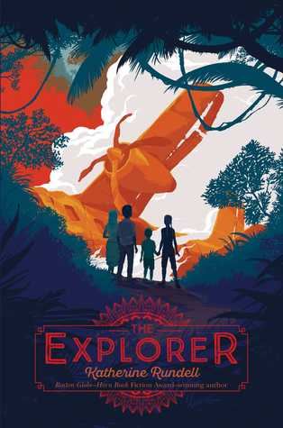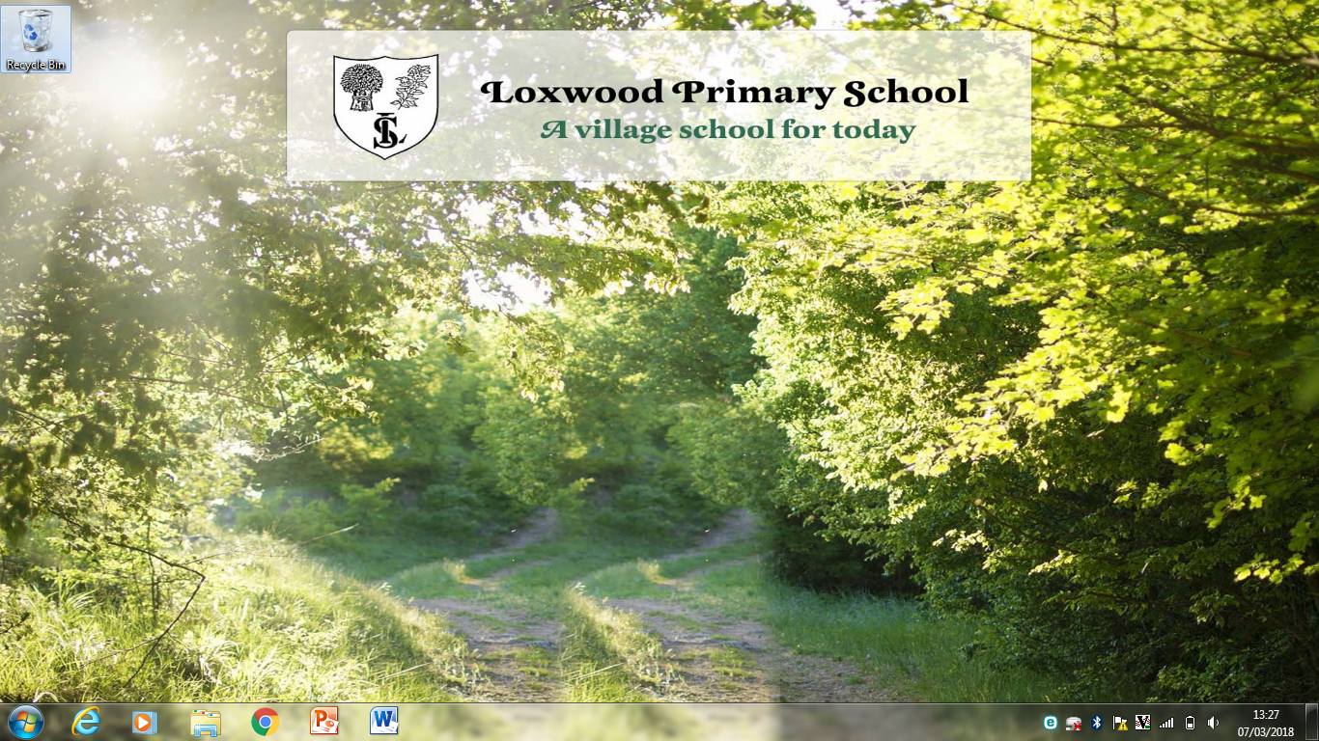

*When their plane crashes, four children are stranded in the Amazon jungle. Now they have to survive alone. But was someone there before them?*

The explorer is an action packed adventure that gets your heart pumping!

-Stuart Moseley.

If you like writing and you want to become an author when you are older, than this book is perfect for you as it has lots of similes and will give you ideas.

-Ellis Hulstaert.