21st & 28th January 2019

**In physical development we are**

**learning to….**

Throw and catch

Please provide school joggers for outdoor PE kit AND SOCKS (if your child wears tights)

Activity

PE with Mr Green.

**In Personal, Social and Emotional**

**Development we are learning to…**

I can say how rules keep us safe

I can follow the school rules

Activities

Discuss rules we have in school

Discuss why we have rules

**In Communication and Language we are**

**learning to…..**

Listen to stories with increasing attention and recall

Answer ‘how’ and ‘why’ questions

Uses language to imagine and recreate roles and experiences in play situations

Activities

Share a range of stories and non-fiction books

**2 week YE Plan**

**planner**

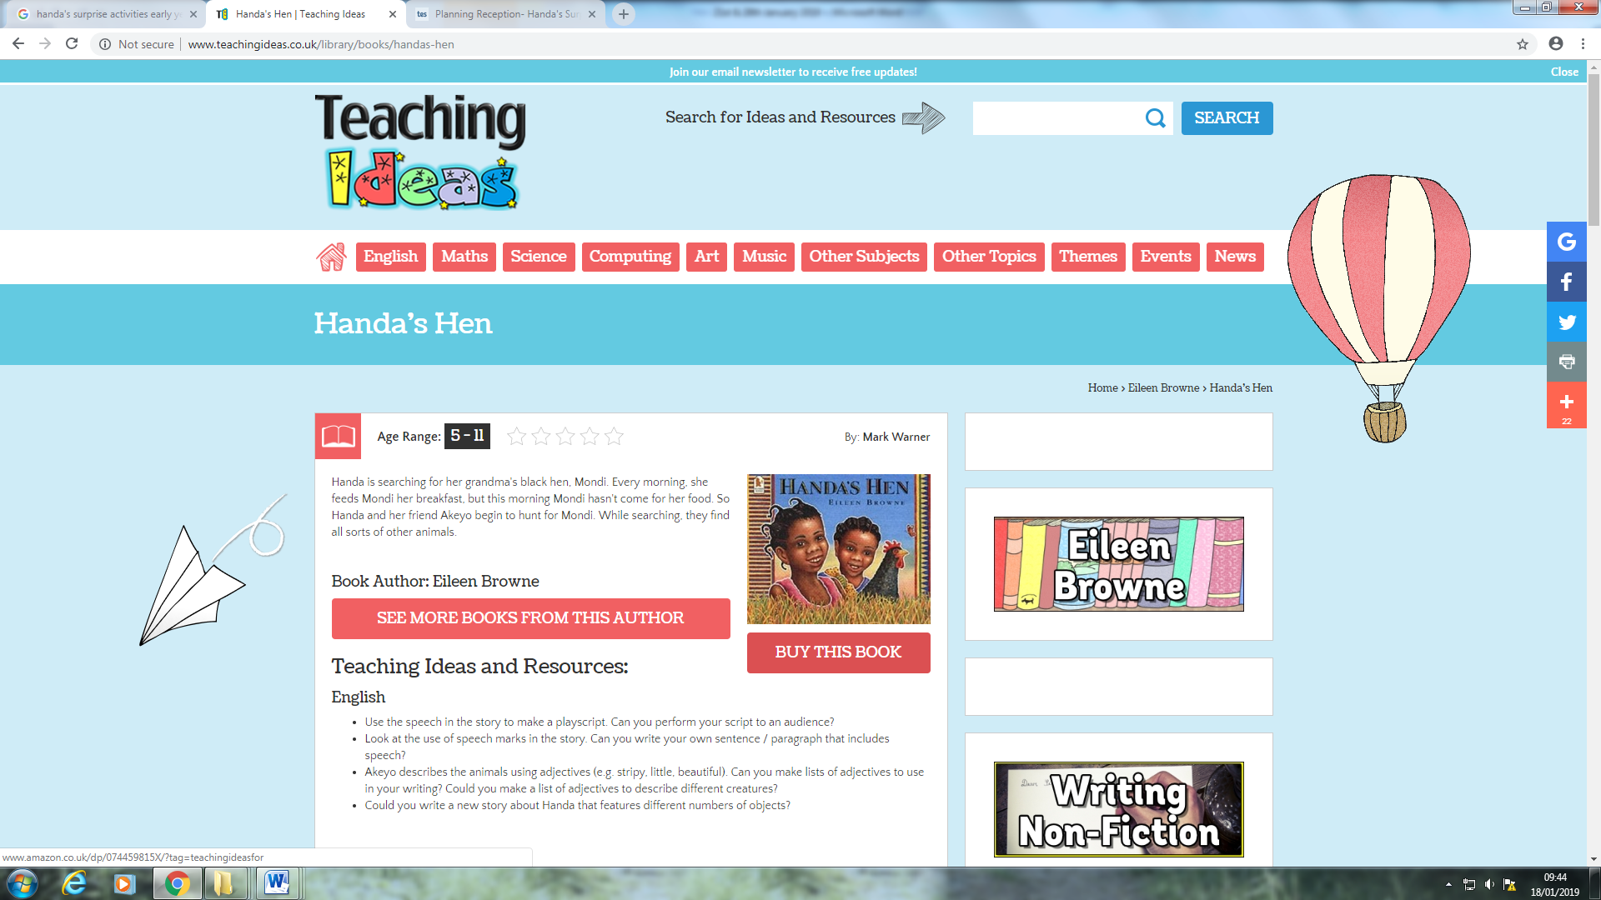

**Ask me about…** ..

[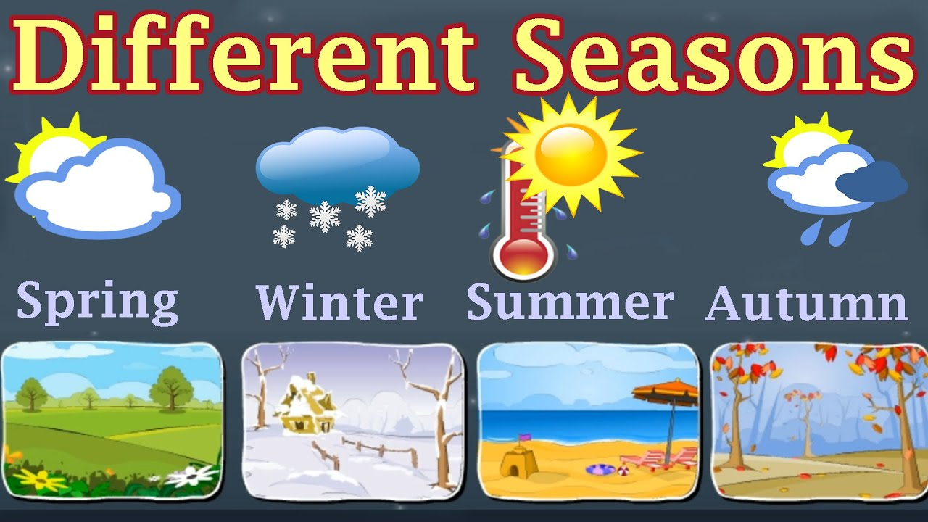](https://www.google.co.uk/url?sa=i&rct=j&q=&esrc=s&source=images&cd=&cad=rja&uact=8&ved=2ahUKEwjHqOjfp_XfAhWs1-AKHdcSB1IQjRx6BAgBEAU&url=https://www.youtube.com/watch?v%3D7UckUHeWXD0&psig=AOvVaw0sMKy8RA_EZFjEjAOoy5ut&ust=1547831470590637)

**In Understanding the world we are learning..**

To recognise the season of winter

To talk about some of the similarities and differences between autumn and winter e.g. weather, trees, animals

Following the visit from Emily’s mum (thank you Mrs Martin), we are learning to act out the role of a veterinary nurse

Activities

Explore the outdoor learning environment

Share non-fiction books about winter

To care for animals in the ‘Animal Clinic

’[](https://www.google.co.uk/url?sa=i&rct=j&q=&esrc=s&source=images&cd=&cad=rja&uact=8&ved=2ahUKEwjukN6gp_XfAhUIORQKHeiNBn8QjRx6BAgBEAU&url=https://petmedicrecruitment.com/pmr-news/protecting-the-title-veterinary-nurse-the-fight-continues/&psig=AOvVaw3BsvpzlUNJpptiorvYG3kv&ust=1547831331135613)

**In Creative Arts and Design we are learning to..**

Investigate winter using the senses

Explore different ways of creating a winter scene

Activities

Make a winter picture using chosen resources

**In Mathematics we are learning to…**

Uses the language of ‘more’ and ‘fewer’ to compare two sets of objects

Finds one more or one less from a group of up to five objects, then ten objects

Have strategies for calculating one more e.g. use practical equipment, rote counting to work out the next numeral, use knowledge of the order of numbers.

Says the number that is one more than a given number

**In Literacy we will are learning to..**

Give meaning to marks as they write and draw.

Learn what a tricky word is. Learn to recognise the tricky word’ I’ in our reading.

Begin to write the tricky word ‘I’

Begin to recognise the HFW: am

Orally blend/independently blend

Hear and say initial sound in words/dominant sounds

Activities

Phonics assessment

Teach tricky word: I (red word)

Teach HFW: am (green word)

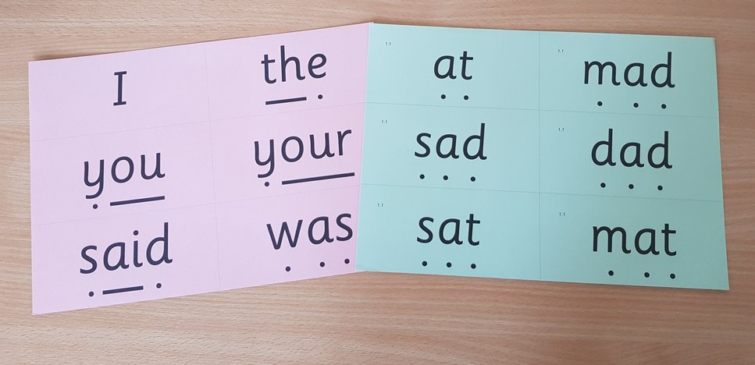

In Early Years we plan across the 7 areas of learning and

make links with our topic. We also follow the ideas and

interests generated by the children. In Reception

children spend time each day self-initiating, this is their

‘Learning time’. Adults will be observing, engaging and

moving their learning on during these times.