SCIENCE -
Earth and Space
Key Skills
Describe the movement of the Earth, and other planets, relative to the Sun in the solar system.
Describe the movement of the Moon relative to the Earth.
Describe the Sun, Earth and Moon as approximately spherical bodies.
Use the idea of the Earth’s rotation to explain day and night and the apparent movement of the sun across the sky.
To be able to explain the change in the seasons as the result of the position of the Earth
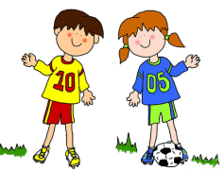
RE

Worship
Explain the practices and lifestyles involved in belonging to a faith community.
Harvest Festival

PE
Football
Basketball

Art
To produce a variety of images based on the moon and the planets
Key Skills
To create sketch books to record their observations and use them to review and revisit ideas
To improve their mastery of art and design techniques, including drawing and painting with a range of materials [for example, pencil, charcoal, paint]
English
Biography Writing
Key Skills
To apply the features of this writing style to a favourite book character.
Ben Hubbard’s Creative Writing Challenge
Fiction – descriptive writing in a Martian setting
Non-fiction – instructions, bullet points and extended sentences.
A focus on reading for pleasure and widening our book choices
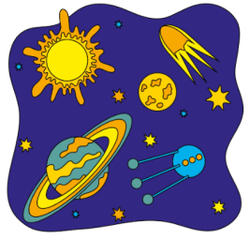
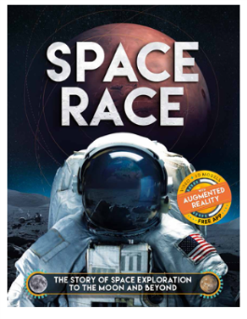
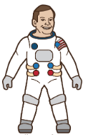
YEAR 5 and 6 AUTUMN TERM 1st Half
‘Out of this World’
HISTORY
The Space Race
Key Skills
A study of an aspect or theme in British history that extends pupils’ chronological knowledge beyond 1066
Know and understand significant aspects of the history of the wider world:
Characteristic features of past non-European societies; achievements and follies of mankind
To learn about the achievements of famous scientists.

PSHE
Growth Mindsets
Residentials: teamwork, perseverance, independence and collaboration

Computing
Online Safety
Maths
Place Value, rounding and negative numbers
French
Ourselves
Name some parts of the body;
Respond appropriately when asked a simple question;
Give a simple description of their eyes and hair;
Place the adjective correctly in a simple
sentence.
Use a small number of everyday verbs in simple dialogues;
Make simple statements in the third person;
Match emotion/health words with their pictures.

