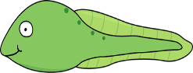
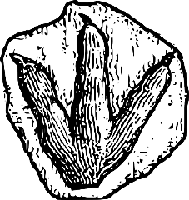
Summer Term Extra Home Work Challenges! Once there were Giants!
This Photo by Unknown Author is licensed under CC BY-SA-NC
Our learning this term is all things GIANT! From dinosaurs to beanstalks, if it is giant, we want to know about it!
Our whole school theme this term is ‘Create’ so these activities are designed to get your creative juices flowing. We are really looking forward to sharing what you have learnt and the new skills you have developed. Please email us your home learning to year2@loxwooschool.com
Creative Giants!  Find out about the life of Vincent Van Gogh and make a poster advertising one of his exhibitions or imagine you are Vincent and write a diary page.  https://www.bbc.co.uk/bitesize/clips/z4pvcdm  You might like to listen to the story ‘Katie and The Sunflowers’. https://www.youtube.com/watch?v=dLx3O02aqyI  Why not paint some still life pictures like Van Gogh and set up your own Gallery then give your family a guided tour!  (Y2 SEND Expectations- Use writing and pictures to create a poster. Write in sentences using a capital letter and a full stop. Use phonics to sound out each word and use a plausible letter or letters. Check spelling using the Year 1 Common Exception Words.) | Time for a Challenge!  Investigate the clocks that you have in your house. What are they like? Now have a go at making your own clock! Maybe it could be a giant one! Here are some ideas!  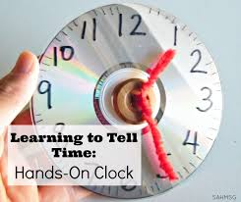  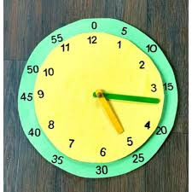  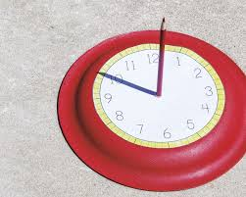  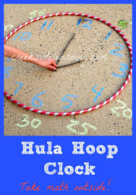  (Y2 SEND Expectations- Talk about what a clock measures. Understand that clocks have two hands and that one is the hour hand and one the minute hand, Arrange numbers around the clock face correctly, Use to show the time for o’clock and half past.) | Lovely Life Cycles!  Find out about the life cycle of an animal that you are familiar with. It could be a frog, butterfly, chicken or even a dinosaur! Create a life cycle to show how the animal grows and changes into an adult. You might find these links useful  https://www.wwt.org.uk/discover-wetlands/home-learning-and-family-fun/the-circle-of-life/  https://www.bbc.co.uk/teach/class-clips-video/science-ks1-animal-life-cycles/zrg9kmn  (Y2 SEND Expectations- Complete a simple life cycle using diagrams and labels and adding captions or talk about what is happening for an adult to scribe. Use arrows to show what happens next, talk about how some animals have similar life cycles and some have different, link to the life cycle of a human.)
Fabulous Fossils!  Create your own fossil find using whatever you have at home. It could be pasta shapes pressed into play dough or shells pressed into clay or even a dino- skeleton made out of sticks on the ground?  Watch this BBC clip for inspiration. https://www.bbc.co.uk/cbeebies/makes/presenters-making-a-fossil  Why not imagine it is an exhibit in a museum and write an information card all about it.  (Y2 SEND Expectations- Help children to gather ideas and resources, look at examples of real fossils and talk about what they look like. Follow simple instructions to make their fossil. Talk about what they need to do first, next, then etc) | Virtual Home School Trip!  Visit the Jurassic coast without leaving your house!  https://www.nhm.ac.uk/discover/360-fossil-hunting-adventure.html  Or why not visit the Natural History Museum and meet a real life palaeontologist, or go on a fossil dig in the USA!  https://www.nhm.ac.uk/events/dinosaur-activities-for-families.html  Now you are an expert make a fact sheet or fact book all about Dinosaurs and fossils!  (Y2 SEND Expectations- Say the sentence before they write it. Write in sentences using a capital letter and a full stop. Check spelling using the Year 1 Common Exception Words. Use phonics to sound out each word and use a plausible letter or letters.) | News Flash!  Watch this clip https://www.theschoolrun.com/homework-help/dinosaurs (scroll down to the bottom of the page) Imagine that one day a dinosaur fossil is discovered in Loxwood when some new houses are being built! Become a news reporter and write a report about what happened or film an interview with a witness! Who would you interview? What kind of dinosaur is it? How do the people of Loxwood feel about it being discovered?  (Y2 Expectations- Write in sentences using a capital letter and a full stop. Check spelling using the Year 1 Common Exception Words. Use phonics to sound out each word and use a plausible letter or letters. Or speak clearly so that the audience can hear. Ask or answer simple relevant questions.)

Links to texts: ‘Tad’ By Benji Davies, ‘Nibbles’ Dinosaur Guide’ by Emma Yarlett and also see https://www.booksfortopics.com/dinosaurs also https://www.booksfortopics.com/homebooks-5-7

