Discover
Writeit  Research a famous Paleontologist and create a fact file or biography.  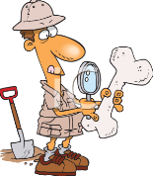  Skills: to use simple organization devices such as headings and sub-headings. | Researchit  What can you find out about Dinosaur Fossils?  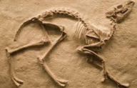  Skills: to describe in simple terms how fossils are formed when things that have lived are trapped within the rock. | Createit  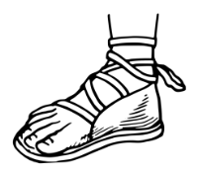  Design and make some Roman sandals.  Skills: to select from and use a wide range of materials and components according to their functional and aesthetic properties. | Createit  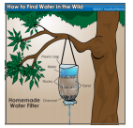  Use rocks to make a water filter. In a funnel put some charcoal, clean sand on top and then rocks. Put some water through. How does it come out?  Skills: to recognize that soils are made from rocks and organic matter.
Researchit  Find out about native British trees and present it in an interesting way.  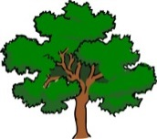  Skills: to use search technologies effectively safely and responsibly | Makeit  Can you make a model of Stonehenge?  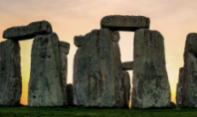  Skills: to develop a secure knowledge and understanding of changes in Britain from Stone Age to the Iron Age. | Writeit  Write a play that has to include a tree, a child and a woodland creature. It has to include scene details etc.  Skills: to create settings, characters and plot in narrative. | Createit  Find a rock and paint it to turn it into a piece of art.  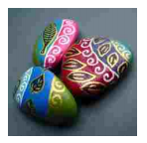  Skills: to improve their mastery of art and design techniques, including painting.
Createit  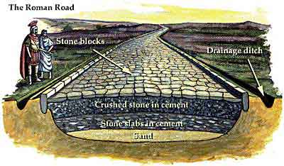  Design and make a Roman Road.  Skills: to understand the Roman Empire and its impact on Britain. | Researchit  Research the different types of rock and what they are used for.  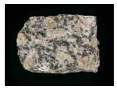  Skills: to compare and group together different kinds of rocks on the basis of their appearance and simple physical properties. | Writeit  Use your knowledge of light, reflection and shadows to create a quiz for a friend or family member. You should ask between 5 and 10 questions.  Skills : to recognize that they need light in order to be able to see things; to notice that light is reflected from surfaces | Researchit  Research the Celts living in Britain at the time of the Romans.  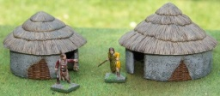  Skills: to understand the Roman Empire and its impact on Britain.
Ideally we would like you to complete two of these activities each half term which would be four projects by Christmas. We will always try to celebrate homework as soon as practically possible.

