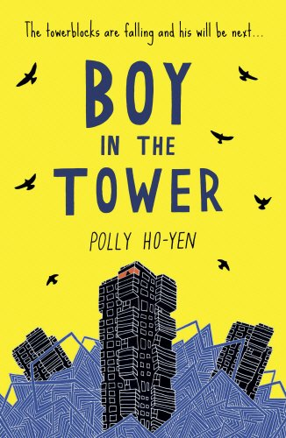
The boy in the tower is all about a boy called Ade and tower blocks are falling all around him; his could fall at any second. I love this story as you get so into it you can’t stop reading it and that is why it is one of my favourites.

