Y6 Homework Grid  ‘Lights, Camera, Action!’ | Knowing | Understanding | Applying | Analysing | Creating | Evaluating
Verbal  I enjoy reading, writing and speaking | Find out and present, in any way you like, the Greek alphabet. Remember to include the names of the letters. Do you recognise any of the letters from anywhere? | Explain what happened in the ancient games. Who took part? How long did the games last? Which events were included? You could create a ‘Good Morning Greece’ style news broadcast. | Create a set of interview questions that you’d like to ask an athlete from the ancient games. You could film yourself asking and  answering the questions! | Write your own Greek playscript based on one of the Myths e.g. Pandora’s Box or Theseus and the Minotaur. | Create a fact file of life in Ancient Greece. This website, https://www.ducksters.com/history/ancient_greece.php should be useful. Choose an aspect of Ancient Greek life and focus on it or showcase an overview of the most interesting facts. | Read a book in the ‘Percy Jackson’ series and write a book review for the school website.
Mathematical  I enjoy working with numbers and sequences | Create a timeline of Ancient Greek events. | Find out about the Greek number system and create your own calculations using it. | Measure out and cut all the pieces to make your own Ancient Greek model e.g. a temple. You choose the material to use. | Find out about the Golden Ratio and have a go at this investigation.  https://nrich.maths.org/7668 | Create a family tree  showing relationships  between the Greek gods  and goddesses. | Create a graph showing the Olympic world records, then evaluate the information which is presented in the graph. What does it show you?
Visual/Spatial  I enjoy painting and drawing | Investigate typical Ancient Greek patterns.  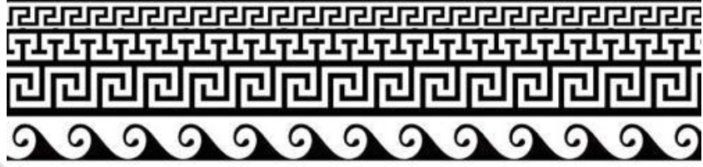  Draw your own set of similar patterns. | Draw a set of Greek pillars, with attention to shading, to create a 3D effect. | Choose a flower from the garden. After studying images from this botanical artist, have a go at your own.  http://www.la-botanicalart.co.uk/ | Have a go at mindfulness colouring with your family. Maybe an Ancient Greek mosaic? Explain how it made you all feel. | Look at some pictures of Greek jewellery. Use these ideas to design your own piece. You can draw it or make it. | Explore the National Gallery virtually. Find a painting you like and explain why you like it.  https://www.nationalgallery.org.uk/visiting/virtual-tours/google-virtual-tour
Kinesthetic  I enjoy doing hands on activities, sports and dance | Make your own ‘Life Cycles Game’ where players have to choose cards to make a complete life cycle for a plant, insect, bird or mammal. | Find out about the original Olympic Games. Make your own set of similar sports and have a ‘family Olympic Games’ in the garden. | Make your own model of a Greek vase. Paint it with authentic colours and patterns. | Put on your own Greek-inspired play at home – you could make different masks for the different characters.  https://www.bbc.co.uk/bitesize/clips/zx67xnb | Create a typical Greek menu for the family and have a go at cooking it. Lay the table and make it a truly authentic experience. | Plan and practise your own Greek Zorba dance with a family member. Ask other family members to score you. https://www.youtube.com/watch?v=FPrUZx9AKSc
Musical  I enjoy making and listening to music | Listen to, and learn, the Greek national anthem. | Explore the pentatonic scale (from the Greek ‘pente’ = five and ‘tonic’ = tone.)  Make your own composition using it. | Create a piece of music to cheer someone up. Think carefully about your choice of  instruments, tempo etc. | Ask your family to take part in your own X- factor competition/ karaoke. Who has the best voice in your family? | Compose a rap which relates to the Greek Gods/Olympics/Greece. | Does music help plants to grow? Set up your own experiment and evaluate the outcome.
Interpersonal | No activities in this section this time, as your interactions with others are limited. Feel free to involve your family in any of the other tasks.
Intrapersonal  I enjoy working by myself | Make an information booklet, use technology if you prefer, about voting in Ancient Greece. Who was allowed to vote in Ancient Greece? What sort of things did they vote on? How were their officials chosen? | Explain what is special about Greek columns and give examples of their use in modern architecture. You could create a PowerPoint with some photographs from around the world! | Find out about Greek Democracy.  Make up some democratic rules for your household now everyone is at home. | Observe, and make a record of, the life-cycle changes in a variety of living things e.g. plants in the vegetable patch or flowers in the garden. | Create your own collage which shows the parts of a flower – this could even be made with fabric with embellishments sewn on. | How would you select the games and events to include in the both the modern and ancient Olympic games? Explain your reasons for choice.

