30th November 2020

**In Personal, Social and Emotional**

**Development we are learning to…**

Aware of own feelings and knows that some actions and words can hurt others’ feelings

Begins to accept the needs of others and can take turns and share resources, sometimes with the support from others.

Usually tolerate delay when needs are not immediately met, and understands wishes may not always be met.

Tries to comfort another child when they realise they have upset them.

**In Communication and**

**Language we are**

**learning to…..**

extend vocabulary, especially

by grouping and naming,

exploring the meaning and

sounds of new words

name different parts of the

body

**In physical development we are**

**learning to….**

change into PE kit

understand what happens to our bodies when we exercise

move in different ways e.g. marching, skipping

to follow instructions

Activity

Session run by Mr Green on Wednesday morning (you may want to send your child to school in joggers but bring spare joggers/school trousers in case of accidents)

**1 Week Plan**

**planner**

**In Mathematics we are learning to**…

Show an interest in representing numbers.

Begin to represent numbers using fingers, marks on paper or pictures.

Record using marks they can interpret and explain.

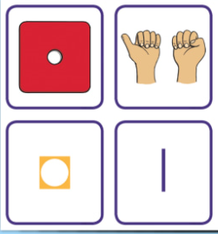

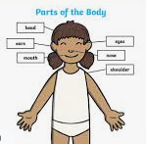



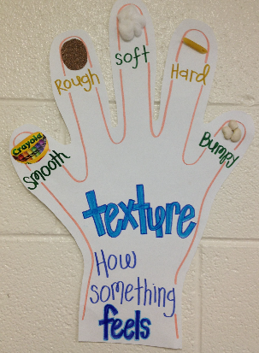

Last week:

 

This week:



**Fred Talk** 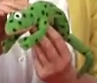

<https://www.youtube.com/watch?v=dEzfpod5w_Q>

**..the human body** 

**In Understanding the world we are learning..**

To be safe when exploring

To explore the environment using our senses

To talk about the things we find

Activities

Texture hunt

**Ask me about…**

**In Literacy we will are learning**

**to..**

Give meaning to marks as they

write and draw.

To learn to recall the phoneme of the day taught in Read, Write Inc lessons (see Sound Book)

To write the letter using the RWI letter patter – see class page link

To look at books independently

To understand information

Can be relayed in the form of

print

Activities

Take part in phonics lessons

Repeat Fred Talk

Listen to a range of texts

**In Creative Arts and Design we are learning..**

To take part in role play activities

To explore the textures

To learn and perform a

song

In Early Years we plan across the 7 areas of learning and

make links with our topic. We also follow the ideas and

interests generated by the children. In Reception

children spend time each day self-initiating, this is their

‘Learning time’. Adults will be observing, engaging and

moving their learning on during these times.