3rd, 10th and 17th June 2019

**In Personal, Social and Emotional**

**Development we are learning to…**

work as part of a group or class, and understand and follow the rules

take account of one another’s ideas

show sensitivity to others’ needs and feelings

adjust their behaviour to different situations, and take changes of routine in their stride.

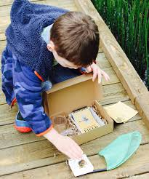

**In Communication and Language we are**

**learning to…..**

give explanations by connecting ideas or events

listen attentively in a range of situations

talk about the features of their own immediate environment and how environments might vary from one another

Activities

Talk about things we have observed e.g. mini beasts and their habitats

Visit Warnham Nature Reserve

**In physical development we are**

**learning to….**

With weather warming up, please provide sun hats and follow school procedure for sun-cream.

Run in a straight line

Take part in Sports Day events

Form letters correctly

Activity

PE with Mr Green

Sports Day

Handwriting sessions

**3 week YE Plan**

**planner**

Pond dipping at Warnham – weather permitting.

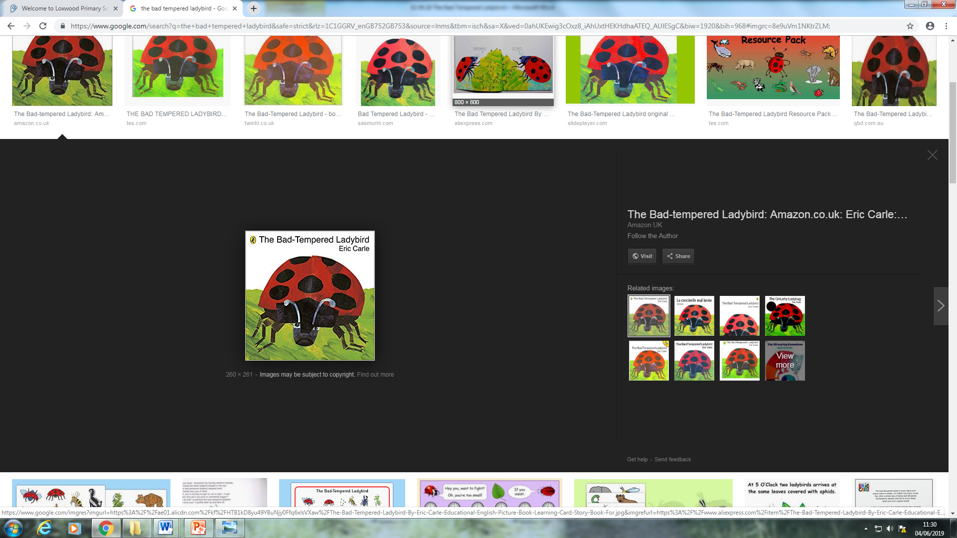

**In Literacy we will are learning to…**

Learn/Consolidate Set 3 digraphs: ay ee igh ow

Read and write words containing set 2 or Set 3 phonemes

Hold a simple sentence in their head

Compose a simple sentence

Complete a modelled sentence

Write a simple sentence.

Write sentences.

Use finger spaces between words.

Punctuate a sentence.

Activities

Daily phonics lessons RWI, writing linked to phonics & topics

Share stories related to topics

**In Mathematics we are learning to…**

recognise, create and describe patterns

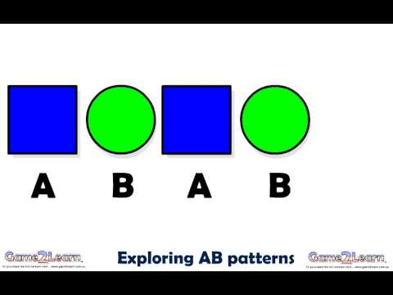

Recall the names of the common 2D shapes

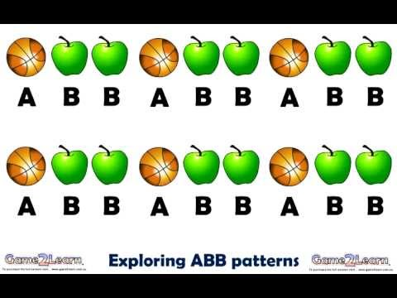

Recognise doubles

Recall doubles

Solve problems, including doubling

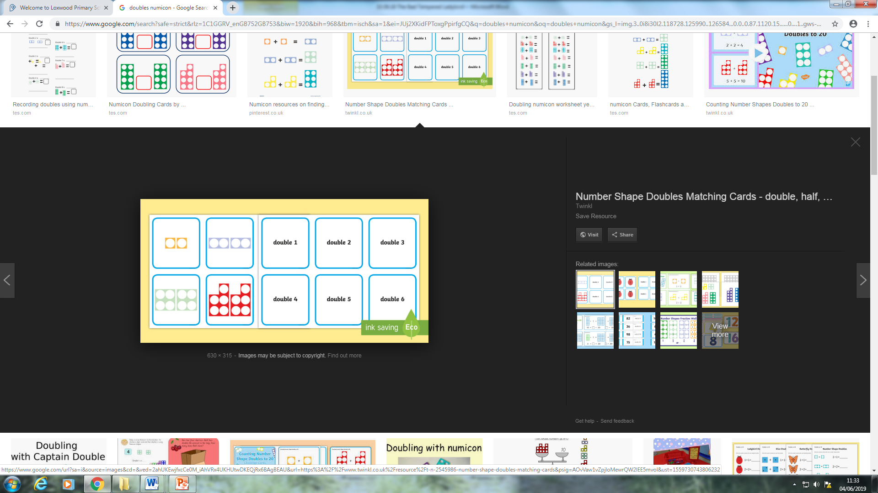 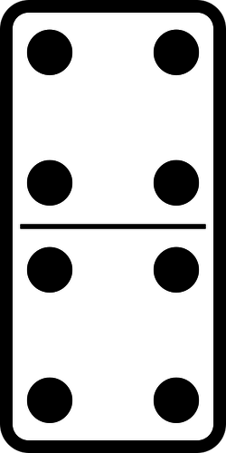

**Ask me about…**

**In Understanding the world we are learning..**

To know about similarities and differences between environments

To make observations of animals and

explain why some things occur, and talk about changes

understand what people do to maintain their locality

to understand the role of a volunteer

Activities

Visit to Warnham Nature Reserve.

Talk to volunteers (parents welcome to visit us to talk about any charity work/events e.g. charity run, litter pick)

**In Creative Arts and Design we are learning to..**

design and make mini beasts and habitats

create symmetrical pictures

Create a range of patterns

Activities –

Activities related toWarnham Nature Reserve

In Early Years we plan across the 7 areas of learning and make links with our topic. We also follow the ideas and interests generated by the children. In Reception children spend time each day self-initiating, this is their ‘Learning time’. Adults will be observing, engaging and moving their learning on during these times.