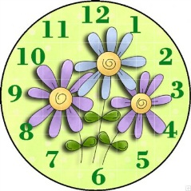
Up to the minute…… 22.3.19

Dear Parents and Carers,
Another busy week, with trips out for Year 5 and Year 6 and a very enjoyable morning of Parent Matches and House Matches. It was really lovely to see everyone enjoying the Year 6 vs Parent games, well done to everyone that was involved!

Eschools App
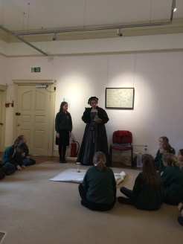
Please can we remind you to download the app. If we send your child’s first and second contact (usually mum and dad) a message and you do not have the app, it costs the school money. If you are unable to download or have any problems please pop in to the school office.
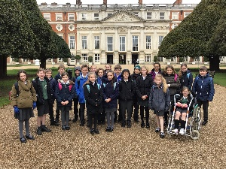
Year 5 & 6 trip to Hampton Court Palace
Year 5 and 6 set off to Hampton Court on Tuesday to find out what
happened when the Tudors set sail to explore the world. We all enjoyed a
workshop with Lady Throckmorten – wife of Sir Walter Raleigh and also
had time to explore the Palace especially the kitchens; tracking down the
delicacies that the explorers brought back with them. The weather was kind
enough to give us an opportunity to sit and sketch in the Palace courtyards too.
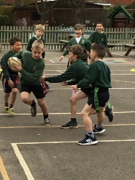
House matches
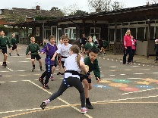
Year 6 vs Parents
We were incredibly lucky with the weather for the Year 6 vs Parents Football and Hockey matches on Wednesday 20th March and the whole school were able to come out and show support for the Year 6s. Both games were enjoyable and friendly whilst giving the children enough of a competitive element. The final results were: the parents won the netball 10-7 and a 5-5 draw for the football. A big thank you to all the parents who found the time to make this fixture possible.
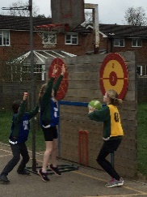
Tag Rugby
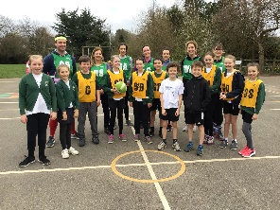
We played this as a mixed 7 aside tournament. Some of the younger children were slightly apprehensive but they were well looked after by the year 5s and 6s, who showed great leadership. Southlands won with 11 points.
Netball
This was also played as a 7 aside tournament. For many children this was the first time they had played competitively and had to learn about positions. Drungwick won with 15 points. Thank you very much all of the parents who came and supported the children.

Treetops week begining March 25th
The building works start for our exciting new library on Monday 25th March. For the duration of the build Treetops will be held in Year 2, please drop off and collect your child via the green gates outside Year 2.

Chartwells return to school menu
Please see attached poster regarding the hot meals for the first few days after the end of term break.

Hawks Holiday Club
Please see attached flyer about Hawks Holiday club for the Easter holidays.

Loxwood Cricket Club
Loxwood Cricket Club are looking for new players aged 9 and over. For more information you should find a flyer in your child’s bookbag or just email cricket@loxwoodsports.org.uk
Kind regards,
Ms Kitson
Did you know……………..
In Tudor times nutmeg was more valuable than gold because it was
believed to cure the Plague!!

Who knows this may come in useful in tonight’s quiz!

Congratulations to the children who received a celebration certificate.
Young Explorers: Harley for Participation and Phoebe for Creativity
Oak Class: Isobel for Dedication, Ivy for Independence and Fi Fi for Attitude
Willow Class: Tillie for Contribution and Sam for Perseverance
Rowan Class: Tate for Engagement, Amelia for Confidence, Halle for Courage and Billy for Kindness
Sycamore Class: Eugenie for Aspiration and Cayden for Kindness
Mulberry Class: Anneka for Confidence, Marco for Focus, Otis for Focus and Florrie for Compassion
Chestnut Class: Flyn for Determination, Fern for Diligence and Skye for Determination

The winning house this week is:
Southlands

General dates
House Matches Infants - 27th March * new date
Church Service - 1st April 1.30 parents welcome – parent helpers needed please
Class Photos - tbc * change of date
Come and See - 2nd April 3.30pm Parents welcome
End of Term Assembly - 5th April 2.30pm Parents welcome
Sports Day - 5th June – times to be confirmed * new date

Summer Term
Year 6 Performance - 3rd & 4th July 6:30pm

INSET days for this Academic Year
Monday 22nd July 2019
Tuesday 23rd July 2019

Half Term / End of Term Holidays 2018/19
Monday 8th April - Monday 22nd April 2019
Monday 27th May - Friday 31st May 2019
Last day of term - Friday 19th July 2019

Forest School Dates
On your child’s Forest School day they can come to school in their Forest School clothing for the whole day, please ensure they are wearing long sleeved tops and trousers – even if the weather is warmer. They will also need suitable footwear, e.g. wellies and a rain coat. If you are able to help on Forest School dates, please see the school office.

Wednesday 27th March Year 5
Wednesday 3rd April Year 6

Year 4 TBC

