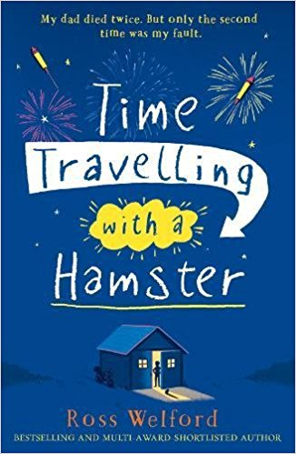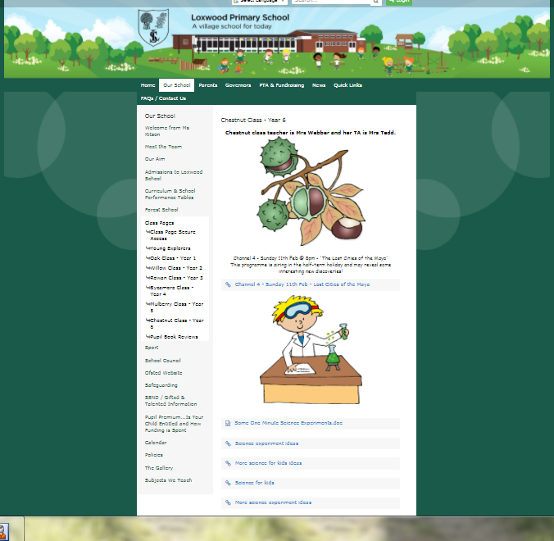

*Albert loves his pet hamster and he also loves his dad.*

*“My dad died twice but only the second time was my fault” explains the loved Albert!*

*This is an amazing novel that Ross Welford created and made official. As well as his other 2 fantastic books!*

Lilly and Keeley`s Book Review

We recommend this book to children age 10-13.

This book had an enticing front cover, which made us want to pick it up and read it.

We would explain this book as a book full of secrets that you can`t wait to find out.

You are able to time travel with a boy and his beloved hamster (Alan Shearer).

*Peter Bunzl*

*Chris Riddell*

*Emma Carroll*

*Ross Welford*

*David Walliams*

*Roald Dahl*

*G.R.Gemin*