Learning Project WEEK 3 (04.05.20) - The Night Pirates
Age Range: EYFS
Daily PE with Joe Wicks

Whole Class Song ‘Together’ Out of the Ark - Week 1 Tuesday
Weekly Maths Tasks (Aim to do 1 per day) | Weekly Reading Tasks (Aim to do 1 per day)
- In line with the rest of the school, we are following White Rose Maths for our daily maths sessions. This week’s activities are based upon the book The Night Pirates (do you remember me reading it in class)? Also The Troll by Julia Donaldson.  Activity 1 - Making telescopes with a pattern. Timing activities – how long can you pretend to be asleep? (We sometimes play ‘Sleeping Lions’ with Year 6 after lunch).  Activity 2 - Floating and sinking. Pick 10 objects. Link with writing – make a numbered list. See below in the ‘Learning Project’ section for more resources on Twinkl.  Activity 3 - Treasure Hunt with positional language. How about making a map or writing your own clues (linked to the writing tasks)?  Activity 4 - Make your own pirate ship (junk modelling). Challenge yourself to make a ship that holds 5 pieces of treasure. Can you make a flag and name your ship. Explore symmetry.  Activity 5 - more pirate fun with a similar game to Buried Treasure which we often play to practise our phonics! 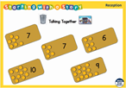  Other Ideas:  - Watch a Numberblocks clip each day at: BBC or CBeebies. Use this guide here to give you ideas on what to do with your children whilst watching an episode.  - If you want to try some different maths activities why not try Maths Factor with Carole Vordemann. It’s free to sign up at the moment.  - Play the Numberblocks pattern spotting game to practise adding one more within 10.  - Look out of the window and count how many houses or buildings can be seen. | - Read a variety of books at home. Favourites can be repeated. Hearing the patterns of language in a story will support your child’s language development. If you haven’t got this week’s focus books at home, see the links in the maths task section to hear The Night Pirates and The Troll.  - Story Time with Nick RWI have made films of well-loved stories read by Nick Cannon, a trained actor, teacher and trainer and a wonderful storyteller.A new story is added to our YouTube channel at 2pm on Monday, Wednesday and Friday each week.  - Also on RWI, listen to some poetry on Poetry Time  - Reception age children: Children to read to parents daily. Visit Oxford Owl for free eBooks that link to your child’s book band. You can create a free account at: https://www.oxfordowl.co.uk/for-home/  Complete the linked Play activities for each book.  - With your child, look in magazines, newspapers and books for our new tricky word ‘you’. They could use a highlighter to highlight in magazines and newspapers. Listen to the tricky word song for Phase 3 to practise; he she be we me was and learn ‘you’ Tricky Word Song 1  - If you need further practise of the Tricky Words to date, listen to this song Tricky Words,It isn’t easy and it takes practise to be able to recall them and:‘Put them in your clever head and remember them forever’.  - Twinkl also has ideas and resources for learning the tricky words and phonics/reading.  - As we have a pirate theme this week, you might want to play Buried Treasure on the phonicsplay website  https://www.phonicsplay.co.uk/
Weekly Phonics Tasks (Aim to do 1 per day) | Weekly Writing Tasks (Aim to do 1 per day)
- Sing Nursery Rhymes and songs together. Add in actions and change the words. Can children think of different rhyming words to add in? Repeat old favourites and learn new rhymes. You can find an A-Z of Nursery Rhymes here: https://allnurseryrhymes.com/  - Daily phonics with RWI - Practice the sounds your child is working on and blend words. This can be oral blending (e.g. spoken out loud c-a-t) or written if appropriate. Interactive games found on link below. https://www.phonicsplay.co.uk/  - Play I-spy with things you can see out of the window. You could alternate between the initial sound in the word e.g. “I spy with my little eye something beginning with t”. Or with oral blending e.g. “I spy with my little eye a t-r-ee”  - Play a listening game- Gather a selection of objects that make sounds from around the house. Cover your child’s eyes with a blindfold and make sounds with the objects collected. Can they figure out what the object is without looking at it? | - Practice name writing. Can they write their first name? Middle name? Surname?  - Practice forming the letters of the phoneme of the day. Follow the RWI script - a copy of which is on our Class Page of the website.  - Ask your child to write out the tricky words they are working on at the moment on pieces of paper and turn them into a pairs game.  - The troll is getting bored of eating fish. Does your family have some better ideas? Ask your child to draw or write a list to help plan for the weekly menu. Encourage them to ask all family members views on what they think the troll would like to eat next week or if everyone else is busy, your child could list their favourite meals.  - Make a treasure map, plan a treasure hunt for adults or siblings, or write your own pirate adventure. Don’t forget to label your pictures with words. Some of you will be writing a sentence for each picture. Aaargh me hearties!
Learning Project - to be done throughout the week
The project this week aims to provide opportunities for your child to learn more about different viewpoints. Learning may focus on physical viewpoints in terms of what you can see outside of the window at home, what others can see looking into your home and then progress onto personal viewpoints and of others.

'Rainbow Art Gallery - Let's Create Together!’
Draw or paint a self-portrait on A5 paper, only using shades of the colour red.
Once complete send it to year2@loxwoodschool.com so that it can be displayed in
our Whole School Rainbow Gallery on the school website. Hang on to your artwork
and bring it into school once we return, so that we can make a real-life Rainbow
Gallery at school!'

- What can you see out of your window?-
  - Ask your child to look out of a window in the house and draw what they can see. Look out of a different window (e.g. back or side of the house), draw what they can see. Look at the two pictures together and discuss what is the same in both pictures (e.g. the sky) and what is different.

- Floating the sinking (linked to White Rose Maths)
  - Can you predict which items will float or sink?
  - Why do you think it will sink? Perhaps you have seem something similar to this sink in the bath or the sea. Or is there another reason for your thinking (the shape, material or weight)?
  - Were there any surprises e.g. things you thought might sink but actually floated?
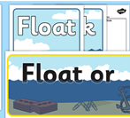More floating and sinking ideas on Twinkl

- Record how many cars/ people walk past your house-
  - Set a timer for 5 minutes on your phone or tablet. Draw out a simple grid (as below) and ask your child to put a tick in the right place every time a person or car goes past. When complete, can they count up the ticks and write the matching numeral? Were there more people or cars?

- How creative can you be with symmetry? Twinkl has some fun activities to do e.g. Symmetry Butterflies or you might like to try Symmetry Matching Game - have fun matching the shapes and pictures on Topmarks Maths.

- How do we differ from others?-
  - Ask your child to look in a mirror at their hair colour, eye colour, skin colour. Ask them to create a self-portrait using either felt-tips, crayons or paint. Look at some pictures in books and magazines. Does everyone look the same way as them? How do people look different?

- Imagine another world when you are asleep-
  - Close the curtains and ask your child to imagine that their house is a pirate ship or that they have landed on an island. What do they imagine? What can they see, hear, smell, touch and taste? Ask them to tell you a story about it…
Your child could create a story map to show what happens in their imaginary world (see right).
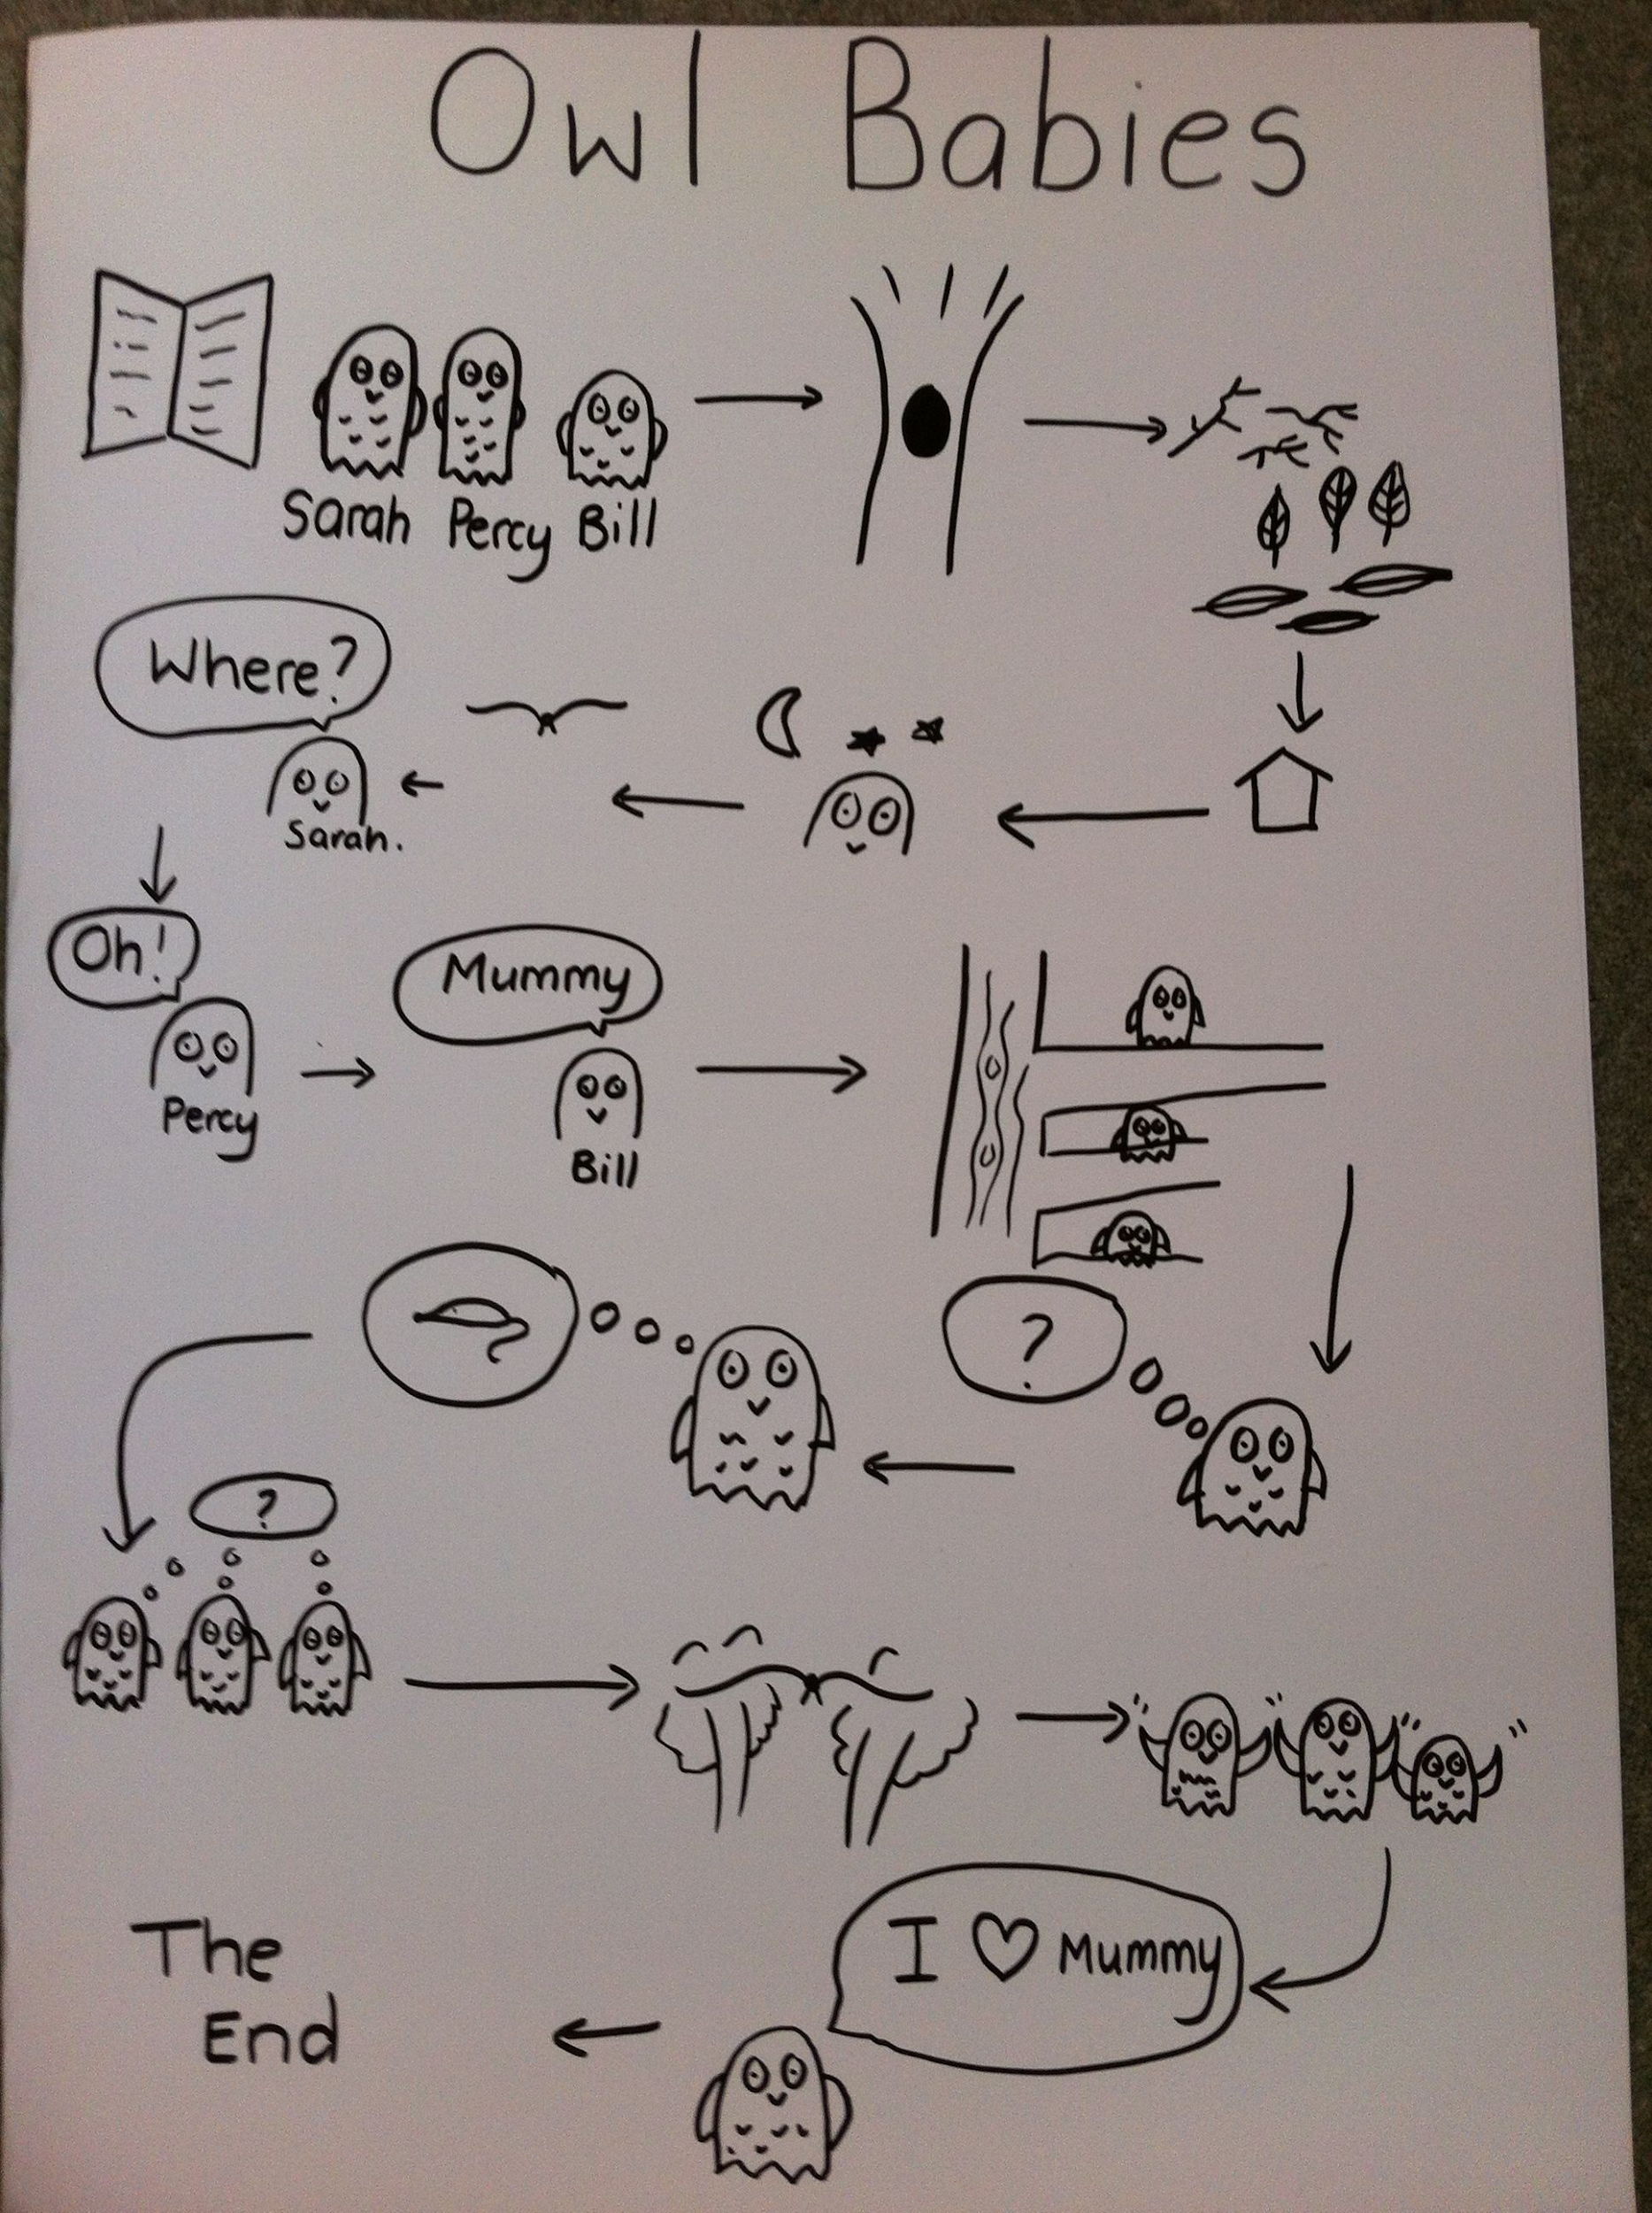
Here is an example story map for ’Owl Babies’.

- Go on a sight hunt-
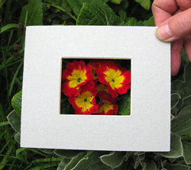
  - Support your child to make a telescope (again this is linked to the White Rose Maths). Take your telescope around the house and garden and explore what things you can see. Linked to White Rose Maths.
  - Your child could write a list of the things they see or draw/ paint a picture.
  - If you have a tablet or phone that could be used by your child they could do the same activity but using photographs to record.

Daily Music Activities with Out of the Ark Week 3
Thank you for the lovely photographs of the children’s learning. It’s so lovely to see them all and share their exciting discoveries. Mrs Coupe is promising a photo of her projects and Mrs Calvert’s will follow (after it has appeared in Up to the Minute first). If you haven’t sent anything in yet, don’t worry. Mrs Calvert will upload more photographs as they arrive. Well down parents it looks like you are doing a marvellous job.
Twinkl - to access these resources click on the link and sign up using your own email address and creating your own password. Use the offer code UKTWINKLHELPS.

