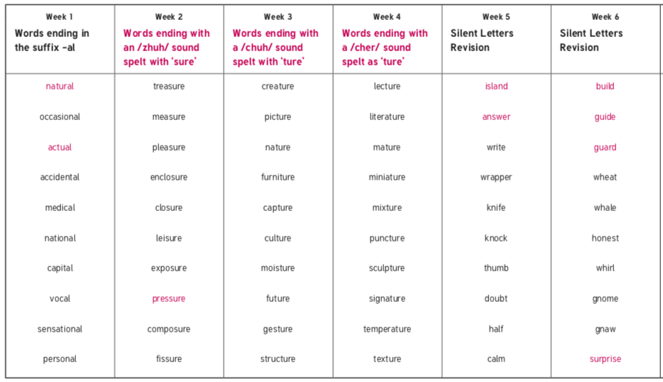
Obejctives that are in pink are Y3/4 statutory requirement and individual pink words are from the Y3/4 statutory spelling list. These are the words that we highlight in class.

8.06.20 | 15.06.20 | 22.06.20 | 29.06.20 | 6.07.20 | 13.07.20

