Learning Project WEEK 4 (11.05.20) - The Very Hungry Caterpillar/Animals
Age Range: EYFS
Daily PE with Joe Wicks
Whole Class Song ‘Together’ Out of the Ark - Week 1 Tuesday
Please note if you are finding this too much, just concentrate on the green tasks e.g. Daily RWI, Daily Maths Task, the Writing Task, Sharing Stories at home and the Gallery Picture
Weekly Maths Tasks (Aim to do 1 per day) | Weekly Reading Tasks (Aim to do 1 per day)
- In line with the rest of the school, we are following White Rose Maths for our daily maths sessions. This week’s activities are based upon the book The Very Hungry Caterpillar by Eric Carle:  Activity 1  - How many circles can you find? Explore more complex patterns with two or three colours. ABAB AABAAB AABBAABB. Exploring patterns in other books. See link to work in collage in the Learning Project Section.  Activity 2  - Finger Painting – make caterpillars of different lengths. Count together then talk about adding more, not just one more – two more or three more (to practise adding). Then one less and extend to 3 less. Draw on legs to explore doubles.  Activity 3  - Explore your fruit bowl. Make a list of favourite fruits. Which is the most popular fruit? Combining amounts e.g. 3 plums and 2 apples. Can you record this and explain it to an adult?  3 5 8  Adults please note children record learning in different ways. It is the mathematical language they use when explaining their learning that is important.  In the example below the child uses speech bubbles to show pictorially the amount each pirate receives, with the remainder given to a non-pirate friend: ‘He’s saying 4 coins each, that’s why I’ve given them speech bubbles. The pirate without a hat isn’t a pirate. They’ve given the other coin to their friend. The number 13 is for all the coins’.  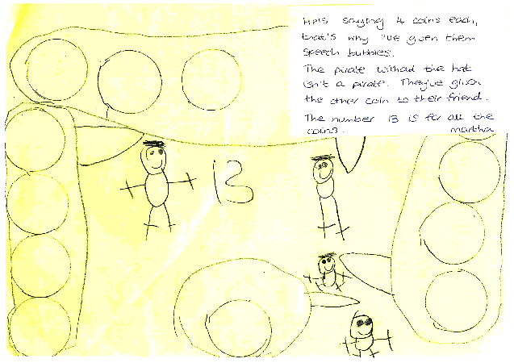  Activity 4  - Picnic Time – make a picnic. Make a plan or shopping list. This activity involves halving, then sharing. See the video link for an example of children sharing smarties Children Sharing Smarties  Activity 5  Make your own playdough caterpillars and compare length and size (can you extend your vocabulary and use words like; smaller, smallest, longest, longer, long). Great for working on fine motor skills too. Can you make a plan of your week? Answer questions based on the words: yesterday, tomorrow. Can you make your own story of The Very Hungry Caterpillar? Sing the song: I went to the cabbages one day…How about a symmetrical butterfly painting?  - Play this counting game. Count how many of each animal you can see.  Other ideas:  - Maths Factor with Carol Vordemann. It’s free to sign up at the moment.  - Or if you prefer a more teacher-led experience use Oak National Academy Lessons | - Enjoy an animated film version of The Very Hungry Caterpillar The Very Hungry Caterpillar  - Reception age children: Children to read to parents daily. Visit Oxford Owl for free eBooks from RWI or you might like to try Songbird Phonics, Traditional Tales or non-fiction books. You can create a free account. Complete the linked Play activities for each book. If you need support selecting suitable books for your child, please email Mrs Calvert.  - Ditty –have you finished all the Ditty sheets you have been given? Can you read them fluently now? Can you ‘Hold a sentence’? Can you write the sentence? Can you make up similar sentences? Could you make up your own Ditty for another child in the class to read? This is quite a challenge as the words need to sound out and include red words we have learned. Or can you read all the Green Words you were given? There are more each day on the RWI website linked to the sounds you are learning. Could an adult write them out for you to practise?  - Learn more about Life Cycles from books you might have at home or from watching a video Life Cycle Video  - Read a variety of books at home. Favourites can be repeated. Hearing the patterns of language in a story will support your child’s language development.  - Story Time with Nick. RWI have made films of well-loved stories read by Nick Cannon, a trained actor, teacher and trainer and a wonderful storyteller.  - Also on RWI listen to some poetry on Poetry Time.  - With your child, look in magazines, newspapers and books for the tricky words they are currently learning. They could use a highlighter to highlight in magazines and newspapers.  This week’s tricky (red) word is my. Listen to the Tricky Word Song 1 to practise those we have learned so far.  Make a collage of phonemes or tricky words:  - The Cautious Caterpillar ebook is on Twinkl as are some activities based on animal life cycles. https://www.twinkl.co.uk/resource/t-t-5221-butterfly-life-cycle-powerpoint
Weekly Phonics Tasks (Aim to do 1 per day) | Weekly Writing Tasks (Aim to do 1 per day)
- Daily phonics - RWI Practice the sounds your child is working on either Set 1 Word Time Reading and Set 1 Spelling or Set 2 Speed Sounds and Set 2 Spellings  - Practice the sounds your child is working on and blend words. This can be oral blending (e.g. spoken out loud c-a-t) or written if appropriate. Interactive games.  - Play this animal sound match game.  - Sing the song, ‘Old McDonald Had a Farm’. Instead of saying the name of the animal, make the sound. Can your child figure out which animal it is? Reception age children could write the digraphs/ trigraphs they can hear in the song e.g. ee, igh, ee, igh, oa | Writing Task - independent task.  Draw a picture and write about your family. If you are learning Set 1 sounds- label the family members e.g. mum, dad, dog etc then you could list the things you like doing with your family e.g. ck (cook), ply (play. Adults please note the children will write down the sounds they hear in the words. They can use the Sound Chart in their pack but please encourage them to find the phoneme (if you tell them please let us know).  Children learning Set 2 sounds should be able to write some sentences about their family. Remember to sound out the words independently and use finger spaces between words.They can tell you their sentence first but please don’t write it for them to copy (you can add it on a post-it or at the end to show what they planned to write/have written).  - Draw an animal of your choice. Label the parts of the animal. Reception children could create a fact file e.g. where does it live? What does it eat?  - After reading Dear Zoo, add your own animal into the story and label it e.g. So they sent me a...hedgehog, but he was too prickly....so I sent him back.  - Practice forming the letters of the alphabet. Follow your school’s script.  - Ask your child to write out the tricky words they are working on at the moment on pieces of paper and turn them into a pairs game.
Learning Project - to be done throughout the week
The project this week aims to provide opportunities for your child to learn more about key animals they are interested in. Learning may focus on exploring the physical aspects of an animal, their habitat, categorising animals etc.

Don’t forget your portrait for the Rainbow Gallery
- Make a collage or circle picture
  - Eric Carle uses collage in the book The Very Hungry Caterpillar. Have a go at making your own collage. There are lots of ideas on Activity Village
  - Another artist that uses circles in art is Kandinsky - can you make a shape collage similar to the one Kandinsky made?

- Identify the birds in your garden-
  - Use the RSPB bird identifier website
  - Draw a picture of the birds you can see.

- Play animal charades-
  - Take it in turns to act as different animals. Add in noises as a clue…

- Learn the song, ‘The Animals Went in Two by Two’
  - Ask your child to draw out two of each animal and practice writing the numeral 2.

- Looking after your pet-
  - If you have a pet at home encourage your child to take part in their daily care. They could help feed, groom and clean up after your pet.

- Big and small animals-
  - Draw as many big animals as you can on one piece of paper and as many small animals as you can on another sheet of paper. Some children may be able to write a list as an alternative.

- Find all of the animal books in your house-
  - Ask your child to look through the books in your house and to find any with animals on the front cover. Ask them to sort the books into groups of their choice e.g. animals that can fly, swim, big, small, live on a farm/ at the zoo.
  - Can you sort the books into non-fiction (information) and fiction (story) books?
  - See if you can spot some differences between fiction and non-fiction books e.g. non-fiction books usually have photographs not drawings, captions under photographs, a contents page, a glossary etc

- Create an animal den-
  - Provide your child with blankets and sheets to make an animal den. Act out being an animal in the den OR
  - Choose a soft toy animal or small animal figure and create a junk modelled container for it.

youngexplorers@loxwoodschool.com
Keep sending the photographs for the Class Page Gallery – we love to see your learning.

Twinkl - to access these resources click on the link and sign up using your own email address and creating your own password. Use the offer code UKTWINKLHELPS.

