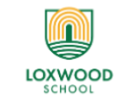

Learning Project WEEK 6: Food
Please use as much or as little as you feel you are able to.
There is still time to complete your Rainbow Portrait!
Willow Class (Y2 SEND Edition)
Start the day with PE with Joe or something similar– every day at 9.00 or have a go at this week’s Virtual School Games challenges!.
Weekly Maths Tasks (Aim to do 1 per day) | Weekly Reading Tasks (Aim to do 1 per day)
- Work on a White Rose Maths Home Learning Task. (Click on your year group and the week that you are following). Worksheets are available to download on the class page.)  - Play on Hit the Button - number bonds, halves, doubles or times tables.  - Look in the cupboards and the fridge. Sort some of the foods you can find into different groups. Which food group has the most or least amount of items? Which item of food is the lightest or heaviest? Why might this be?  - Play the game Fruit Fall - answer the data handling questions based on how many pieces of fruit you catch.  - Choose and draw a 2D shape of your choice. List how many sides, vertices and lines of symmetry it has. You could draw around food packets! Can you find any food packets that are regular 3D shapes?  - Fruit survey: ask in your family the different fruits they like to eat. Collect the information and add it to your tally chart. Can you represent this information in a particular way? | - Look in your cupboards, how many words can you read on tins and packets? Can you use Fred talk to segment the words eg p a s t a, or  b ea n s  - Look at the books that you have at home and make a list or draw all the different types of food you find.  - Have a go at the Giant Jam Sandwich activity from our Home work Challenges if you haven’t already!  - Listen to Joe Wicks reading ‘Would you like a Banana?’ https://www.bbc.co.uk/iplayer/episode/m000j5n2/cbeebies-bedtime-stories-755-joe-wicks-would-you-like-a-banana (or pick another bedtime story). Tell a grown up about the story. Did you enjoy it? Why/why not? What was your favourite part? Would you recommend this book? Is it a rhyming story? Draw a picture from the story and write a sentence about what is happening.
Weekly Phonics/Spellings  Tasks (Aim to do 1 per day) | Weekly Writing Tasks (Choose one or more to try)
Each day you could choose one of BBC Bitesize’s English lessons: https://www.bbc.co.uk/bitesize
Daily phonics – ask your child to practice their sounds (found in the front of their Reading Records) and blend words. Interactive games found on link below. (Focus on speed sounds)  - Daily phonics - your child to practice their sounds and blend words. Interactive games found on link below.  - Phonics play  - Top Marks  - Spelling  - Spell the days of the week  - Grammar, punctuation and spelling with Karate Cats.  - Spell Year 1 common exception words or revise Year group spelling patterns using Spelling Frame  - Make a list of food in alphabetical order and add on sound buttons if you can. | Remember to use your sounds in the front of your Reading Record and common exception words for spelling. Think about capital letters and full stops and joining ideas using and. Don’t forget those finger spaces!  - Help to write a shopping list for the week. Can you group the items into food groups on the list e.g. fruit and vegetables, meat, dairy?  - Write a set of instructions for making a yummy fruit salad. Watch this lesson to help you. https://www.thenational.academy/year-2/english/to-identify-the-key-features-of-instructions-year-2-wk1-3#slide-2  You might draw a picture for each step and add a sentence if you can.  - Design a new label for a cereal box. What eye catching information will you add? Can you use an exclamation mark?  - Write apoem about food. Will it rhyme? You might like to watch the story ‘Don’t put your finger in the Jelly Nelly’ for some inspiration! https://www.youtube.com/watch?v=YnL8PdbhBR0
Learning Project – Choose one or more of the activities below to try

Food
The project this week aims to provide opportunities for your child to learn more about food. Learning may focus on where different foods originate from, what makes a healthy meal, opportunities to cook etc.

BBC Bitesize Find a new topic to learn about - choose from any KS1 lesson to find something that really interests you.

Balanced diet: Show your child this video about how to have a balanced diet.

Play these games about healthy eating.
What do we have today? Look in the kitchen to see if you can create an A-Z list of foods.

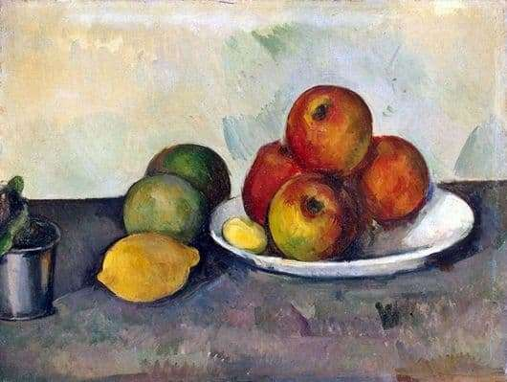
Fruit and vegetables - Draw pictures of fruit and vegetables in your house. Can you arrange them into a still life picture?
This painting by Paul Cezanne might inspire you!

Sorting activity: Collect food from the kitchen and sort into healthy and unhealthy foods.
Design a poster - think about the foods you like to eat and food that you need to eat to keep you healthy. Create a poster that you can put in the kitchen or in the school hall. Will you be able to use any food wrappers or make your poster interactive?

Healthy lunchbox: can you play this game and make a healthy lunchbox?

Traditional food: Many cultures have various dishes of food to celebrate their festivals. Find out about a festival and compare it to a different festival. What are the similarities? What are the differences? How is the food prepared? Do you have any traditional food you enjoy with your family?

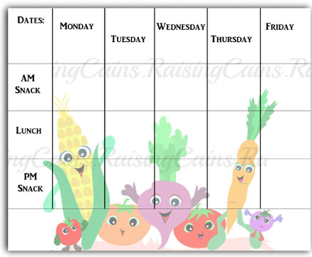
Restaurant: Create your own role play café! Can you plan a menu? Think about what you would like to have on your menu. Look around the house for any leaflets or take away menus. What price is the food?

Designing a school menu. Can you design a new school menu? What could you add? What would you keep the same? Will it be a healthy school menu? Can you find pictures or draw pictures to add to your menu? Plan out your menu and remember to include prices.
Will you have a different menu everyday?

Cooking: Can you help to make the dinner this week? What will you cook? Can you help to do the measuring?
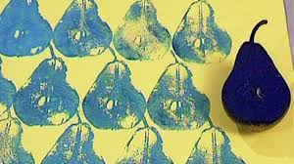
Fruit and vegetables printing: Look at the work of the artist: Lynn Flavell. How does she represent fruit and vegetables? Can you create a piece of artwork in the style of Lynn Flavell.

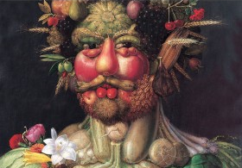
Look at the work of Giuseppe Arcimboldo.
Using different drawing materials, can you create a picture of your own? Or cut out food from magazine pictures to make it!
Additional learning resources parents may wish to engage with
Classroom Secrets Learning Packs - These packs are split into different year groups and include activities linked to reading, writing, maths and practical ideas you can do around the home.
Twinkl - to access these resources click on the link and sign up using your own email address and creating your own password. Use the offer code UKTWINKLHELPS.
Headteacherchat - This is a blog that has links to various learning platforms. Lots of these are free to access.
#TheLearningProjects

