Egyptians Homework Grid: Autumn 2022
You will be expected to complete two activities per half term, to a high standard! Please use this sheet to tick off which projects you have chosen
.
Art & Technology  Inspired by the Art of David Hockney, create a collage version of one of his pictures, using bright and bold colours on an iPad or tablet.  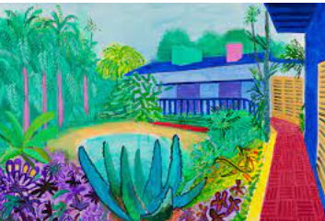 | Geography  Research a country in Europe and write a fact file about it  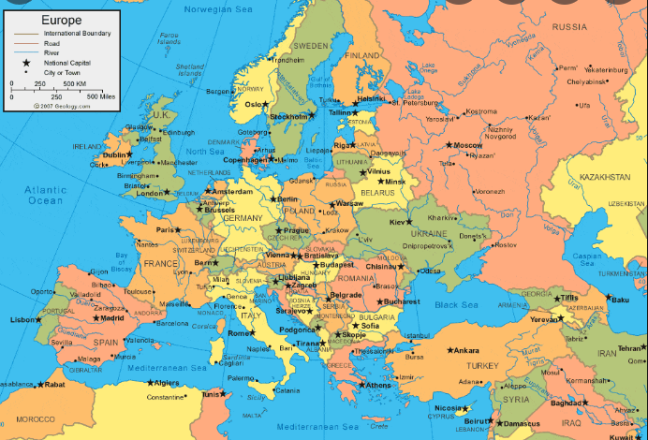 | Reading  Write a book review on a recent story you have read.  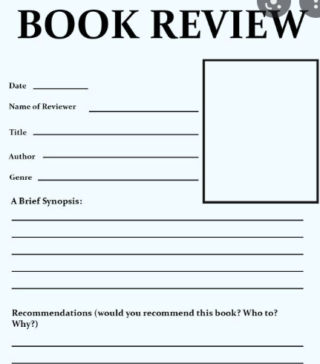
Writing  Write a short story as if you were an archaeologist discovering Tutankhamun for the first time.  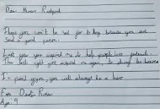 | History  Using any type of material, make a Egyptian pyramid.  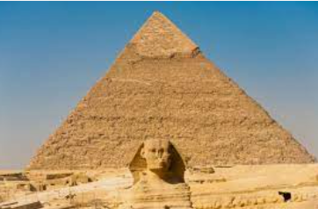 | 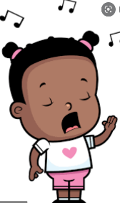  Maths  Record a video of yourself reciting a times table that you have learnt (3, 4, 6, 8, 9 or 12s)
Woodland  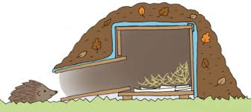  Go outside and make a home or feeder for a native British Mammal or Bird.  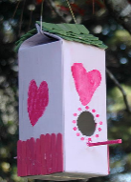 | French  Can you remember how to talk about yourself in French? Write a simple conversation in French.  - Hello!  - My name is ____.  - I am _____ years old.  - I’m fine, thank you.  - Goodbye!  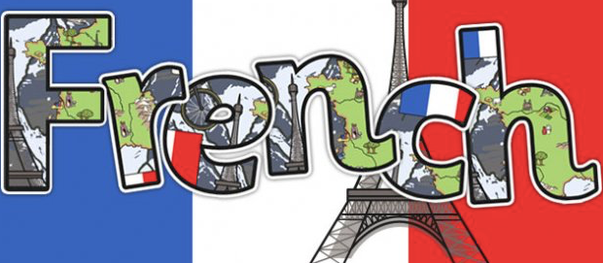 | Design  Computer-Science  Research and make a PowerPoint on the different types of teeth you have and their functions.  