25th  April – 9th May 2022

**In physical development we are**

**learning to….**

Understand the importance of healthy food choices.

Develop co-ordination in movement e.g. skipping

Form letters correctly.

Write their first name and surname.

Activity

Session run by Mr Green on Wednesday morning

Please note: the children have access to a range of resources to develop their physical skills. This includes balancing equipment, hoops, balls and catchers.

**In Personal, Social and Emotional**

**Development we are learning to…**

Show an understanding of their own feelings and those of others, and begin to regulate their behaviour accordingly

Work and play cooperatively & take turns with others. Be confident to try new activities and show independence, resilience and perseverance in the face of challenge.

Activities

Theme day making a sandwich, drawing Paddington with Year 1 and 2.

Discuss Paddington’s feelings and the actions of the Brown family in looking after Paddington.

**In Communication and**

**Language we are**

**learning to…..**

Engage in story time

Respond with relevant questions, comments and actions.

Make comments about what they have heard and ask questions to clarify their understanding

Express their ideas in **full** sentences

**3 week YE Plan**

**planner**

**In Understanding the world we are learning..**

Know some similarities and differences between the natural world around them and contrasting environments, drawing on their experiences and what has been read in class e.g. **Paddington, London, Peru**. **Use Google maps to compare places.**

Know some similarities and differences between things in the past and now, drawing on their experiences and what has been read in class e.g. how Paddington greets others by lifting his hat and saying ‘Good morning’.

**Share non-fiction books about bears**

Where do bears live?

What do bears eat?

**In Literacy we will are learning**

**to..**Clap the syllables in a word

Read and write two syllable words e.g. farm/yard, sitt/ing

Learn the split digraphs a-e, e-e, i-e, o-e e.g. make, these, like, home.

Read and write words beginning with consonant clusters e.g. stow, stop, start, stem

Describe characters and settings

To look at books independently

Learn the tricky words my they said

Activities

Daily phonics lessons inc.

handwriting, reading and writing

sentences.

Writing sessions 3 times a week

Listen and discuss a range of texts

In Early Years we plan across the 7 areas of learning and

make links with our topic.

In Reception children spend time each day self-initiating, this is their ‘Learning time’. Adults will be observing, engaging and moving their learning on during these times.



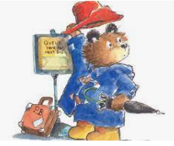

Using a range of resources to represent numbers beyond 10 e.g. bead string, numicon, cubes.

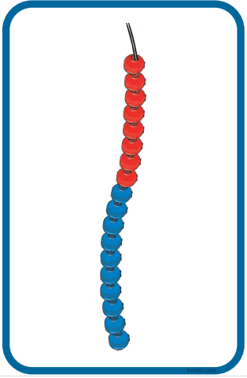  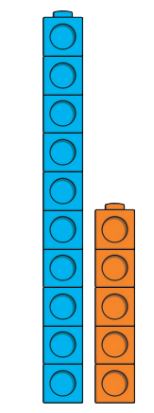

**In Mathematics we are learning to**…

Recite numbers in order beyond 10

Recognise and talk about counting patterns beyond 10

To build numbers beyond 10

|  |
| --- |
| To understand that the two-parts in these numbers e.g.  15 is made of one 10 and one 5, 15 is one more than 14. |

**In Creative Arts and Design we are learning..**

To match, rotate and manipulate shapes (linked to maths learning).

**Cityscape using shapes** based on Maisy Goes to the City pages 3&4 and **Shapes at Play** – Silvia Borando (Walker)

Safely use and explore a

variety of materials,

tools and techniques

**Ask me about…**