12.09.19 | 19.09.19 | 26.09.19 | 03.10.19 | 10.10.19 | 17.10.19
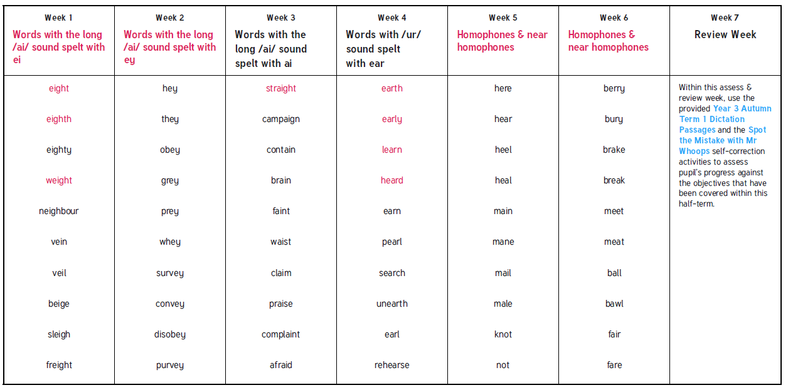
Obejctives that are in pink are Y3/4 statutory requirement and individual pink words are from the Y3/4 statutory spelling list. These are the words that we highlight in class.

