7th & 14th December 2020

**In Personal, Social and Emotional**

**Development we are learning to…**

Be confident to try new activities

Sing in front of an audience

Say when they do or don’t need help

Activities

A festive surprise performance

Christmas lunch

**In Communication and Language we are**

**learning to…..**

Listen to and follow instructions

Explain own knowledge and understanding and ask appropriate questions of others

Activities:

Discuss their Christmas traditions

with a talk partner

Compare similarities and differences

**In physical development we are**

**learning to….**

change into PE kit (PE shirt, PE shorts, joggers, jumper or cardigan, plimsolls, socks – gloves if cold)

understand what happens to our bodies when we exercise

move in different ways e.g. marching, skipping

Activity

Session run by Mr Green on Wednesday morning (you may want to send your child to school in joggers)

**2 week YE Plan**

**planner**

**Fred Talk** 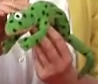

<https://www.youtube.com/watch?v=dEzfpod5w_Q>

Repeat Fred Talk e.g.

p-i-g/pig (My Turn, Your Turn – MTYT).

**In Mathematics we are learning to**

.. recognise 1p coins

… count 1p coins accurately to pay for items.

… recognise numerals (read price tags)

… make price labels

…find out how many coins they have altogether

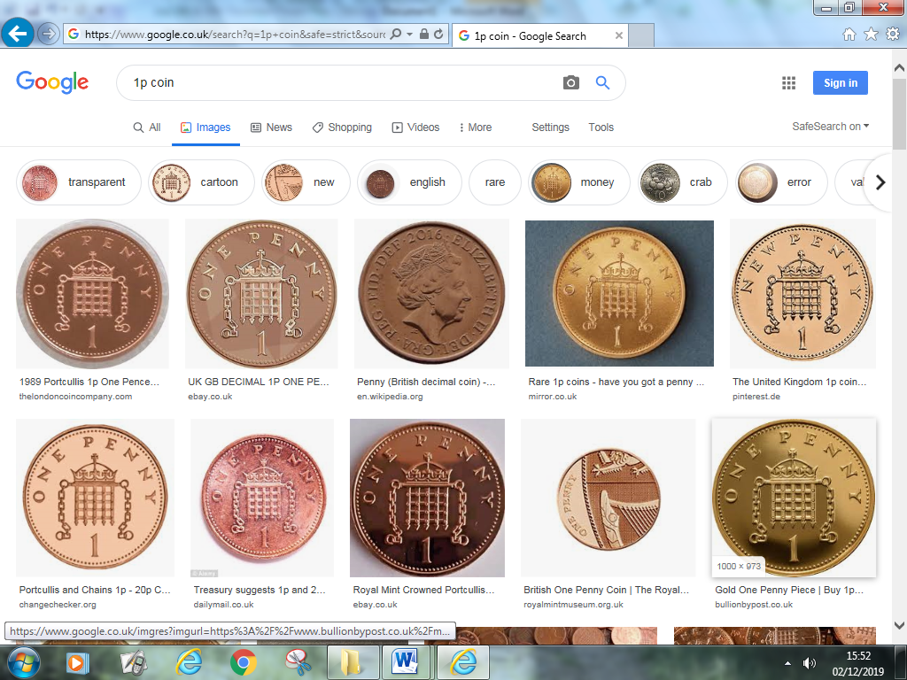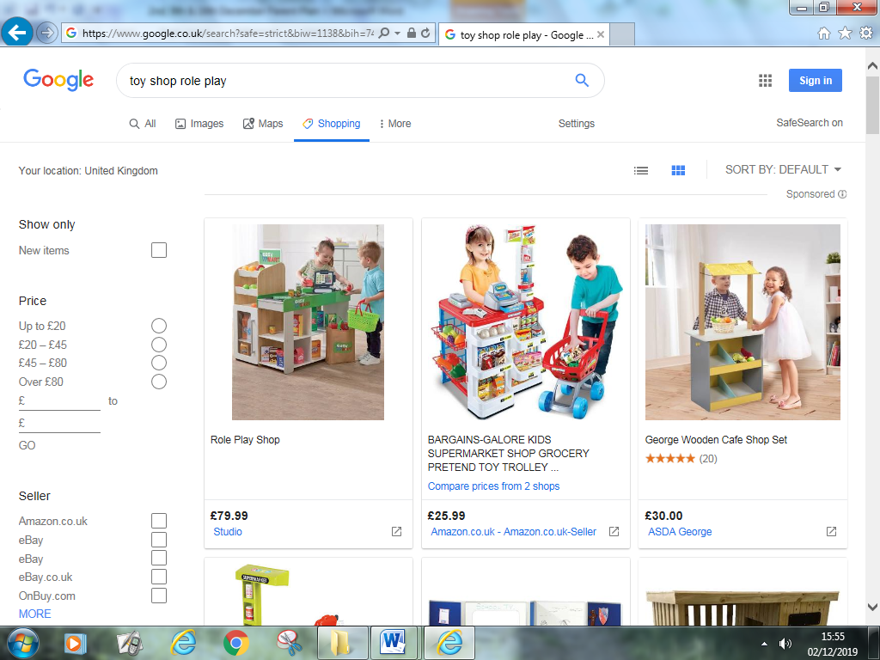

**In Literacy we will are learning to..**

Give meaning to marks as they write and draw.

To use story language and full sentences when reading

To write the letter using the RWI letter patter

Begin to identify and record (write) the initial phoneme (first sound in a word) or dominant phonemes



Activities

Daily Phonics lessons

RWI Word Time /Words or Ditty reading.

Begin to select correct graphemes in simple words.

Make a Christmas list

Make a book of Christmas Traditions and label our pictures



**Ask me about…**



**In Understanding the world we are learning..**

about some of the traditions around Christmas

about the meaning of Christmas to Christians

about different ways to celebrate Christmas

Activities

Share a range of Christmas stories and texts

Make a Christmas Book

Take part in Christmas activities in school

**In Creative Arts and Design we are learning to…**

Act out a narrative with other children

Use a range of resources e.g. paint, construction, role play props, junk modelling, music and singing

Activities

Christmas activities

Christmas Shop themed role play area

In Early Years we plan across the 7 areas of learning and

make links with our topic. We also follow the ideas and

interests generated by the children. In Reception

children spend time each day self-initiating, this is their

‘Learning time’. Adults will be observing, engaging and

moving their learning on during these times.