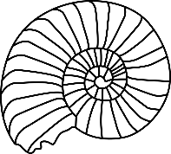
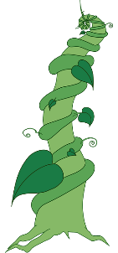
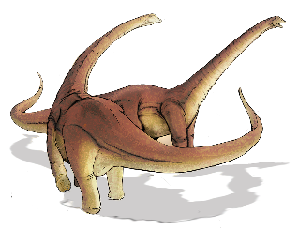
Summer Term Home Work Challenges!
This Photo by Unknown Author is licensed under CC BY-SA
Once there were Giants!
Our learning this half term is all things GIANT! From dinosaurs to beanstalks, if it is giant, we want to know about it!
Our whole school theme this term is ‘Create’ so these activities are designed to get your creative juices flowing. We are really looking forward to sharing what you have learnt and the new skills you have developed. Please email us your home learning to year2@loxwoodschool.com
Super Sandwiches  Linked to the story The Giant Jam Sandwich https://www.youtube.com/watch?v=rnr65z4AN_I  Design your own sandwich and then make it! Write the instructions for how to make it using time adverbials and bossy verbs. Make your instructions clear and easy to follow. Email them to us and we can share them with the class to see if anyone can follow your instructions.  (Y2 SEND Expectations- Talk about what they did. Use First, Next, Then etc to sequence their instructions. Draw a picture for each step and add a simple sentence for each. Start each sentence with a capital letter and end with a full stop. Child to sound out the words and be praised for any correct sounds. No need for words to be spelt correctly. Use Year 1 Common exception words to refer to spellings. Encourage finger spaces.) | Create-a-saurus  Linked to the poem The King of all the Dinosaurs  https://resource-bank.scholastic.co.uk/resources/27520  Get creative and draw, paint, sculpt a picture or model of the King of all the Dinosaurs.  You could use natural objects, junk or even make a sock puppet version. Be as creative as you like and send us photo of your creation.  (Y2 SEND Expectations-Work as independently as possible gathering resources and thinking of ideas, but give suggestions if this is needed. Talk about what they are doing to an adult. Ask What did you do first? What did you do next? Etc. Have a go at cutting and joining materials independently, but support as necessary.) | Engineering Giants!  Isambard Kingdom Brunel Giant Bridge Maker!  Brunel was a great builder of tunnels, railways and bridges.  What is the biggest bridge you can build?  What materials will you use? Recycling? Lego? How will you join your materials together?  https://www.ssgreatbritain.org/brunel-institute/learning/stuff-do-home  (A good link with lots of fun ideas)  (Y2 SEND Expectations-talk about ideas with a grown up, talk about the sequence things need to happen using words like First/Next/Then/Finally, lead the practical making of the bridge asking for help where appropriate. Look at images of real bridges and use these as a starting point for their ideas.)
Mary Anning-Fossil Queen!  Find out some facts about Mary Anning. Who was she? Why is she still famous? Is she still alive? What did she find out? What fun fact can you find out?  https://www.bbc.co.uk/bitesize/topics/zd4dy9q/articles/zng7gwx  This link might be helpful.  Can you make a fact poster about Mary Anning? How could you present this creatively?  (Y2 SEND Expectations- Draw some pictures and write 2 or 3 factual sentences trying to use a capital letter and full stop. Use phonics to help spell unknown words (see advice above) and refer to the Year 1 Common Exception Words to check spellings of these. Join ideas with and.) | Virtual Museum Visit!  Visit Horsham Museum via the power of the internet!  Take a 3D virtual tour of the museum https://www.horshammuseum.org/virtual-tour. Go upstairs to ‘Flints and Fossils’ and see what you can find!  Make your own pop up museum in your house – it can be displaying anything you like but if you have dinosaurs why not make your own Dino museum?  (Y2 SEND Expectations- Work as independently as possible gathering resources and thinking of ideas. Make signs and posters and captions. Take someone on a tour of their museum.) | Grow a Giant!  Linked to the story of Jack and the Beanstalk  https://www.bbc.co.uk/teach/school-radio/english-ks1-jack-and-the-beanstalk-episode-1/zjfwkmn  Find a seed to plant and keep a diary of what happens to it. Water it and watch it every day. Maybe take photos, sketch it and even measure it. Record in cms how much it is growing. Ask an adult to use their phone as a magnifying glass so you can see it up close. Send us a picture.  (Y2 SEND Expectations- Look at a plant and talk about the parts of a plant. Talk about what plants need to grow. Work together to make observations using simple equipment such as rulers. Record their observations with a photo or a picture.)
Extra Challenge! Terrific Timetables – Draw pictures to sequence your day at home. Ask a grown up to draw the hands on the clock for the time that you do things. Focus on o’clock and half past.
This Photo by Unknown Author is licensed under CC BY-NC

