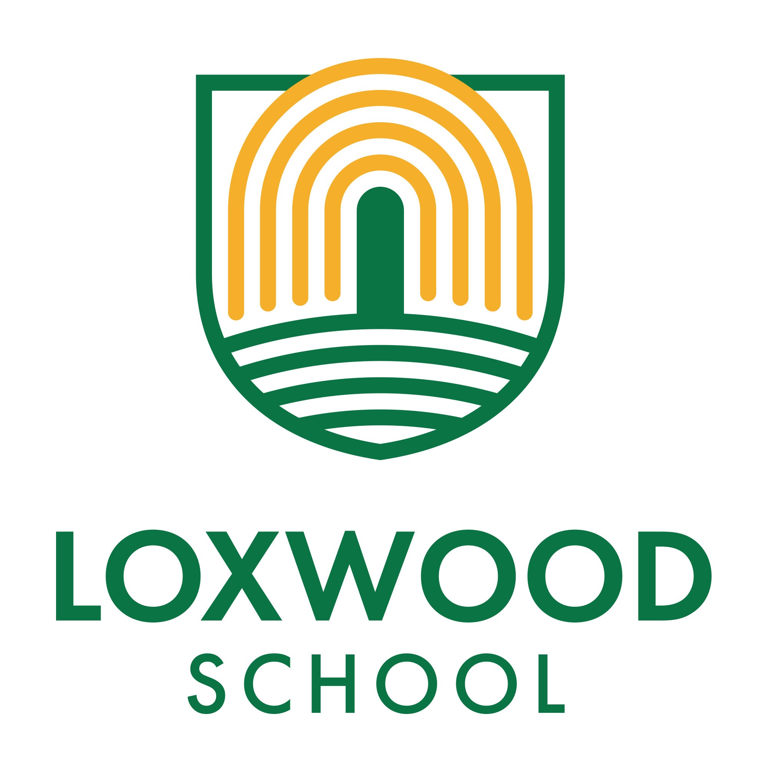

Up To The Minute 26.09.25

This week at Loxwood has certainly been a sporty and exciting one! Our talented athletes have showcased their skills at the Weald, and it's been wonderful to see the enthusiasm from our children. Participating in these events not only helps to nurture their athletic talents but also fosters teamwork and resilience.

Additionally, we've continued to promote a love of reading throughout the school. Thanks to Mrs O'Mara’s efforts, the library bus visit was a fantastic success! The children had the opportunity to explore a variety of books, and choose some new books for their classrooms.

# Use Of Class WhatsApp

Please can we ask that any concerns or complaints are shared with the school directly so that we can address them and not shared on the class WHATSAPP.

Our Parent Code Of Conduct states that parents -

1. Respect the purpose and objective of the group. The primary goal of the Class WhatsApp group is to facilitate the sharing of information that is pertinent to the pupils in our class. We encourage all parents to refer to the ‘Up to the Minute’ (our weekly newsletter) and official website for updates and important announcements prior to reaching out to the class representative. This will help ensure that the group remains focused on relevant class matters.

2. Furthermore, the group serves as an avenue for social interaction among parents and is instrumental in enlisting support for school events. Your involvement and cooperation are crucial in building a strong community spirit.

3. The WhatsApp group is not an appropriate platform for discussions of a personal nature, nor should it be used to promote businesses or convey biased opinions. For personal messages, please utilise direct messaging to maintain the group’s intended purpose.

4. The group administrator, typically the class representative, acts as the moderator and will monitor communications to ensure adherence to our guidelines. Should messages frequently diverge from the agreed purpose, the administrator will intervene to keep conversations on track.

5. You are encouraged to refrain from sending content, information or “news” that hasn’t been verified. If you feel uncomfortable in a group for any reason, feel free to notify the group administrator. If appropriate, the group administrator can report any concerns to the school.

6. Do not share any opinions about a teacher’s teaching style or personality. Should you have any personal views or concerns relating to a specific teacher or school matter, these should be raised with the teacher, in the first instance.

7. Please remember that not every message will receive a response, and this should not be interpreted personally. If you require a reply, sending a direct message would be more effective. If you find yourself engaged in a discussion with a specific member, I encourage you to transition that conversation to direct messaging, as the rest of the group may not find it relevant.

8. Before sending a video, picture, meme or any content, analyse if such material will be in the interest of the majority of the members of the group. Consider whether you would be happy for your message or comment to be written or published before sharing it.

# Smartphone Free Childhood

St. Mary's Primary School, Pulborough, is offering a free parent workshop. Papaya is coming to talk about smartphones and the impact that this can have on children.

Please see the leaflet attached.

It is on the 3rd October at 9am. Just click the QR code and fill in the booking form. Everyone is very welcome.

# We Are Looking For Sponsorship

We are desperately needing to update our gates and signs out the front, we are looking for a company to sponsor us. Please do contact one of us if you know of anyone. Thanks so much.

# Textile/Clothing Recycling Bin

To support our fundraising efforts, we now have a textile/clothing bin outside year 6. Please feel free to fill it up with any of the items below. Please do not leave bags of clothes if the bin is full. Don't worry, it will be emptied every 2 weeks.

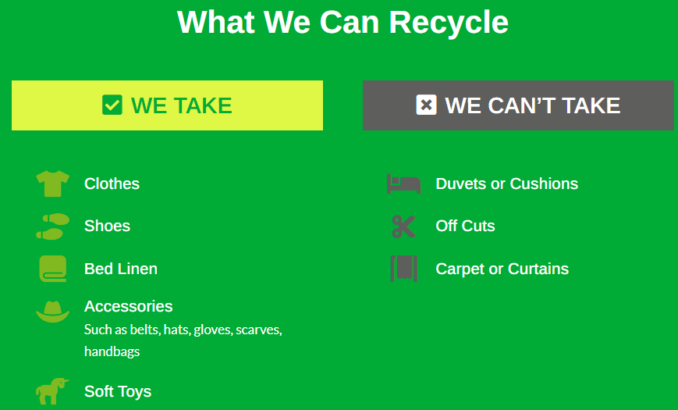

# Free Swimming & Gym

Our school has been adopted by Cranleigh Leisure Centre for the month of October. This allows our families to use the facilities for free for two weeks, that include swimming for the children, and parents for swimming, gym and classes.

To access this amazing offer, you just need to scan the QR code on the leaflet attached and add your details. Your pass will be activated from the 1st October.

# 12 Ways To Help Your Child Make Friends

Making relationships with other children is one of the prime purposes of the educational system. Particularly in lower key stages, the social aspect of schools is vital to the socialisation of children at important points of their lives. Properly socialised children make for properly socialised adults, who in turn make excellent citizens in later life. That being said, for some children it may be easier said than done. Navigating the topsy-turvy of these nascent relationships is not for the faint hearted, yet it must be done. ACAMH Learn has produced a webinar with Dr. Eileen Kennedy-Moore to explore some of the ways this can be helped.

[12 ways to help your child make friends](https://acamhlearn.org/Learning/12_Ways_to_Help_Your_Child_Make_Friends/09c3dce7-6ada-4c93-8872-00118c4f46ce)

# Staff Carpark

Please can we remind you that the staff car park is for staff use only. Thank you.

# Class Amazon Wish lists - Thank you for your generosity

Reception <https://amzn.eu/gLHtZpZ> Year 1 <https://amzn.eu/a4xNMIg>

Year 2 <https://amzn.eu/jgEyKhf> Year 3 <https://amzn.eu/79yqHNk>

Year 4 <https://amzn.eu/99XXQ2I> Year 5 <https://amzn.eu/2BJd9KK>

Year 6 <https://amzn.eu/00TBN9v> SEND <https://amzn.eu/08DgIhS>

ELSA <https://amzn.eu/agbYnPv>

# PALs Update

A big thank you to everyone who attended our PALS Annual General Meeting – your time, ideas, and support are greatly appreciated, and it was fantastic to see some new faces too! For anyone who was unable to attend, the minutes, Chair’s Report, and Treasurer’s Report are available on request. We are also delighted to welcome our committee for the coming year: Chair – Jasmine Chilton; Vice Chair – Victoria Swart; Treasurer – Pippa Court; and Secretary – Danny Adams.

PALS Quiz Night – Come and Join the Fun! We are excited to invite you to our PALS Quiz Night on Thursday 13th November at 7:30pm at The Onslow Arms. Tickets are £20 per person, which includes a delicious meal and a drink, and there’s a £200 cash prize up for grabs! This is always a brilliant evening full of fun, laughter, and a little healthy competition, so gather your friends, test your knowledge, and support our school at the same time. All money raised will go towards funding an all-weather surface for part of our school field.

🍰 PALS Cake Raffle Winner:

This week we had not one but two cakes in the raffle – which means two lucky winners! 🎉 Congratulations to Teddy (Y6) and Finley SS (Y2). Please pop by Reception to collect your cakes. We’re also delighted to share that this morning’s raffle raised around £80! Thank you, as always, for supporting our PALS fundraising – every ticket really does make a difference! 💜

Dates for the Diary:

Cake Raffle – Friday 26th September, Friday 24th October, Friday 21st November at 8:30am

Uniform/Cookie sale – Friday 10th October, Friday 7th November at 3:05pm

Quiz Night – Thursday 13th November from 7:30pm

# Young Minds World Mental Health Day - Hello Yellow

10th October

Wear something yellow

Our school will be taking part in Hello Yellow on Friday 10th October (World Mental Health Day) to raise awareness and funds for YoungMinds, the UK’s leading charity for young people’s mental health. No young person should feel alone with their mental health and that’s why Hello Yellow matters. We’re taking this opportunity as a school community to come together and show our children that we’re with them and they’re never alone with their mental health. We’ll be taking part by wearing a yellow item (t-shirt, socks, tie, ribbon, badge) and talking about how to take care of our mental health.

You can also donate via the YoungMinds website https://fundraise.youngminds.org.uk/event/hello-yellow/donate .

Most importantly, we want to share the resources which YoungMinds offer to support parents and carers if you ever need help and advice to support your children.

This includes: • online resources (www.youngminds.org.uk/parent/)

• a phone line, open 9.30am-4pm (0808 802 5544)

• an online chat for parents and carers to speak to trained professionals if you’re concerned about your children’s mental health ([www.youngminds.org.uk/parents-helpline/)](https://www.youngminds.org.uk/parents-helpline/))

You can also find help and advice on our school website - https://www.loxwoodschool.com/web/wellbeing/704245

# Please Name Everything

Please can you ensure all items of uniform, bags, coats, snack pots, water bottles and lunch boxes are named. We are unable to return lost items that do not have names on them.

If your child looses their responsibility badge we will have to ask for a contribution towards a new one, this is due to budget constraints.

Many thanks for your support.

# Our Loxwood Superstars

OAK - Primrose for curiosity. Louie for kindness. (Reception will have their certificates presented in class for this term)

CHERRY - Lake for independence. Rufus for kindness.

WILLOW - Fredi for respect. Alex for kindness.

ROWAN - Pearl for curiosity. Layla for respect.

SYCAMORE - Zachary for resilience. Ivy for independence.

MULBERRY - Leila for kindness. Harry DD for kindness. Frankie for independence. Freddie for independence.

CHESTNUT - Sole for independence. Charlotte for curiosity.

# House Points

1st Drungewick 2nd Malham 3rd Southlands 4th Brewhurst

# Reading Rocket Results

This week we have read 388 times. Well done! In total we have read 955 times.

# Cake Raffle Winners - (thanks to Mrs Z for making a very lovely chocolate cake)

Teddy (Year 6) & Finley SS (Year 2)

# Dates For Your Diary

Autumn 2025

30.09.25 - Room to Bloom Opening & SEND Tea and Chat 9-10am

02.10.25 - Census Day

02.10.25 - Harvest Festival at Church 1:50pm

03.10.25 - Individual and sibling photos

08.10.25 - Year 3 Multiskills at The Weald

10.10.25 - Hello Yellow: World Mental Health Day (see UTTM 19.09.25)

17.10.25 - Show Racism the Red Card Day (more information to follow)

23.10.25 - Accelerated Reader Parent Workshop 8:30am

13.11.25 - Parent Pause: Tea and Talk 8:50am (Anti-Bullying Theme)

18.11.25 - Parents' Evening 3:30 - 6pm (more information to follow)

19.11.25 - Parents' Evening 3:30 - 6pm (more information to follow)

19.11.25 - KS2 Autumn Term House Matches (more information to follow)

01.12.25 - Whole-School Panto (more information to follow)

02.12.25 - SEND Tea and Chat 2:30pm

09.12.25 - Infant Nativity 1:45pm

09.12.25 - KS2 Carols at Church 5pm

11.12.25 - Infant Nativity 9:30am

# Term Dates

2025-2026

Thursday 4th September 2025 – School starts

Friday 24th October 2025 – Break up for half term at 3:15pm

Monday 3rd November 2025 – School starts

Friday 19th December 2025 – Break up for Christmas holidays at 1:30pm

Tuesday 6th January 2026 – School starts

Thursday 12th February 2026 – Break up for half term at 3:15pm

Monday 23rd February 2026 – School starts

Friday 27th March 2026 – Break up for Easter Holidays at 1:30pm

Monday 13th April 2026 – School starts

Friday 22nd May 2026 - Break up for half term at 3:15pm

Monday 1st June 2026 – School starts

Wednesday 22nd July 2026 – Break up for Summer holidays at 1:30pm

INSET Days 2025-2026

Wednesday 3rd September 2025 Thursday 27th November 2025

Monday 5th January 2026 Friday 13th February 2026

Friday 12th June 2026

We value your feedback . Please do catch Mrs Mellors or Miss Price on the gate or email us at messages@loxwoodschool.com.