Does music help/stop plants from growing?
Plant: Basil
How many: Three
Genre of Music for Each Plant: (1). Rap, (2). Peaceful/Quiet.
For the third plant there will be NO music at all.
Day One
Basil (one), will get the song ‘Black’ by Dave, on repeat for 30 minutes.
Basil (two), will get the song ‘Gymnopedie No.1.’ by Satie, on repeat for 30 minutes.
Basil (three), will get no song, on repeat for the whole day (NS)
Day Two
Basil (one), will get the song ‘Rap God’ by Eminem (30mins)
Basil (two), will get the song ‘Venus the Bringer of Peace’ by Holst (30mins)
Basil (three), ‘NS’
Day Three
Basil (one), will get the song ‘Godzilla’ by Eminem (30mins)
Basil (two), will get the song ‘Peace Piece’ by Bill Evans (30mins)

Basil (three), ‘NS’
Day Four
Basil (one), will get the song ‘Gucci Gang’ by Lil Pump (30mins)
Basil (two), will get the song ‘Angel’ by Sarah McLachlan (30mins)
Basil (three), ‘NS’

For the other 10 days of the two weeks, I will be replaying these songs for the same amount of time each day. And watering them evenly.

At the end of the weeks I will see which plant (one, two or three) has grown the most during a week, two of them listening to music. I will also see if they have grown the same length

Prediction: I predict that the music could help the plants grow; in music, there are sound waves which are sources of energy. Plants/any living things need energy to move around and grow. But also, it could not help them develop, as it is not giving them the three key factors a plant needs: Water, nutrients and carbon dioxide. I know it will not stop them from growing- they will be getting everything plants use to survive, water, nutrients, air, water, light, temperature and space. But, overall I believe that music can help plants grow.
Fair Test: I will make it a fair test, by giving them the exact same water, sunlight, nutrients. Also, by playing the music for the same amount of time each day. And I will make sure all the plants are the same type (Basil). Lastly, planting them to the same depth.
Safety First: I will not play the music extremely loud into my ear, I will not throw the plants at people, I will not eat the daffodils, and finally, will not stay awake all night watching them grow.
Independent Variable  The Music | Dependent Variable  The Length of The Plant (Daffodils) | Control Variable  The Same Factors,  Playing Music for the Same Length of Time,  Plants Are the Same Type

Answer Table
‘NA’ means ‘No Appearance’
Repeat x0
Music Type | Plant Type | Length of Plant | Days Growing
Rap, Peaceful, ‘NS’ | Basil | ‘NA’ ‘NA’ ‘NA’ | One
Rap, Peaceful, ’NS’ | Basil | ‘NA’ ‘NA’ ‘NA’ | Two
Rap, Peaceful, ‘NS’ | Basil | ‘NA’ ‘NA’ ‘NA’ | Three
Rap, Peaceful, ‘NS’ | Basil | 1.5mm, ‘NA’ ‘NA’ | Four
Repeat x1
Rap, Peaceful, ‘NS’ | Basil | 3.5mm, 1mm, ‘NA’ | Five
Rap, Peaceful, ‘NS’ | Basil | 5mm, 2.5mm, ‘NA’ | Six
Rap, Peaceful, ‘NS’ | Basil | 7mm, 4mm, 1mm | Seven
Rap, Peaceful, ‘NS’ | Basil | 8.5mm, 6mm, 2mm | Eight
Repeatx2
Rap, Peaceful, ‘NS’ | Basil | 1cm, 7.5mm, 3.5mm | Nine
Rap, Peaceful, ‘NS’ | Basil | 1.2cm, 9mm, 5mm | Ten
Rap, Peaceful, ‘NS’ | Basil | 1.35cm, 1.05cm, 7mm | Eleven
Rap, Peaceful, ‘NS’ | Basil | 1.5cm, 1.3cm, 9.5mm | Twelve

Conclusion
In this investigation, I discovered that music could help plants expand.
As written in the answer table, each day I measured them and came to the intriguing conclusion that the plants (Basil) with music were developing remarkably faster than the plant (Basil) without melody. Furthermore, the seed supported by the ‘rap’ music grew to a much bigger extent than the seed boosted by the ‘peaceful’ music. I came to realize that the Basil surviving without melody, did not appear from the soil until the seventh day into the experiment. To make this a fair test, every two days, I poured 85ml of water into each of the plants’ soil. However, before sprinkling the Basil seed in the pots we had ‘Lily of The Valley’ bulbs which we watered once, before deciding that they would not grow to a big enough size to be able to measure them frequently. And so, I feel that this could have made the investigation slightly inaccurate.
The Basil with the rap music in the background, grew the fastest and made the most height. My thought behind this is that, as the rap music is louder than the peaceful music, it creates more sound waves (sound is a source of energy), the more sound waves means that there is more energy. And so, all the energy moves into the plant, causing the Basil to expand at a faster rate. The calm music is more subtle and so generating little sound waves, thus meaning there will not be as much energy. Also, after researching it, scientists have discovered that sound (music), can help plants grow.
This leads to my prediction being correct. My estimation being accurate, before I learnt more about music, was surprising as I had forgotten that it generates sound waves/energy. I feel my results were reliable, as I gave each of the seeds the exact same amount of water (85ml), relatively the same amount of soil, and the same temperature. Therefore, I am confident that melody does help plants grow.
Basil (rap)
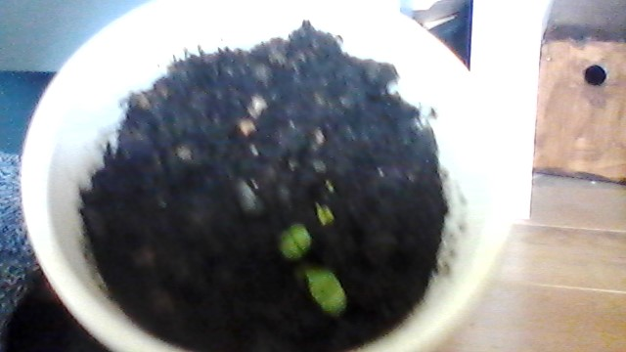
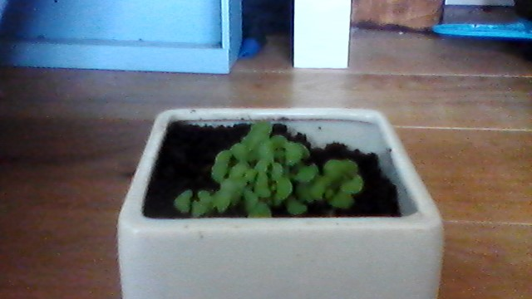
Basil (‘NA’)
Basil (Peaceful)
