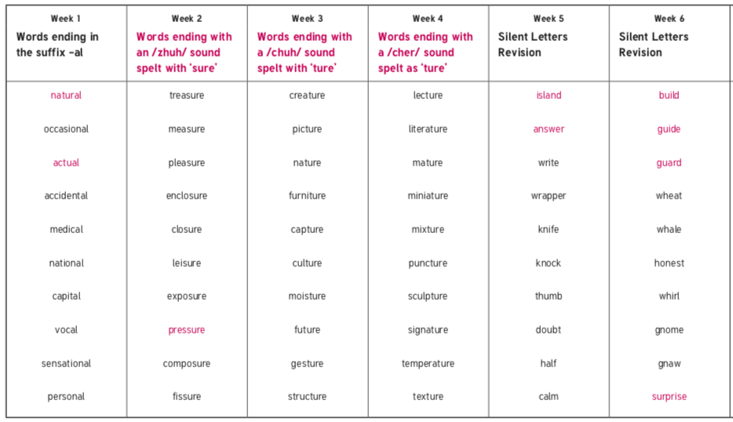
Obejctives that are in pink are Y3/4 statutory requirement and individual pink words are from the Y3/4 statutory spelling list. These are the words that we highlight in class.

14.06.19 | 21.06.19 | 28.06.19 | 05.07.19 | 12.07.19 | 19.07.19

