Willow Class
Loxwood Primary School
Nicholsfield
Loxwood

Wednesday 13th January 2021
Dear Children,
I am writing this letter to explain how letters are written, so that you can all learn how to write one.
Next it is important to explain your main ideas or points that you want to make. Be clear and use bossy verbs if you want to be listened to. Use powerful adjectives to describe things to the reader.
Finally end by saying what you would like to happen next or ask a question to the person you are writing to.
Yours Sincerely
Mrs Rolland
P.S
Use the letter above. Cut out the different parts of the letter, such as the address and stick them around the edge of the toolbox like we do at school. Can you think of any more things to add? What do your sentences need in your letter?
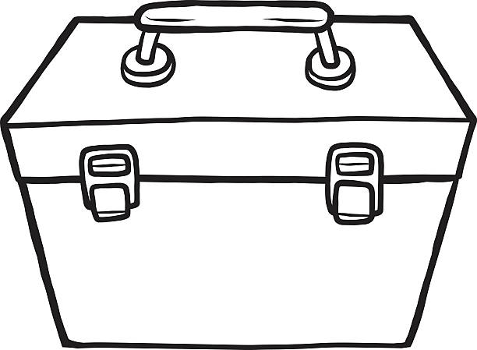

Letter Writing
Toolbox

