3rd, 7th & 14th January 2019

**In physical development we are**

**learning to….**

follow instructions to play a team game

work as a team

move in different ways e.g. skipping, side-stepping

understand the importance of a warm-up

Please provide school joggers for outdoor PE kit

Activity

PE with Mr Green.

**In Personal, Social and Emotional**

**Development we are learning to…**

Identify some of the bad choices Goldilocks made.

Say what she should have done instead and suggest how she can put things right

Speak to others about own interests and opinions (things they enjoyed in the holidays/what they think of Goldilocks’ behaviour)

Activities

Discuss Goldilocks’ actions

Circle Time activities.

**In Communication and Language we are**

**learning to…..**

Listen to stories with increasing attention and recall

Listen to stories from beginning to end and answer questions based on the story.

Uses language to imagine and recreate roles and experiences in play situations

Activities

Share a range of stories and non-fiction books

**3 week YE Plan**

**planner**



**In Mathematics we are learning to…**

To count forwards and backwards 10, (then 20 if knowledge of working to 10 is secure)

Uses the language of ‘more’ and ‘fewer’ to compare two sets of objects

Use the words ‘full’,

‘empty’, ‘half full/

full empty’ when

measuring capacity

Orders two items by

capacity

[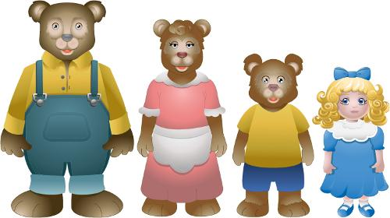](http://www.google.co.uk/url?sa=i&rct=j&q=&esrc=s&source=images&cd=&cad=rja&uact=8&ved=0ahUKEwjb9en484LYAhXJRhQKHfoRDwoQjRwIBw&url=http://www.mibepa.info/bb/bb015.htm&psig=AOvVaw05xCZ_5IzzMclPKZ9tPIBe&ust=1513113983761702) **Ask me about…** ..**t…**

**In Understanding the world we are learning..**

To talk about our Christmas holidays and understand that families celebrate Christmas in similar or different ways.

Other activities will be linked to our learning in Forest School

Activities

Share our ‘My Learning Diary’ news.

Forest School (Wednesday 9th January 2019). Please wear suitable clothing to school and wellies and

waterproofs to change into. Hats and gloves too.

  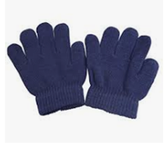

**In Literacy we will are learning to..**

Give meaning to marks as they write and draw.

Link sounds to letters: sh, th, ch, qu, ng, nk RWI

Orally blend/independently blend

Hear and say initial sound in words/dominant sounds

Use story language when acting out a familiar story and when reading individually to an adult

Join in with the repeated refrains

Use expression e.g. low voice for daddy bear

Make up alternative refrains e.g. it was too salty

Writing: draw & write about a holiday event

Write messages e.g. linked to Goldilocks

Activities

‘My Turn Your Turn’ RWI

Writing linked to our Christmas Holiday/Stories

Act out familiar stories e.g. **Goldilocks and the Three Bears.**

**In Creative Arts and Design we are learning to..**

Investigate textures.

Describe textures and group materials according to properties e.g. rough, smooth, shiny.

Play cooperatively as part of a group to develop and act out a narrative.

Activities

Collecting collage pots of similar textures

Describing textures to our talk partner

Adding different materials to paint e.g. porridge

In Early Years we plan across the 7 areas of learning and

make links with our topic. We also follow the ideas and

interests generated by the children. In Reception

children spend time each day self-initiating, this is their

‘Learning time’. Adults will be observing, engaging and

moving their learning on during these times.