Y6 | Knowing | Understanding | Applying | Analysing | Creating | Evaluating
Verbal  I enjoy reading, writing and speaking | Write an acrostic poem about London. | Write a newspaper article announcing the Queen’s Platinum Jubilee. | Make a list of questions you would like to ask the queen, if you met her. | Get two different non-fiction books about London from the library. Write a detailed book review of each one, explaining what you learnt and how the layout helped you to understand the information. | Write your own Greek Myth. Use these as inspiration. | What is the value and importance of the monarchy? Construct your opinion and present it to the class.
Mathematical  I enjoy working with numbers and sequences | Plot a bar graph showing the five tallest buildings in London. | 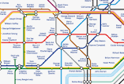  Make your own London Tube map. Take care to draw accurately and label neatly. | Research statistics of the population in London 1952 compared to now. | Plan and work out the cost for a day trip to London for three days. Think about: • Journey and transport • Accommodation • Food • Excursions and visits | Create a vibrant (colourful, exciting) fact file about London. It should contain  facts and information, pictures, a heading and subheadings | Find out how big 5 of the London Land Marks are. Without using a calculator, work out the size of each compared to your house.
Visual/Spatial  I enjoy painting and drawing | Draw a silhouette of the London sky line. | Use a photograph of London to inspire a collage. Choose one medium for the collage (e.g. tissue, fabric, wool). | Using the National Gallery Website, find a cityscape of your choice and research the artist. | 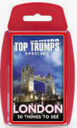  Create a set of ‘London Landmark’ Top Trump cards. | Design an island you’d like to live on. Think about what features it would have, then create a simple key, using grid references to show where each feature is located. | Find an artist who has painted a cityscape and do your own copy of it. Explain why you chose it and why you like it.
Kinesthetic  I enjoy doing hands on activities, sports and dance | Design an ancient Greek pot, showing your knowledge of ancient Greece. | Draw and label a map of significant landmarks in London.  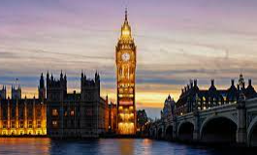 | 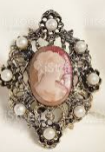  Design a new broach for the queen. | 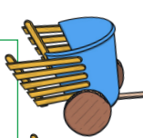  Make a small model chariot based on those the ancient Greeks used for racing and battle using craft. | Create a game – a board game or computer-generated. The aim is to help other children learn about classification of animals based on specific characteristics. | Design and make a cake or dish for the Queen’s Platinum Jubilee and evaluate it.
Musical  I enjoy making and listening to music | Make and perform your own piece of ‘London’ themed music. Use instrument/s of your choice. | Make a radio recording announcing the Queen’s Platinum Jubilee. | Compose a piece of music for a musical or play that can be played using percussion instruments. | Create your own London rap using this as your inspiration. | 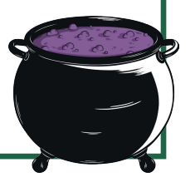  Create your own Macbeth’s Witches’ Spell. | Listen to a song from a West End musical and evaluate how the different instruments contribute to the sound it creates.
Interpersonal  I enjoy working with others | Describe the difference in the life cycles of a mammal, an amphibian an insect and a bird. | Make a 3-D model which shows the main London Landmarks. | Conduct a mock interview with a monarch of your choice. | Look at a map of your chosen area of London. Think about how it might have been during Queen Victoria’s reign (1837-190). What kind of buildings would be there? Draw a map of what it might have looked like. | Write your own play script. Use this as an example. | Make a model of a famous bridge. Can you make it strong enough to carry a weight? Evaluate how successful it would be when it rains!
Intrapersonal  I enjoy working by myself | Research about William Shakespeare.  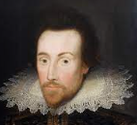 | Pretending you are a weatherman, create a video on the weather in London. | Prepare a lesson to teach the class about Horse Guards Parade. (Be ready to teach it).  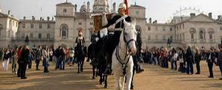 | Draw a family tree for the Queen. | Create your own Greek God or Goddess. Think about their name, symbol and the original myth or story about him or her. Include detail and elaboration. | Research a legacy of ancient Greece and compare it to now. This could be: architecture, language, Olympics, learning, theatre. What is similar? What is different?
Hand-in Dates: 23rd May, 6th June, 20th June and 11th July. Each task should be taken from a different row and a different column.

