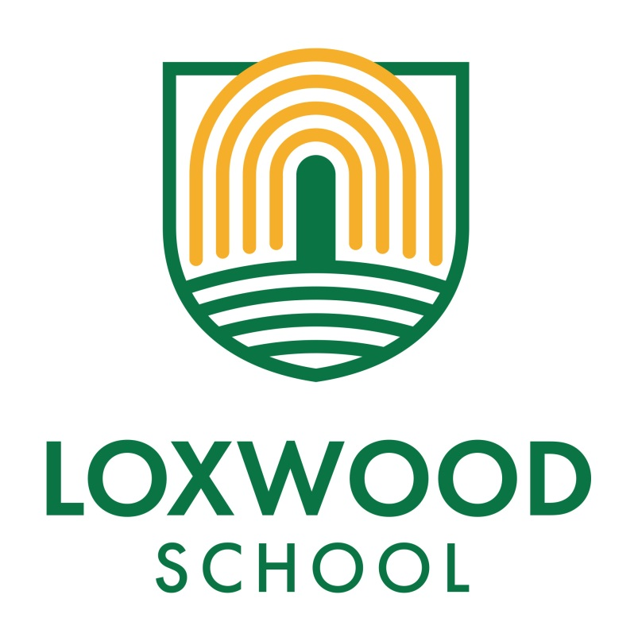
Key Stage 2 Long Term Plan 2020-2022
KEY STAGE TWO LONG TERM PLANNING OVERVIEW

 | YEAR 3 & 4 Cycle A |  |  |  | YEAR 3 & 4 Cycle B |  |  | YEAR 5 & 6 Cycle A |  |  | YEAR 5 & 6 Cycle B
TOPIC | AUT  DISCOVER  Back to the Future  (WALK LIKE AN EGYPTIAN) |  | SPR  EXPLORE  Extreme Earth  DESERTS  (Antarctica & Sahara) | SUM  CREATE  Weird and Wonderful  HABITATS  (Pulborough Brooks) | AUT  DISCOVER  Back to the Future  STONE AGE  (Sayers Croft)  ROMANS  (Novarium) | SPR  EXPLORE  Extreme Earth  WHAT A DISASTER | SUM  CREATE  Weird and Wonderful  PLANTS  (Wakehurst) | AUT  DISCOVER  Into the Light | SPR  EXPLORE  Chocolate  ( Mexicolore) | SUM  CREATE  It’s a wonderful life | AUT  DISCOVER  Out of this World |  | SPR  EXPLORE  River Story  (Cuckmere Haven) |  | SUM  CREATE  Lights, Camera, Action!  (Art Gallery?)
ENGLISH  ..\..\Skills Progression Grids\English-Progression-of-Skills.pdf | TEXT:  Little Red Riding Robes. narrative- biography. Newspaper  Play Scripts-Christmas Play  NF: Non-Chron report  Instructions (Mummification) |  | TEXT:  Shackleton’s Journey  Characterisation  NF: Letter  Newspaper Report. Diary  Advert.  F: Sky Song- character description  The Robin –Film. Complex sentences | TEXT: Sparky  Narrative writing  NF: Non- Chronolgical Reports Forest habitat  Poetry- Where My wellies Take Me-Christina Rossetti  Persuasive writing  Environmental  Letter  (Zoos; The Rainbow Bear Zoos and Ice Bear) | Texts: Stone Age Boy. How Skin a Bear.  Narrative, story writing.  Play Scripts (Xmas Play)  NF: Information texts Diaries. Letter (Roman Soldiers,)  NF: Recount  Instructions  NF- Non Chron  Roman Army | TEXT: Hurricane. Flood. Running Wild  F: narrative description  Recount. Disaster Diary  Newspaper  P: Image Poetry | TEXT: Varmints by Helen Ward Explanation. Poetry- persuasive writing  F: Westlandia non-chronological report  F: Tin Forest  Persuasive writing  Environmental  Pollution  NF:  Stories which raise dilemmas-Heart & the Bottle. Narrative description. Letter. | Fiction  ‘Thornhill’ by Pam Smy – Ghost Story  ‘The Present’ – story  Non-Fiction  ‘Letters from a Lighthouse’ - Recount  Letter to Mr Scrooge – Persuasive Letter  Poetry | Fiction  ‘The Great Chocoplot’ – Mystery  ‘The Quest’ – Quest  Non-Fiction  ‘The Rain Player’ – Newspaper report  Screen-Use – Balanced Argument  Poetry | Fiction  ‘Varmints’ by Marc Craste – Story  ‘I believe in Unicorns’ – story  Non-fiction  Plastic Pollution – speech  Neverbelieve – non-chronological report  End-of-year Play  Prepare poems and plays to read aloud and to perform, showing understanding through intonation, tone and volume so that the meaning is clear to an audience. | Fiction  ‘Theseus and the Minatour’ – Myth  The Saga of Biorn  ‘A Monster Calls’ – Horror ?  Non-Fiction  Goldilocks – newspaper report  Poetry  Viking kennings/imagery |  | Fiction  ‘The Great Kapok Tree’ Narrative description  ‘The Explorer’ by Katherine Rundell – adventure  Non-Fiction  Logging/  saving the rainforest – persuasion  Diary (based on Scott of the Antarctic)  River explanation? |  | Fiction  Mythical Movie (LitfilmFest)  Theseus & the Minatour – myth  Non-Fiction  Book Review  (LitfilmFest)  Greek Impact on the World  Goldilocks – Newspaper report  End-of-year Play  Prepare poems and plays to read aloud and to perform, showing understanding through intonation, tone and volume so that the meaning is clear to an audience.
SCIENCE  ..\..\Skills Progression Grids\Science-Progression-of-Skills.pdf | Digestive System & Teeth  Skeletons,  Muscles & Nutrition.  Physical Health & fitness PHE |  | States of Matter  Water Cycle  Sound | Living Things & Habitats  Food Chains | Rocks  Light & Shadow | Electricity  Forces & magnets | Plants | Electricity (changing circuits)  How we see, properties of light | Animals including Humans  (circulatory system; healthy living | Evolution and inheritance  (Include the human offspring aspect in this)  Own Mr Men/Little Misses  Human aging  (Sex Education) | Earth & Space  Forces |  | Properties and changes of materials |  | Living Things and their habitats  Human aging  (Sex Education)  Life cycle of plants and animals
GEOGRAPHY  ..\..\Skills Progression Grids\Geography-Progression-of-Skills.pdf |  |  | World Location  Poles/ Tropics  Antartica- Africa  Identify the position and significance of latitude, longitude, Equator, Northern Hemisphere, Southern Hemisphere, the Tropics of Cancer and Capricorn, Arctic and Antarctic Circle, the Prime/ Greenwich Meridian and time zones (including day and night)  Europe Location  To locate the world’s countries using a map to focus on Europe. Compass points, grid references.  Locate the world’s countries, using maps to focus on Europe (including the location of Russia) and North and South America, concentrating on their environmental regions, key physical and human characteristics, countries, and major cities | UK Location  A local history study – Canal/  Church walk?  Name and locate counties and cities of the United Kingdom, geographical regions and their identifying human and physical characteristics, key topographical features  Understand geographical similarities and differences through the study of human and physical geography of a region of the United Kingdom, |  | Extreme Earth (volcanoes, earthquakes, mountains, extreme weather etc.)  Describe and understand key aspects of: ◊ physical geography, including: climate zones, biomes and vegetation belts, rivers, mountains, volcanoes and earthquakes, and the water cycle  Fair trade  Human geography, including: types of settlement and land use, economic activity including trade links, and the distribution of natural resources including energy, food, minerals and water | Maps-Fieldwork  Using maps Follow a route on a large scale map Locate places on a range of maps (variety of scales) Identify features on an aerial photograph, digital or computer map Begin to use 4 and 8 figure compass and four figure grid references to identify features on a map |  | Human Geography including types of settlement & land use, trade links and resources  -Fairtrade  -6-figure grid references  - mapwork/atlases  e.g European versus world trade. | Mountains  Locational Knowledge – physical features N. & S. America.  Describe and understand key aspects of: ◊ physical geography, including: climate zones, biomes and vegetation belts, rivers, mountains, volcanoes and earthquakes, and the water cycle |  |  | Rainforest – Living things and their habitats.  Biomes.  (mini unit Micro-organisms)  Geographical skills  Google Earth  Locational Knowledge – Europe  Locational Knowledge – equator, tropics of Cancer & Capricorn, hemispheres,  Locate the world’s countries, using maps to focus on Europe (including the location of Russia) and North and South America, concentrating on their environmental regions, key physical and human characteristics, countries, and major cities  Rivers  Describe and understand key aspects of: ◊ physical geography, including: climate zones, biomes and vegetation belts, rivers, mountains, volcanoes and earthquakes, and the water cycle  Field Work  Cuckmere Haven |  | Maps incorporating Fieldwork  Follow a short route on a OS map Describe the features shown on an OS map Use atlases to find out data about other places Use 8 figure compass and 6 figure grid reference accurately Use lines of longitude and latitude on maps
HISTORY  ..\..\Skills Progression Grids\History-Progression-of-Skills.pdf | The achievements of the earliest civilisations – Ancient Egypt  The achievements of the earliest civilizations – an overview of where and when the first civilizations appeared and a depth study of one of the following: Ancient Sumer; The Indus Valley; Ancient Egypt; The Shang Dynasty of Ancient China |  |  | Local History Study  Develop increasingly secure chronological knowledge and understanding of history, local, British and world Put events, people, places and artefacts on a timeline Use correct terminology to describe events in the past | Changes in Britain from the Stone Age to the Iron Age  The Roman Empire and its impact on Britain |  | Anglo Saxons & Scots settling in Britain | Victorians  A significant turning point in British history-  ELECTRICITY | A non-European society that provides contrasts with British history - Mayan civilization c. AD 900. |  | Vikings - raids & invasions, Alfred the Great, Anglo-Saxon laws, Edward the Confessor  Trip: National Maritime Museum |  |  |  | Greeks - – life, achievements & influence on Western world
ART & DESIGN  ..\..\Skills Progression Grids\Art-and-Design-Progression-of-Skills.pdf | Drawing/Clay/  Papier Mache  Self Portrait  Ancient Egyptian Art:  Drawing faces and masks in pencil, charcoal, and pen. Making masks in clay and papier mache.  Man Ray and Fernand Leger. |  | Sculpture  Art in the Environment -Can We Change Places? (Plan Bee)  Henry Moore  Barbara Hepworth | Collage/Painting/Watercolour/Textiles  Collage- OA  Landscape- A Sense of Place  INSECTS  Observational drawing.  Sewing  Louise Bourgeois. Jennifer Angus.  Anna Angus.  Self portrait challenge.  .  Sketchbooks.  Skills  Sketching/  observational drawing | Colour Mixing/  Sculpture/Printing  Painting, colour mixing.  Ceramic Focus-OA  Cave paintings  Clay pot  Roman shield  Roman road  Jackson Pollock  John Constable. Thomas Cole. Claude Monet  Self portrait  Rembrant  Sketchbooks.  Skills. | Sketching/Shading  Objects and Meanings- Still Life (Plan Bee)  Cezanne  Great Artists through time  Anslem Keifer, Michelangelo, Dali, Chanel, Rembrant, Le Corbusier. | Drawing/Painting  Georgia O’Keefe  Textiles-OA  Plants and Flowers:  Drawing plants in pencil and colour, printing plants using hammers, making plants in paper and sculptures.  Self portrait | William Morris –  Applique designs  Art Illusions (plan Bee)  Surrealism | Beatrice Milhazes  South American Collage | Observational still lives – feathers, shells etc…  Landscape? | (Street Art? 2021 only)  Viking Jewellery |  | Henri Rousseau  Painting |  | Cityscapes (Plan Bee)  Child inspired artist  Pop Art  Lichtenstein portraits
DT  ..\..\Skills Progression Grids\Design-and-Technology-Progression-of-Skills.pdf | Cooking and Nutrition- Healthy and varied diets (Oak)  Research, design, make, evaluate.  Healthy Eating PHE  Ancient diets  Teeth models  Shaduf  Moving muscle  Research, design, make, evaluate. |  |  | Keep it safe: solid and combination structures (Oak x 10)  Research, design, make, evaluate.  Sewing  Insects | Shield.  Mosaics  Mosaic artists Emma Biggs. Gary Drostle.  Research, design, make, evaluate. | Electronics- simple circuits and switches (Oak)  Research, design, make, evaluate. | Edible Garden  Research, design, make, evaluate.  Labelled diagrams  Design & make a shed &  Garden | DT – Switches and Alarms | Healthy eating and the Eatwell plate.  Design and make a healthy wrap.  (Twinkl – Super Seasonal Cooking |  | Viking Long Boats  Viking Catapult FS |  | CAMS (Rainforest creatures – link with Art Rousseau) |  | Fairground (Plan Bee)
COMPUTING  ..\..\Skills Progression Grids\Computing-Progression-of-Skills.pdf | eSafety  Internet safety & Harms PHE  Internet research and communication |  | Coding- Scratch  Vectors (Oak) | Online Relationships PHE  Presentation Skills | eSafety  Internet safety & Harms PHE | Animation  Google Maps  Google Earth  Photo Stories | Using & Applying  Online Relationships PHE | Online Safety (Y6)  Excel Spreadsheets (Y6) (Chocolate Tasting) | Scratch –  Developing Games (Y5) Animated Stories (Y6) | Using and applying  Y5  Y6  Year 5- Film a mockumentary based on the creature from ‘The land of Neverbelieve.’ | Online Safety (Y6)  3D Modelling: sketch up |  | Scratch –  Developing Games (Y5) Animated Stories (Y6) |  | Using and applying  Y5  Y6  Radio Station
MFL  ..\..\Skills Progression Grids\Languages-Progression-of-Skills.pdf | All around town |  | Going shopping | Food | All about me | Friends and family | Getting to know you | All about ourselves | Family and friends | Let’s visit a French Town | School Life |  | Let’s go shopping  . |  | This is France
MUSIC  ..\..\Skills Progression Grids\Music-Progression-of-Skills.pdf | Ongoing Skills & Performance:  Charanga (Y4) (Glockenspiels)  Recorders (Y3)  ‘Term to Learn’ learn a musical instrument. (Y4) |  | Charanga- Mama Mia | Pulse and Metre 1 (Y3)  Oak Academy  Pulse and Metre 2 (Y4)  Oak Academy | Ongoing Skills & Performance:  Charanga (Y4) (Glockenspiels)  Recorders (Y3)  ‘Term to Learn’ learn a musical instrument. (Y4) | Charanga- Dancing in the street | Rhythm 1 (Y3)  Oak Academy  Rhythm 2 (Y4)  Oak Academy | Charanga | Charanga | Ongoing Skills & Performance:  Performance | Charanga |  | Charanga |  | Singing – choral and solo arrangements. End of Year Performance
PE  ..\..\Skills Progression Grids\Physical-Education-Progression-of-Skills.pdf | Football (Y3/4)  Ball & game skills (Y3)  Fitness (Y4)  Hockey (Y3/4)  Fundamentals (Y3)  Yoga (Y4) |  | Netball (Y3/4)  Dance (Y3/4)  Tag Rugby (Y3/4)  Gymnastics (Y3/4) | Cricket (Y3/4)  Athletics (Y3/4)  Tennis (Y3/4)  OAA (Y3)  Athletics (Y4) | Football (Y3/4)  Ball & game skills (Y3)  Fitness (Y4)  Hockey (Y3/4)  Fundamentals (Y3)  Yoga (Y4) | Netball (Y3/4)  Dance (Y3/4)  Tag Rugby (Y3/4)  Gymnastics (Y3/4) | Cricket (Y3/4)  Athletics (Y3/4)  Tennis (Y3/4)  OAA (Y3)  Rounders (Y4) | Football (Y5/6)  OAA (Y5)  Fitness (Y6)  Hockey (Y5/6)  Basketball (Y5)  Yoga (Y6) | Netball (Y5/6)  Dance (Y5/6)  Tag Rugby (Y5/6)  Gymnastics (Y5/6) | Cricket (Y5/6)  Athletics (Y5/6)  Tennis (Y5/6)  Golf (Y5)  Rounders (Y6) | Football (Y5/6)  OAA (Y5)  Fitness (Y6)  Hockey (Y5/6)  Basketball (Y5)  Yoga (Y6) |  | Netball (Y5/6)  Dance (Y5/6)  Tag Rugby (Y5/6)  Gymnastics (Y5/6) |  | Cricket (Y5/6)  Athletics (Y5/6)  Tennis (Y5/6)  Golf (Y5)  Rounders (Y6)
RE | Christianity  Jesus  Ten commandments; Special places  Christians place of worship  Forty days, forty nights  The Bible  Christian symbols |  | Sikhism  Diwali (Rama & Sita Story)  The founder of Sikhism  Sikh’s place of worship;  Sikh Festival  Guru Granth Sahib | Buddhism  India  Know that Siddhartha Gautama was the Buddha.  Nirvana  Buddhist temple Wesak lantern. Tipitaka. Buddhist symbols. | Judaism  Abraham founded Judaism.  Ten key rules. Synagogue  Jewish festivals. Holy book for Jews Jewish symbols. | Hinduism  Hindu deities and symbols.  Hindus place of worship.  Hindu festival. | Islam  Show where Islam was founded.  The key prophet was. List the main Muslim beliefs.  Muslims place of worship.  The Muslim holy book. | The true meaning of Christmas  Discuss Christian acts of love at Christmas. Explain how people can help refugees. Debate whether the true meaning of Christmas is lost. | Quakers  Humanism  Explain the difference between atheism and Humanism  To know two humanist beliefs  Recognise the Happy Human symbol | Peace  Choose acts of peace they can carry out. Explain religions view of peace. Show comparisons within religions of peace | Forgiveness  Define forgiveness. Understand Jews follow the ten commandments and Yom Kippur. Understand Buddhists do not believe in god. Explore the eightfold path. |  | Creation  Sequence and tell creation stories  Demonstrate an understanding of Sikh creation beliefs  Identify similarities and differences between creation stories |  | Worship  Explain what worship is, make the link between worth and worship. Understand prayer. Discuss religious art and artefacts.
RHE | Relationships and Health and Well Being units to be taught throughout the year, using PSHE Association Lesson Plans and SEAL materials as support.
 | Class Charter –  E-Safety  Internet Safety & Harms  (Computing)  Physical Health & fitness  (Science)  Healthy Eating (DT)  Anti-Bullying Week. | Caring Friendships  Fairtrade Fortnight |  | Online Relationships  (Computing)  Basic First Aid  My Money Week | Class Charter –  E-Safety  Internet Safety & Harms (Computing)  Mental Wellbeing  (emotions, self-care, bullying)  Anti-Bullying Week. | Being Safe  (Growing Up safe)  Respectful Relationships  Fairtrade Fortnight | Online Relationships  Computing)  Bereavement.  Mental Wellbeing  My Money Week | Class Charter – R&R  E-Safety  Relationships  Anti-Bullying Week. | Wider World – respect for others, responsible behaviours  Wider World - Forest Schools  Allocation of the World’s resources  Fairtrade Fortnight | Wider World - Forest Schools  Democracy. Rules & Laws  Human rights  My Money Week  Sex & relationships education – gender stereotyping  families | Class Charter – R&R  E-Safety  Relationships  Anti-Bullying Week. | Wider World  Lives of people in other places  Fairtrade Fortnight  Keeping Safe (Bikeability) |  | Health & wellbeing (independence & increased responsibility)  Sex & Relationship Education  My Money Week/Class enterprise projects
MATHS | Maths in all year groups follows the long term plan from White Rose Maths https://whiterosemaths.com/

