Learning Project WEEK 1- What the Ladybird Heard
Age Range: EYFS
Daily PE with Joe Wicks
Weekly Maths Tasks (Aim to do 1 per day) | Weekly Reading Tasks (Aim to do 1 per day)
- Go to White Rose Home Learning – Early Years https://whiterosemaths.com/homelearning/early-years/ for a week’s worth of maths activities based upon the story ‘What the Ladybird Heard’,  - Can they begin to learn the ‘White Rose’ days of the week song? Do they know other days of the week songs? What day is it today?  - Can they count the spots on the ladybirds, match the number of spots to the correct numeral and order the amount of spots from smallest to largest number of spots? https://www.topmarks.co.uk/learning-to-count/ladybird-spots  - A quick introduction to doubling (more instruction in future as this will be a maths topic later this term) with mirror doubling, partner doubling and placing the same amount in two hoops or on two plates (it doesn’t have to be children, it could be objects: https://www.youtube.com/watch?v=ry65EUJ-QV0 | - Read a variety of books at home. Favourites can be repeated. Hearing the patterns of language in a story will support your child’s language development.  - Listen to the story: ‘What the Ladybird Heard’ by Julia Donaldson and Illustrated by Lydia Monks:  https://www.youtube.com/watch?v=u__ngDWYmqQ  - Children to read to parents daily. Visit Oxford Owl for free eBooks. You can create a free account.  Complete the linked Play activities for each book. Or continue with a Ditty a day.  - Tricky Words - listen to the tricky word song and learn the tricky words we have learned in class so far. https://www.youtube.com/watch?v=TvMyssfAUx0 Challenge - can you listen to the song (without looking at the words) and write them?  - With your child, look in magazines, newspapers and books for the tricky words they are currently learning. They could use a highlighter to highlight in magazines and newspapers.
Weekly Phonics Tasks (Aim to do 1 per day) | Weekly Writing Tasks (Aim to do 1 per day)
- Sing Nursery Rhymes and songs together. Add in actions and change the words. Can children think of different rhyming words to add in? Repeat old favourites and learn new rhymes. You can find an A-Z of Nursery Rhymes here.  - Daily phonics – use the RWI Phonics – Learning to Read at Home: Set 1 Speed Sounds 9.30 am - for children in Reception  - Set 2 Speed Sounds 10.00 am - for children in Reception that can read Set 1 Speed Sounds https://www.ruthmiskin.com/en/find-out-more/parents/  - Practice the sounds your child is working on and blend words. This can be oral blending (e.g. spoken out loud c-a-t) or written if appropriate. Interactive games.  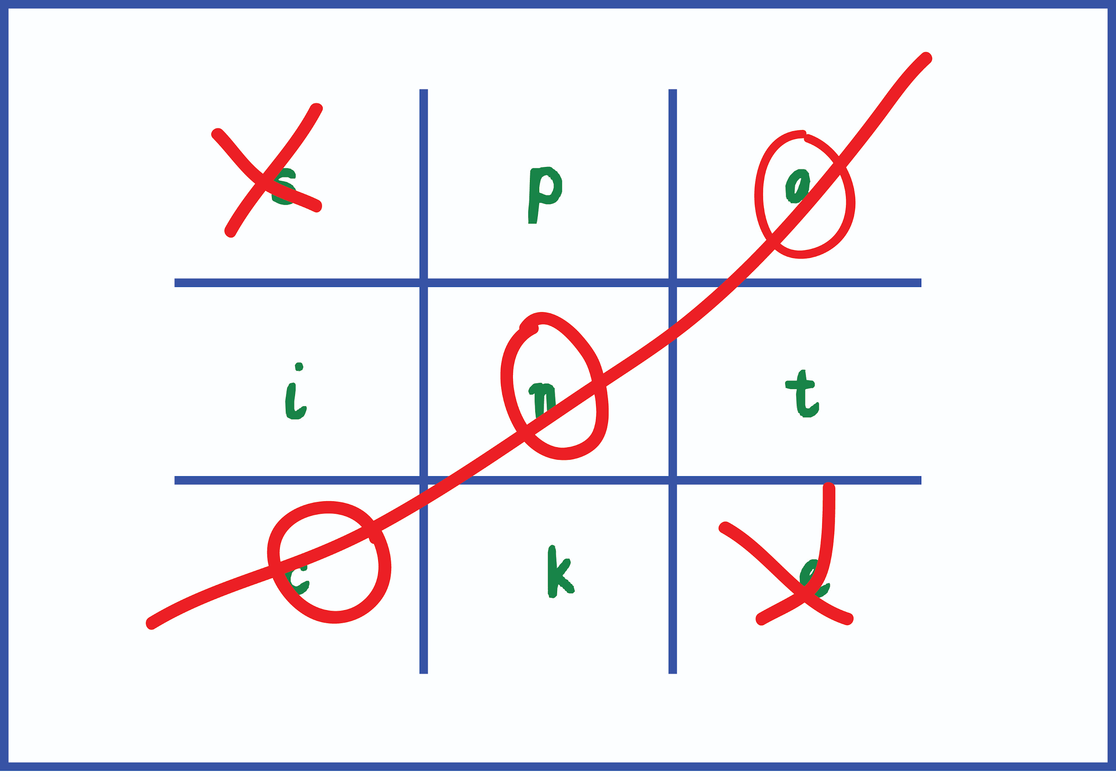  Play phonics noughts and crosses. Draw out a grid and write a letter, digraph, trigraph or tricky word in each part of the grid. Take it in turns to name what is written in the grid. If you say it correctly you can add your nought or cross in that square. | - When you have made a map of the farm (linked to the ‘White Rose’ maths learning for the week), can you label it or write a list of the animals on the farm? Adults please remember the children need to sound out using Fred Fingers not copy the correct spellings of the words. Praise them, even if they only hear the first sound in a word. If they say a sound but haven’t learned it, you can show them it on the sound chart e.g. ‘ee’ ‘That’s ‘ee’ ‘what can you see?’  - Practice name writing. Can they write their first name? Middle name? Surname? Are they forming the letters correctly and using the RWI letter patter?  - Concentrate upon one letter a day/week and practice forming the letter using the correct script. Start with ‘c’ and group similar letters together e.g. c, a, o, g or link it to the RWI phonics letter of the day.  - Ask your child to write out the tricky words they are working on at the moment on pieces of paper and turn them into a pairs game.
Learning Project - to be done throughout the week
The project this week aims to provide opportunities for your child to gain a better understanding of animal similarities and differences. Learning may focus on sorting and grouping animals e.g. all those with four legs, six legs, farm animals, insects. Can you learn more about farming in the UK?

- Look at a selection of animal pictures and describe the animal.
  - Play the ‘White Rose’ game ‘I’m thinking of an animal... It lives in ...’
  - Look at a picture of an adult and a baby (are they similar or different). Discuss how the adult cares for the baby, how the animal grows and what it learns.

- Do a tally of the animals How many cows in your farm set or in the book ‘What the Ladybird Heard’.

- Out of the Ark - Music -enjoy the Home Learning activities for each day from Move-it Monday to Fun Friday at: https://www.outoftheark.co.uk/ootam-at-home/?utm_source=homepage&utm_campaign=ootamathome2&utm_medium=banner

- Use play dough to make some animals- Use ready made play dough or make your own using this recipe:
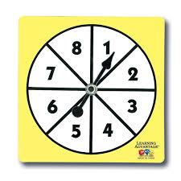
  - 2 cups of plain flour, one cup of salt, a tablespoon of oil, a cup of water (add gradually), a couple of drops of food colouring (optional), a teaspoon of cream of tartar (optional, but will make it last longer)

- Play a family board game- Play a game together. Talk about taking it in turns and playing fairly. Dice games will support your child’s number recognition. You could use a spinner with numerals on to help develop numeral recognition. If you don’t have a spinner you could make one using an old cereal box and a split pin.

- Learn more about farming and farm produce - there are also fun things to make on this website if you have the resources at home: CBeebies ‘Down on the Farm https://www.bbc.co.uk/cbeebies/shows/down-on-the-farm

- Harvest - find out more about harvest time with: https://www.youtube.com/watch?v=5d2Mft72CXg

Additional learning resources parents may wish to engage with
Twinkl - to access these resources click on the link and sign up using your own email address and creating your own password. Use the offer code UKTWINKLHELPS.

