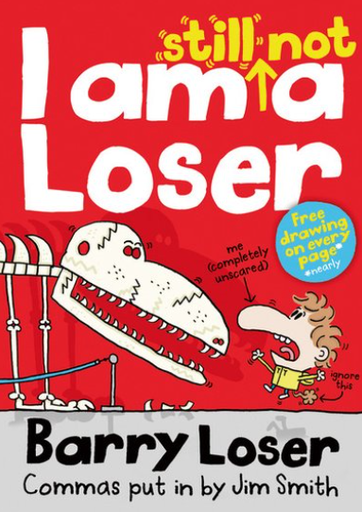
Barry loser book review by George.
I read this book and after a couple of chapters I didn’t want to put it down and the next time I picked it up I read the rest of the book. I would recommend this book to 7 to 11 year olds the genre of this book is comedy. The book is about Barry Loser and his loserish life. My favourite character is definitely Barry Loser because he just wants to be normal but he can’t because his best friend left to be friends with someone else. I hope you enjoy the book as much as I did!

