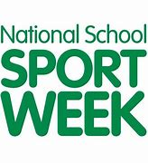
NATIONAL SCHOOL SPORTS WEEK 2020

MR MEANEYS SPORT CHALLENGES

ATHLETES NAME | Challenge 1 PB | Challenge 2 PB | Challenge 3 PB | Challenge 4
SAQ CHALLENGE

TENNIS CHALLENGE
FOOTBALL CHALLENGE

ATHLETICS CHALLENGE
FITNESS CHALLENGE

PRACTICE SCORES

NATIONAL SCHOOL SPORTS WEEK 2020

MR MEANEYS SPORT CHALLENGES

ATHLETES NAME | Challenge 1 PB | Challenge 2 PB | Challenge 3 PB | Challenge 4
SAQ CHALLENGE

TENNIS CHALLENGE
FOOTBALL CHALLENGE

ATHLETICS CHALLENGE
FITNESS CHALLENGE

PRACTICE SCORES

