23rd, 29th April & 6th May 2019

**In physical development we are**

**learning to….**

keep safe when out and about e.g. holding adult’s hand, looking where you are going, walking around the school, transporting equipment safely etc

With weather warming up, please provide sun hats and follow school procedure for sun-cream.

Remember we still have cold days so joggers in PE kit as well as shorts please.

Activity

PE with Mr Green: Striking and fielding

Ball skills, balance bikes, beanbags, obstacle courses and construction as part of outdoor provision.

**In Personal, Social and Emotional**

**Development we are learning to…**

be sensitive to others’ needs and feelings

simple awareness of different personalities

let others take the lead

Activities

Share stories

Watch children negotiating play (video)

Circle Time: talk about feelings and what causes that feeling

**In Communication and Language we are**

**learning to…..**

retell past event in the correct order

show awareness of past and future tenses

use a range of tenses with some accuracy

Activities

Respond to discussions and stories with comments & questions

Retell events e.g Easter News

Anticipate what might happen next

**3 week YE Plan**

**planner**

Ask me what these actions mean: 

**In Literacy we will are learning to…**

Understand words are made up of phonemes (sounds).

Understand that sentences are made up of words.

Understand that a sentence makes sense (we understand it).

Understand words are separated by a finger space to make it easy to see and read the word.

Understand the difference between a phoneme, word and sentence.

Understand that we read and write from the left hand side of a page.

Understand a sentence starts with a capital letter and ends with a full stop.

Activities

Daily phonics lessons RWI. Write a recount of our Easter holidays. Talk about the features of maps. Make maps of familiar places. Share stories about places e.g. Mr Gumpy’s Motor Car, The Balloon, My Town, Maisy in the city

**In Mathematics we are learning to…**

Count accurately

Recognise coins

Order coins in order of value

Use coins to pay for items

Begin to count in two’s

**On-going** daily maths skills e.g. numeral recognition, counting forward and back, one more than, 1 less, 2D shape, 3D shape…play a variety of maths games.

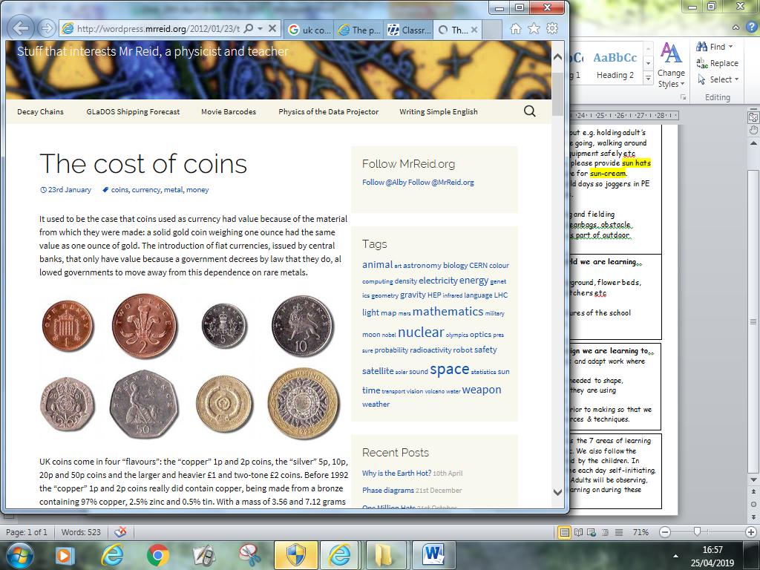

**Ask me about…**

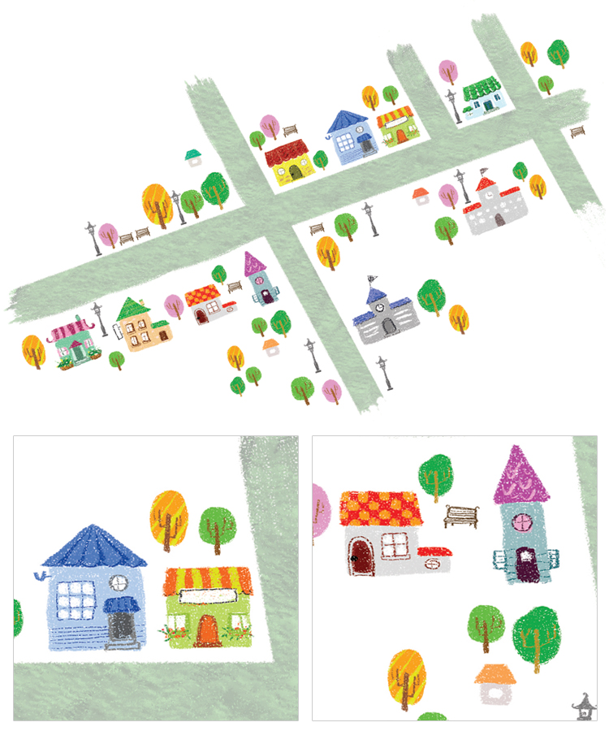

**In Understanding the world we are learning..**

To know familiar places

Identify features e.g. playground, flower beds, café, park, village shop, butchers etc

Activities

Walk around and map features of the school

Share books about places.

Examine simple maps.

**In Creative Arts and Design we are learning to..**

select appropriate resources and adapt work where necessary

select tools and techniques needed to shape, assemble and join materials they are using

Activities - Junk modelling:

We will be learning to plan prior to making so that we can select appropriate resources & techniques.

In Early Years we plan across the 7 areas of learning and make links with our topic. We also follow the ideas and interests generated by the children. In Reception children spend time each day self-initiating, this is their ‘Learning time’. Adults will be observing, engaging and moving their learning on during these times.