4th and 11th February 2019

**In physical development we are**

**learning to….throw accurately**

Throw up straight to chin height

Throw and catch a bean bag

Catch in two hands

Throw an object from hand to hand

Overarm throw to a target

Please provide school joggers for outdoor PE kit

Activity

PE with Mr Green

Ball skills, balance bikes, obstacle courses and construction as part of outdoor provision.

**In Personal, Social and Emotional**

**Development we are learning to…**

Accept differences and show respect when learning about other cultures, beliefs and ways of life

Understand we all have different opinions, likes and dislikes

Activities

Chinese New Year experiences

**In Communication and Language we are**

**learning to…..**

talk about our experiences linked to Chinese New Year – **The Year of the Pig**

Follow simple instructions in a range of contexts

Follow two-part instructions

Activities

Take part in activities linked to Chinese New Year

Carry out simple/two-part instructions

**2 week YE Plan**

**planner**

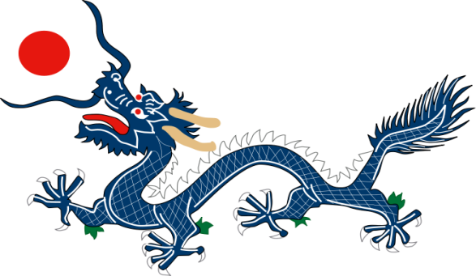**Ask me about…**

**Ask me about…** 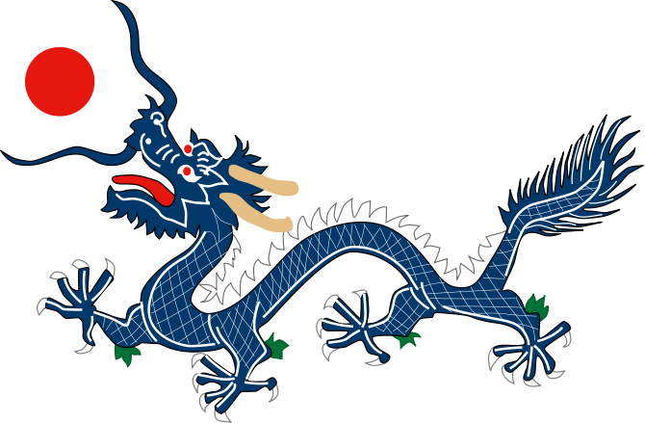

In Early Years we plan across the 7 areas of learning and

make links with our topic. We also follow the ideas and

interests generated by the children. In Reception

children spend time each day self-initiating, this is their

‘Learning time’. Adults will be observing, engaging and

moving their learning on during these times.

**In Creative Arts and Design we are learning to..**

Try out and experience arts (including music and dance), crafts and food linked to Chinese New Year

Respond creatively to our experiences

Activities

Chinese craft e.g. Chinese music, dragon dance, lantern making, origami, making and sampling Chinese food, using chopsticks etc



**In Literacy we will are learning to…**

If your child is beginning to orally blend/independently blend – Revision of RWI Set 1 phonemes for reading and writing: m a s d t i

Hear and record initial sound in words/dominant sounds

For children competent at Set 1 phonemes and independently blending to read: ck ss ff ll, then start RWI Set 2: ay, ee, igh

Understand how lists are set out

Understand how lists help us remember all sorts of things

Story Focus: The Three Little Pigs

Activities

Daily phonics lessons RWI

Writing linked to phonics & topics e.g. writing lists

Acting out the narrative: The Three Little Pigs

**In Mathematics we are learning to…add**

I can understand that a group of things changes in quantity when something is added or taken away.

I can use number names and number language spontaneously.

I can use some number names accurately in play.

I can counts up to three or four objects by saying one number name for each item.

I can counts objects to 10, and beginning to count beyond 10.

I can find the total number of items in two groups by counting all of them.

In practical activities and discussion, I am beginning to use the vocabulary involved in adding and subtracting.

**In Understanding the world we are learning..**

To know about similarities and differences in relation to places e.g. China

Activities

Watch videos of life in China including Chinese New Year

Share books about China: fiction & non-fiction