Y6 | Knowing | Understanding | Applying | Analysing | Creating | Evaluating
Verbal  I enjoy reading, writing and speaking | 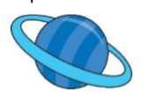  Write an acrostic poem about one of the planets. | Complete a factfile on Neil Armstrong or any other famous astronaut/ cosmonaut. | Pretend you are an astronaut who has just discovered a new planet. Write a letter home to your family about the discovery. | Write a newspaper article announcing the first moon landing, | Write a story set in Space.  Include: a beginning, a build-up, a problem, a solution and an ending. | What is the value and importance of space missions? Construct your opinion and present it to the class.
Mathematical  I enjoy working with numbers and sequences | Research how far away each planet in the Solar system is from the Earth. How long would it take you to travel to all of them? | Research two different things that were invented because of Space travel. | 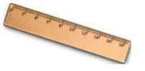  Work out the distance between each planet and the Sun in miles, kilometres and metres. | Research and draw 3 constellations.  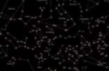  Use the ‘Star chart’ app to help you if you can. | Can you make a poster about the size of planets and how far away they are from Earth? | Find how big each of the planets are. Without using a calculator, work out the difference between the size of each planet and the Earth.
Visual/Spatial  I enjoy painting and drawing | Design and draw a picture of what you think an Alien would look like. | 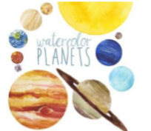  Paint a picture of a planet. | Make a set of ‘Space’ Top Trump Cards.  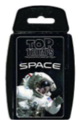 | Design and make a robotic machine (model!) to walk on the moon.  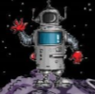 | Choose a Space picture that interests and intrigues you. Recreate it on paper using any materials you wish. | Make a 3D model rocket with a parachute to aid reentry. Evaluate its performance.
Kinesthetic  I enjoy doing hands on activities, sports and dance | Imagine you had a time machine. What 5 questions would you ask the first astronaut in Space? | 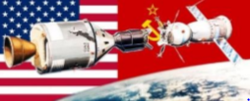  Draw and label a map of the countries involved in the Space race? | 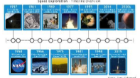  Create a timeline of the History of Space travel with pop-ups! | In Space, astronauts have to make sure they get the correct nutrients. Can you make a nutritious astronaut smoothie? | Research the phases of the moon and design a mini ‘Moon Flick Book’. You should include a front cover, headings and any relevant information to each phase. | Create a model and explanation of how the earth spins on its axis as it orbits the sun.
Musical  I enjoy making and listening to music | Make and perform your own piece of ‘Space-themed’ music. Use instrument/s of your choice. | Make a radio recording announcing the first moon landing. | Create a new mnemonic that will help others in the class remember the names of the planets and their order from the sun. Present it as a song! | Research and answer the question- Would you be able to hear music in Space? | Using an app (like iMovie) act out and record a video as though you are an astronaut going into Space | Listen to Gustav Holst’s ‘The Planets’.  Which planet’s music do you prefer? How does the music relate to this planet?
Interpersonal  I enjoy working with others | Make a space mobile to hang in the classroom.  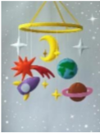 | Pretend you are a Space expert. Ask someone to quiz you to test your knowledge. | 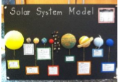  With a partner, make a Solar System model board | Create your own device that measures 1 minute exactly, each time it is used. | With a family member, use scrap paper, foil, sweet wrappers and other materials around the house to create your own space collage. | 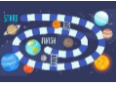  Make a space-themed board game.
Intrapersonal  I enjoy working by myself | Find out facts about the space missions.  What interesting facts can you present? | Create a “Moon Diary”. Every night look at the moon and draw and describe what you see. | Prepare a lesson to teach the class about an aspect of Space you enjoy  (Be ready to teach it!) | Watch and take notes on the BBC bitesize KS2 Earth and Space website. | Create and film your own news broadcast about discovering a new planet. | Keep a sky at night journal for a whole week. Write about or draw everything you can see in the sky.
 |  |  | https://www.bbc.co.uk/bitesize/topics/zkbbkqt
‘Out of This World’ Year 6 Independent Homework Grid 2021
Hand-in Dates: 27th Sep, 18th Oct, 8th Nov,22nd Nov, 13th Dec Each task ideally to be taken from a different row and column.

