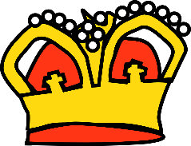
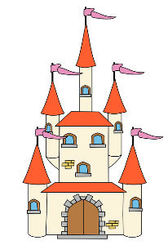
Castles in the Sky
Autumn Term Home Learning Projects Year 2
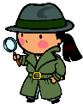
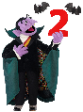
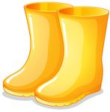
Aim to complete 2 of these projects each half term so that by the Christmas Holidays you will have completed four of the activities below. These activities are designed to get your creative juices flowing and to be a great opportunity to develop your learning with support from someone at home. I am really looking forward to sharing what you have learnt and the new skills you have developed. Either share your learning on Tapestry or bring into class to share it in person!
Counting in 2s, 3s, 5s & 10s  Practise counting in 2s at home, on the way to school, in the car, at the supermarket, wherever you like!  Why not demonstrate your skills by recording yourself, taking a photo or a video? | Find out about a king or queen  We will be learning about William the Conqueror, but what other Kings or Queens can you tell us about?  You might like to make a poster about this person or write a list of 10 facts about them? | Marvellous materials  In Science we are going to be finding out about the suitability of different materials. Can you find out about a famous inventor of a new material. Like Dunlop, Macintosh or McAdam.  You could give us a presentation about them or even make a power point!
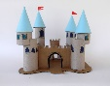  Castle Model  Make a model of a castle (real or fairy tale) and practise your cutting and drawing skills.  Maybe you could tell us about who lives in your castle, you could even write a story about them! | 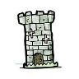  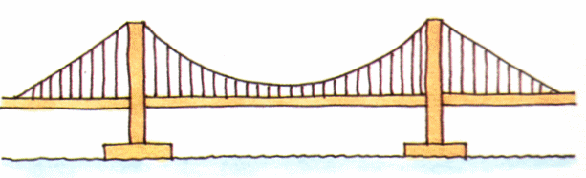  Visit a Castle  Visit at a castle with your family or go  on a virtual tour using the internet!  Perhaps you could make a map or a guidebook based on your visit or share some photos with us! | Fabulous Fairy Tales  Show us or tell us about your favourite fairy tale.  You could bring it in and read some of it to us or write a book review about it. Why not write your own version?
Or get creative and amaze us with some of your own choice topic related learning!

Don’t forget to read every day at home and practice reading and spelling the Year 1 and 2 Common Exception Words (which you can find on out Class Page on the school website).

