Learning Project WEEK 5 (18.05.20) - Environments
Age Range: EYFS
Daily PE with Joe Wicks or Specsavers Virtual Sussex School Games 2020 or Daily exercise
Whole School Song Together

NB: if this is too much please concentrate on the White Rose daily Maths, daily RWI phonics learning, one writing activity per week, Sharing Stories at home, PE/exercise and one activity from the selection in the Learning Project section.
Weekly Maths Tasks (Aim to do 1 per day) | Weekly Reading Tasks (Aim to do 1 per day)
- In line with the rest of the school, we are following White Rose Maths for our daily maths sessions. This week’s activities are based upon the story The Very Busy Spider by Eric Carle.  - Activity 1: exploring spider webs. Can you make a spider web? Do you want to have a go at some weaving? There are lots of ideas on the internet (get an adult to do the search). Lollipops, sticks and string can be used or you could all get involved and make a spider’s web together Large Wool Spider's Web  - Activity 2: Can you see if the spider stories are correct? Practise taking away (subtraction). Keep fit and practise counting with Spider Lunges’  - For more fun, play the Numberblocks add and subtract quiz.  - Activity 3: Play an adapted version of ‘Beetle Drive’ with spiders instead. Learn a different version of the rhyme ‘Incy Wincy Spider’ to practise number bonds to 10. Make a Ten’s Frame for further practise:  - Activity 4: Doubling. Which spider legs are doubled? Can you sort them? More learning about halving and an introduction to ‘odd’ and ‘even’ numbers.  - Activity 5: Use positional language to describe where the fly is. Remember it’s not good enough to say ‘it there’  - Listen to a number song from the CBeebies website. After listening to them, watch again and sing along if you can. Talk about the maths you can see in the video clip. | - Read a variety of books at home. Favourites can be repeated. Hearing the patterns of language in a story will support your child’s language development.  - Reception age children: Children to read to parents daily. Visit Oxford Owl for free eBooks that link to your child’s book band. You can create a free account.  Complete the linked Play activities for each book.  - With your child, look in magazines, newspapers and books for the tricky words they are currently learning. They could use a highlighter to highlight in magazines and newspapers.  - Don’t forget Storytime with Nick  Read a selection of spider stories including an animated version of The Very Busy Spider
Weekly Phonics Tasks (Aim to do 1 per day) | Weekly Writing Tasks (Aim to do 1 per day)
- Daily phonics with RWI. Practise the sounds your child is working on either Set 1 Speed Sounds, Set 1 Word Time Reading and Set 1 Spelling or Set 2 Speed Sounds and Set 2 Spelling.  - Daily phonics - Practice the sounds your child is working on and blend words. This can be oral blending (e.g. spoken out loud c-a-t) or written if appropriate. Interactive games.  - Sing the song, ‘Incy, Wincy Spider’ and add in the rain sounds using your rainmaker (from the learning project below).  - Practice forming the letters of the alphabet. Follow your school’s script and link it with the phoneme they are learning each day in RWI sessions.  - Ask your child to write out the tricky words they are working on at the moment on pieces of paper and turn them into a pairs game. This week’s tricky word is they | - Retell the story of The Very Busy Spider or make up your own spider story. This might take several days.  - Find out about spiders and make a fact file e.g. Spiders have 8 legs, Spiders make webs, They lay eggs. They eat flies. Please encourage your child to write independently. Their writing might look like this: Spdr hav 8 legs. Spr mayc webs (they have used phonemes to sound out the words).  - Make a weather book to record the daily weather e.g. On Monday it…  - Write instructions for making a rain stick.  - Take your child for a litter pick around your front and back garden. Create a poster to remind people to put rubbish in the bin or make a list of items you collected.
Learning Project - to be done throughout the week
The project this week aims to provide opportunities for your child to learn more about the environment. Learning may focus on changes to different environments, the impact of humans on environments, climate change etc .

- Create a daily weather chart-
  - Record using pictures and written labels (where appropriate). How has the weather changed over the week?
  - If it is raining, leave a container outside to collect the rain e.g. a water bottle with the funnel cut off. Draw a line or make a mark to show where the rain came up to. Repeat overnight or the next day and compare your results.

- Recycling/ Exploring Materials-
  - Provide your child with a selection of packaging to sort into groups to recycle. Can they identify plastic, paper, card, metal.

- Create your own rain cloud-
  - Use a plastic container with a lid (e.g. a water bottle) and make small holes on one side. You could stick on cotton wool to decorate. Fill the container with water and watch as the water drips out.

- Weather sounds (Rainmakers)
  - Provide your child with either a plastic container, bottle or other junk modelling item. Pour in a spoon or two of rice or lentils and secure with a bottle lid or sellotape. Decorate with stickers, glitter and sequins if you have them available. Have fun exploring making rain sounds.

- Ice-
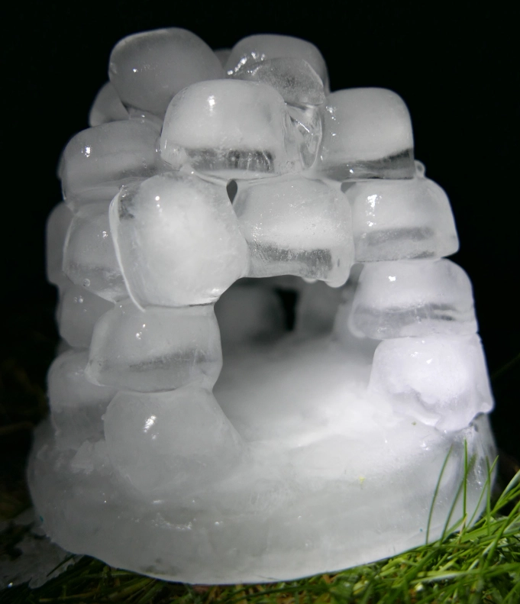
  - Watch ‘Frozen- In Summer’. Discuss with your child what they think will happen to Olaf when it gets warm. Support your child to fill up ice cube trays or plastic containers, if ice cube trays are not available, and freeze. Once frozen, take them out and explore how quickly they melt: in your hands, in the fridge, on the windowsill and when blown with the hairdryer.
  - Search on Google Maps for the UK. Discuss with your child the colour of the land and sea. Scroll up to look at the Arctic. Discuss why the land looks different in the Arctic, because the land is covered in snow and ice. Discuss the differences in temperature in the UK and the Arctic. Look at a picture of an igloo on google.
Fill an ice cube tray with water and when frozen take out and support your child to create their own igloo out of the ice cubes.

youngexplorers@loxwoodschool.com
Twinkl - to access these resources click on the link and sign up using your own email address and creating your own password. Use the offer code UKTWINKLHELPS.
The Class Page Gallery is looking really good. Thank you for all the photographs. Please keep sending them.

