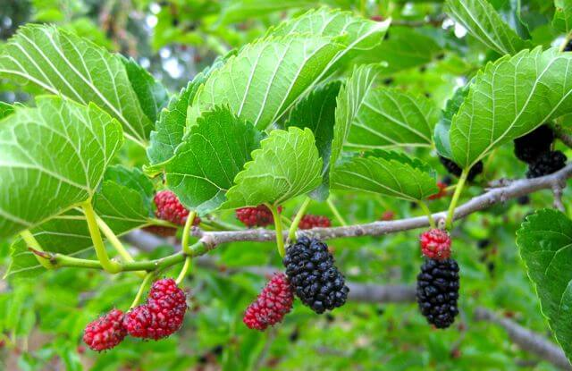
Mulberry Class

15th November 2018

Dear Parents,

This term is flying by and we are already busy with our learning in the second half of the Autumn term.
Year 5 and 6 had a fantastic visit from the people from Mexicolore on Tuesday. It was such a fun day, the children had a chance to hear and play different musical instruments, dress up in traditional Maya clothing and they learnt a lot about the Maya culture which will enhance our learning in class.

In maths, we are currently working on multiplication and division and we are now encouraging the children to think carefully about their reasoning and to begin to explain more fully why things can and cannot be true mathematically. It is really important that the children know their times tables so please keep practising them at home as these will help to develop strategies they can use when reasoning.

In English we have combined our history topic of the Maya and have been developing our skill set building up to writing a non-chronological report about our Mexicolore experience.

As part of our computing lessons and during class discussions we have looked at how to keep ourselves safe online. During our discussions in class we have talked about online chatting, particularly in the context of online gaming. It has become clear that a lot of children in the class enjoy online gaming so please do take a minute to have a chat with your child and ask them what they have learnt about how to stay safe whilst online particularly when they are chatting to others online.

We have already had some lovely homework from our second homework grid. Hard copies went home a few weeks ago and the electronic version is now on our class page. In addition to your child choosing a project if they wish it is really important that they are learning their spellings and times tables.

Kind Regards

Mrs Winter and Miss Durkin

