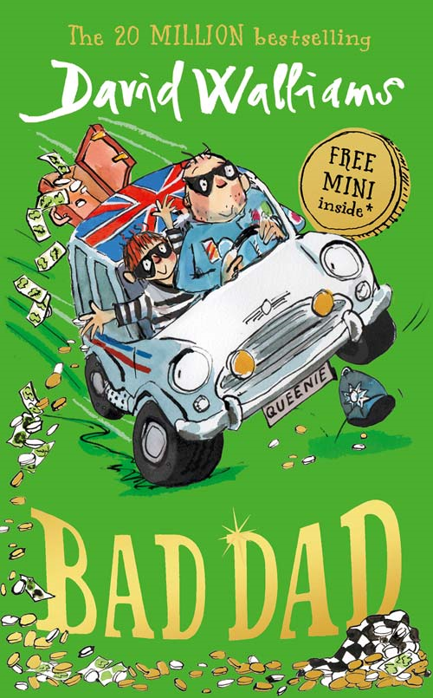

Bad Dad is an amazing book by David Walliams telling the story of a father and his son working together to catch Mr Big’s top crime gang to get their normal life back. I would definitely recommend this book for children aged 5-12 and that enjoy adventure books. I would have to say this book is definitely one of the best books I have read!

