13th, 20th May 2018

**In Communication and Language we are**

**learning to…..**

use descriptive vocabulary

use a range of tenses with some accuracy

Activities

Respond to discussions and stories and events with comments & questions

Anticipate what might happen next

**In physical development we are**

**learning to….**

With weather warming up, please provide sun hats and follow school procedure for sun-cream.

Remember we still have cold days so joggers in PE kit as well as shorts please.

Activity

PE with Mr Green: Striking and fielding

Ball skills, balance bikes, beanbags, obstacle courses and construction as part of outdoor provision.

**In Personal, Social and Emotional**

**Development we are learning to…**

look after animals and plants

keep safe when out and about

Activities

Share stories

Circle Time: talk about how we care for animals

How to keep safe when shopping

Discuss what to do if we get lost

**3 week YE Plan**

**planner**

Superworm

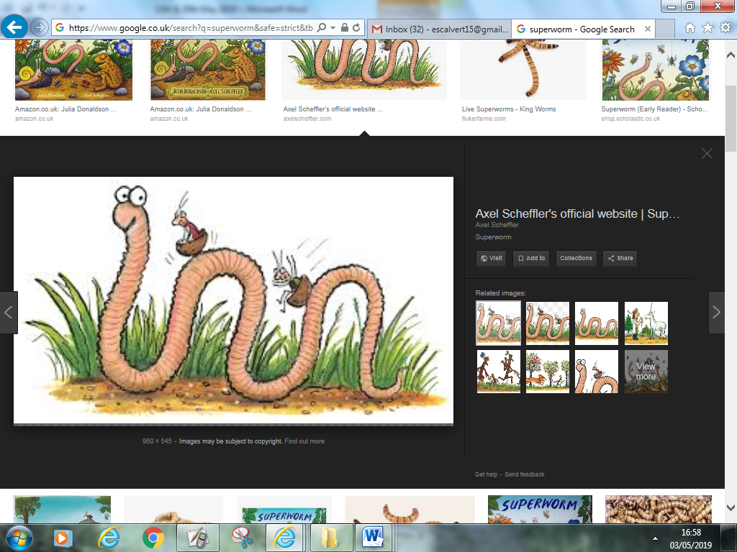

**In Understanding the world we are learning..**

About the life cycle of a caterpillar

To care for animals we find in the environment

About the features of mini beasts

Activities

Make a mini beast

Share books about mini beasts

Describe a mini beast

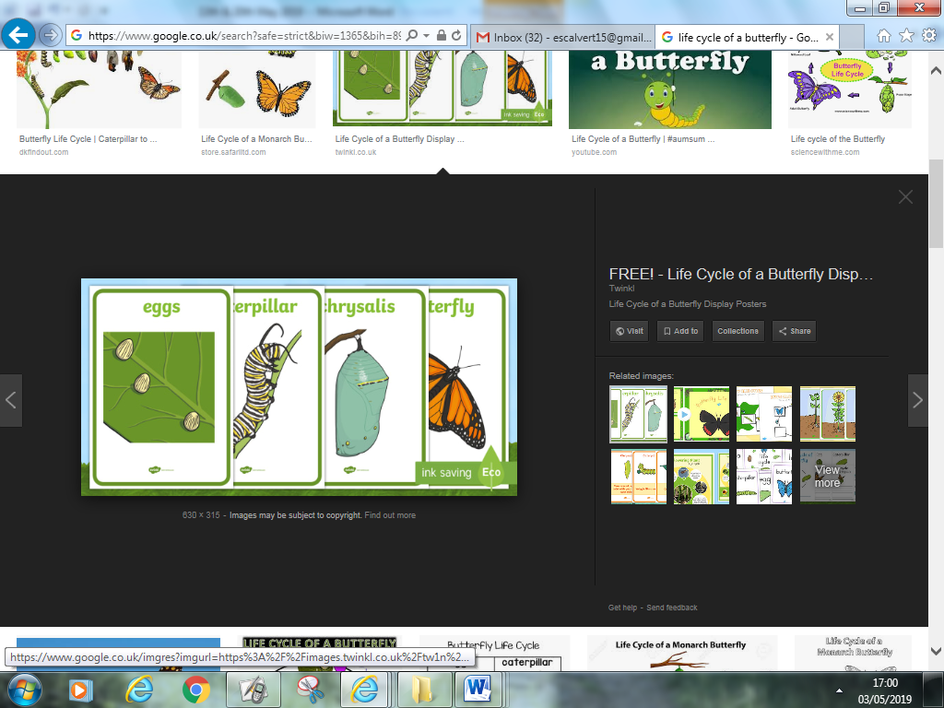

**Ask me about…**

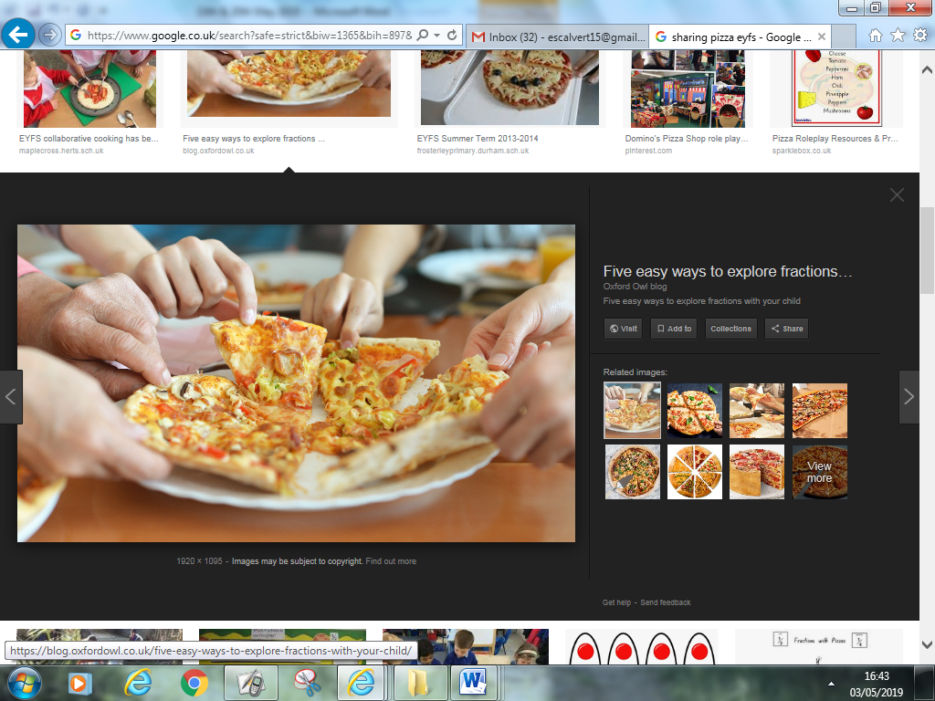

**sharing**

**In Mathematics we are learning to…**

Share between 2

Understand vocabulary ‘share’, ‘half’, ‘equal’

Recall the days of the week

Understand there are 7 days in a week

**On-going** daily maths skills e.g. numeral recognition, counting forward and back, one more than, 1 less, 2D shape, 3D shape…

The Very Hungry Caterpillar

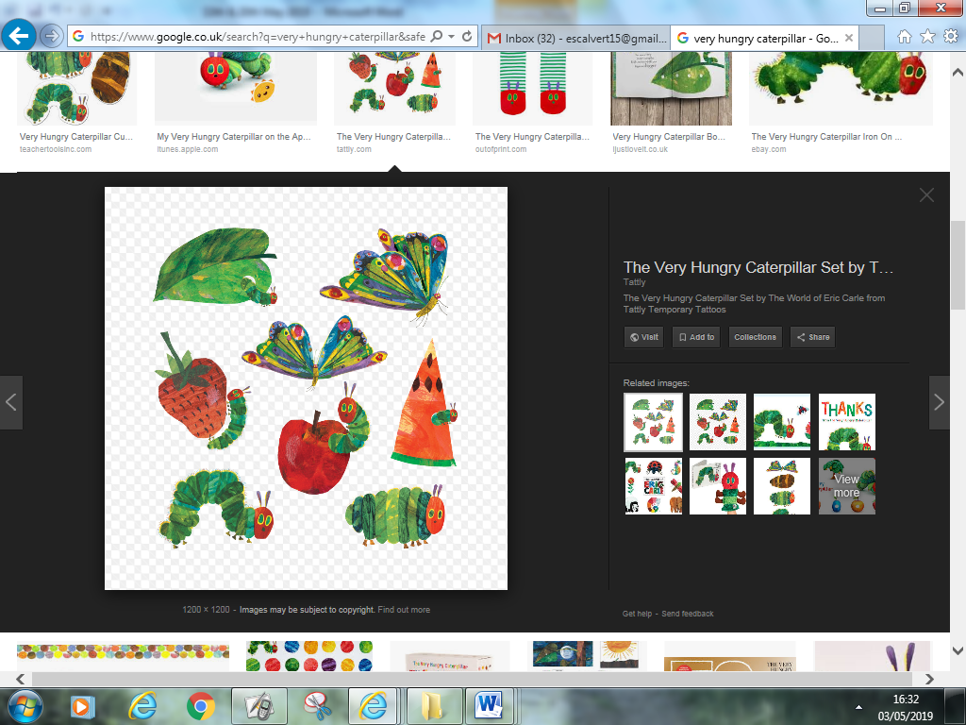

**In Literacy we will are learning to…**

Recall Set 1 phonemes and use them in our reading and writing.

Recall Set 2 & 3 phonemes and use them in our reading and writing.

Read high frequency words and tricky words to date

Mrs Calvert’s group: **‘y’ often makes the ‘ee’ sound** when it is on the end of a word and the previous letter is doubled e.g. mummy, daddy, puppy, hungry, very.

We will also learn ‘e’ at the end of a word can be silent e.g. **live, have**

Recognise words/sentences.

Activities

Daily phonics lessons RWI, writing linked to phonics & topics

Share stories about places and bugs

**In Creative Arts and Design we are learning to..**

select appropriate resources and adapt work where necessary

select tools and techniques needed to shape, assemble and join materials they are using

Activities - Junk modelling

In Early Years we plan across the 7 areas of learning and make links with our topic. We also follow the ideas and interests generated by the children. In Reception children spend time each day self-initiating, this is their ‘Learning time’. Adults will be observing, engaging and moving their learning on during these times.