24thJune, 1st and 8th July 2019

**In Communication and Language we are**

**learning to…..**

give explanations by connecting ideas or events

listen attentively in a range of situations, especially to our new teacher/children in our house group and in assembly

Activities

Talk about events and things we have observed

Recount information from a range of sources

**In Personal, Social and Emotional**

**Development we are learning to…**

Try lots of new activities including Meeting our new teachers on ‘Moving Up Mornings’ and taking part in Enterprise Afternoon

[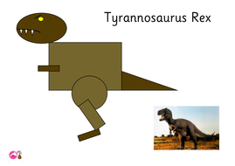](https://www.google.com/url?sa=i&rct=j&q=&esrc=s&source=images&cd=&cad=rja&uact=8&ved=2ahUKEwjeoN28s4jcAhWI1hQKHfVEBOYQjRx6BAgBEAU&url=https://www.tes.com/teaching-resource/dinosaur-shape-picture-t-rex-and-pterodactyl-6318470&psig=AOvVaw1RPbnDAcuHW_IDsIkjBmjP&ust=1530895262574270)

**In physical development we are**

**learning to….**

With weather warming up, please provide sun hats and follow school procedure for sun-cream.

Form letters correctly

Activity

PE with Mr Green with a striking and fielding focus

Ball skills, balance bikes, skipping etc and construction as part of outdoor provision.

Regular handwriting sessions.

**3 week YE Plan**

**planner**

**In Mathematics we are learning to…**

Name and describe, using mathematical language, common 2D shape and 3D shapes.

Add two single-digit numbers and count on to find the answer.

count reliably with numbers from one to 20,

place them in order and say which number is one more or one less than a given number.

**In Understanding the world we are learning..**

To know about similarities and differences between dinosaurs

To make observations of dinosaur fossils

Act out the role of a palaeontologist

Discuss the importance of looking after our world

and caring for the environment

What the term ‘extinct’ means and how can we

help endangered species

Activities

Finding out from non-fiction books.

Dinosaur museum role play

Excavating in the sand pit

**In Creative Arts and Design we are learning to..**

create a dinosaur from a range of resources

make fossil prints using salt dough

plan and make a2D shape dinosaur picture

practise our cutting skills

**Ask me about…**

[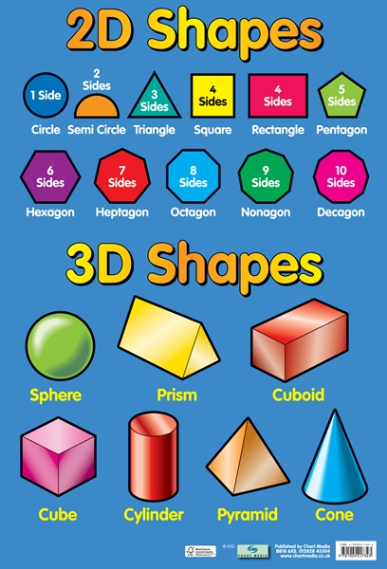](http://www.google.com/url?sa=i&rct=j&q=&esrc=s&source=images&cd=&ved=2ahUKEwjJ8JP0t_jiAhXJAWMBHcN_BvcQjRx6BAgBEAU&url=http://www.teachingdisplays.co.uk/products/706-2d3d-shapes-learning-chart.aspx&psig=AOvVaw3MI-U0muQ9SDafENsQcZe-&ust=1561133027596168)



**In Literacy we will are learning to…**

read and write words containing RWI Set 2 - oo (as in book) or ar air ir ou oy

Hold a simple sentence in our head

Compose a simple sentence

Complete a modelled sentence

Write a simple sentence.

Write sentences.

Some children will be starting sentences in a variety of ways and building up the stamina to write stories/information books linked to topics and interests.

Activities

Daily phonics lessons RWI, writing linked to phonics & topics

Share stories related to topics

In Early Years we plan across the 7 areas of learning and make links with our topic. We also follow the ideas and interests generated by the children. In Reception children spend time each day self-initiating, this is their ‘Learning time’. Adults will be observing, engaging and moving their learning on during these times.