The Great Loxwood Lookout
for Nature!
Why not use your Science observation skills at home and keep a ‘lookout for nature’? Whether it is in your back garden or in the woods, fields and streets where you live, we want to know what you are finding.
You might go for a walk, turn your playhouse into a bird hide, set up an observation station by your patio window, or just keep a lookout while you are eating your breakfast?
Make a tally chart, draw a picture, take a photo, use your recording skills in some way to show us what you have observed and share the results with us.
Things to look out for might be…
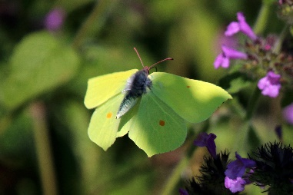
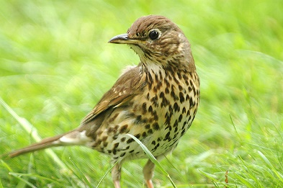
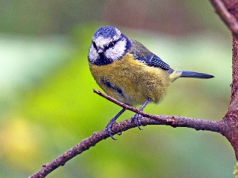
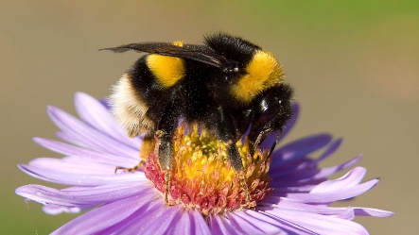

a thrush a brimstone butterfly a bumble bee a blue tit
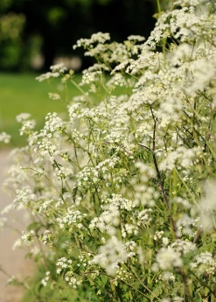
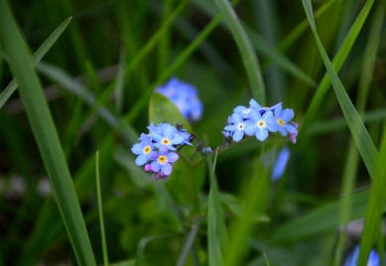
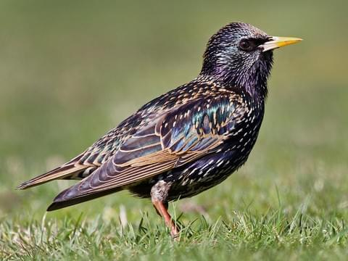
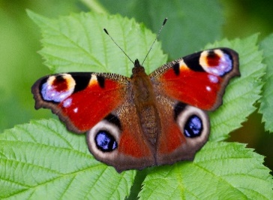

a peacock butterfly a starling forget-me-nots cow parsley

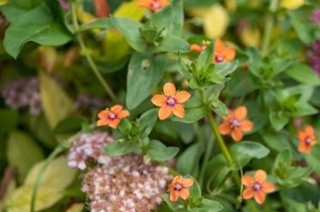
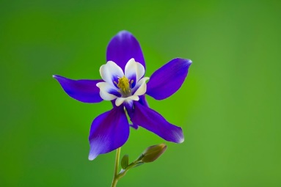
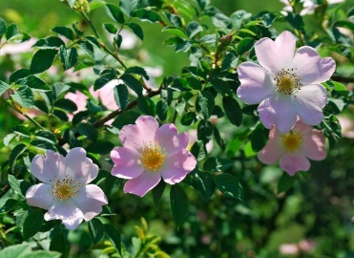
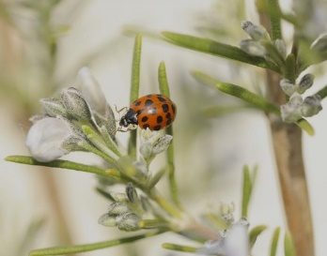

a lady bird dog roses columbines scarlet pimpernel
What else will you spot?

