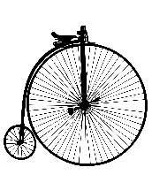
Autumn Term Home Learning Projects
Please complete 2 of these projects each half term so that by the Christmas Holidays you will have completed 4 of the activities below. These activities are designed to get your creative juices flowing and to be a great opportunity to develop your learning with support from someone at home. We are really looking forward to sharing what you have learnt and the new skills you have developed.
Gingerbread Man  Design and decorate your own gingerbread person.  (Please do not bring in biscuits to share with the class.)  Take a photo of them and tell us how you made them! | Welly Walk  Go on a welly walk with your family and take a photo of some of the signs of Autumn that you find.  It might inspire you to write an Autumn poem or draw/ paint a picture! | 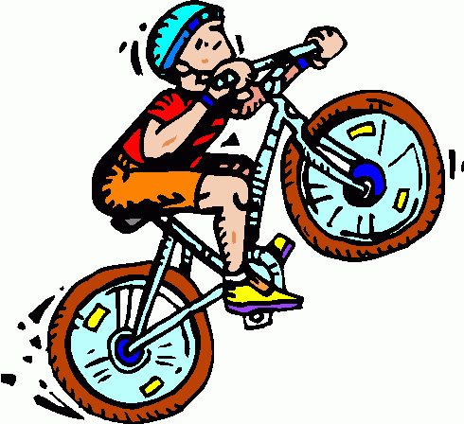  On your bike!  We are reading Mrs Armitage on Wheels. Take your family on a bike/ scooter ride and show us a picture of you in your safety gear! You might like to design a poster to remind people about bike/ scooter safety.
Transport Tales  Go on a journey on a train, bus, boat or whatever takes your fancy! Show us a photo, a drawing or write a report about your journey. You might even want to research the history of that form of transport! | 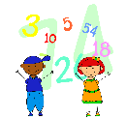  Counting challenge  Show off your counting skills by counting in 2’s, or counting forwards or backwards from any number.  Ask a grown up to film you or show us in person! | 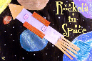  Materials Collage  We are investigating materials in Science. Make a collage using materials that you find. You could label the materials that you use or try to make a collage using only one type eg just shiny materials.
Or get creative and amaze us with some of your own choice topic related learning!
Don’t forget to keep up your reading at home and practice reading and spelling the Common Exception Words.

