[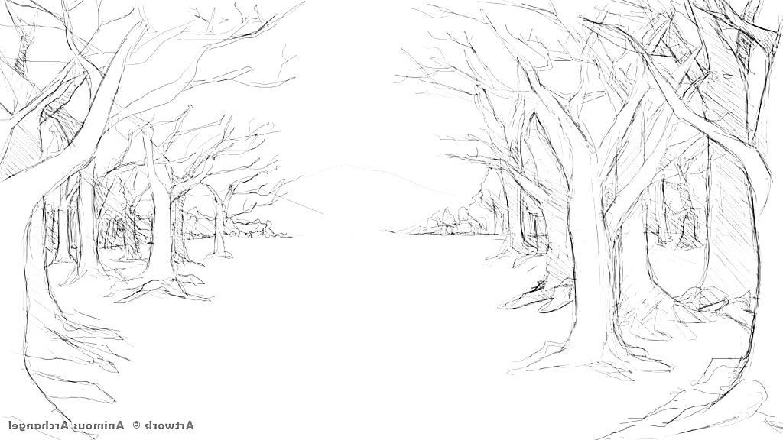](http://www.google.co.uk/url?sa=i&rct=j&q=&esrc=s&source=images&cd=&cad=rja&uact=8&ved=0ahUKEwj7rqncxdLYAhUFvRQKHQ0hAcUQjRwIBw&url=http://drawingpencilarts.com/simple-forest-drawing/&psig=AOvVaw3xWXgWQUQfICg4lANKzYee&ust=1515850602992836)

**In RHE**

-Keeping safe online

-Mental wellbeing and feeling a range of emotions.

-Caring friendships and their characteristics.

-How to choose and make friends

**In RE**

**we will look at….**

-Identifying things that are important in our own lives through the Islamic Creation story and the Christian Creation story

-The basic teachings of another main religion: Sikhism

-The Christian Bible story of Easter.

**In Maths we will be improving our skills of…**

-addition and subtraction within 20.

-counting and understanding place value to 50.

-measuring length and height.

-measuring weight and volume.

**PE**

**We will improve on…**-team building

- sending and receiving

**English**

**We will be learning to…**

- retell story by story mapping.

-sequence the beginning, middle and end of story.

-explore another character’s point of view.

-write a postcard from another character’s point of view.

- recite a poem.

**-**write a non-fiction booklet.

-write a simple recount.

**Also**

-to continue to learn to read and spell the Year 1 Common Exception Words.

-to continue learning the Year 1 spelling patterns.

-to continue to learn the grammar for Year 1.

**Geography  
Will focus on..**

Seasonal weather patterns in UK & hot & cold locations around the world.

Comparing local area to a non-European country.

Simple Fieldwork & Observation Skills to study the immediate environment   
Using basic geographical vocab and refer to local and familiar features.

**Computing**

**Will focus on…**

-understanding what algorithms are, and that programs execute by following precise and ambiguous instructions.

-to record an algorithm and program a. Bee-Bot

-to program the Bee-Bot to follow a set course.

**Science**

**“Animals” will be our focus and within this we will be exploring…**

Identify and name a variety of animals, including mammals, birds, reptiles, amphibians, fish, herbivores, omnivores and carnivores.

Describe and compare the structure of a variety of animals.

.

**In Music…**-we will be playing tuned and un-tuned instruments.

-we will be percussion experimentation.

-we will be using voices as instruments.

**Art/DT  
We will be learning to…**

-make rubbings and using textures to create pictures.

-use clay to make leaf print bowl.

-join materials to make own stick man.

-sketch leaves and natural objects.

-collage using found materials

**Fantastic Forests**

**Year 1 Spring Term 2022**