[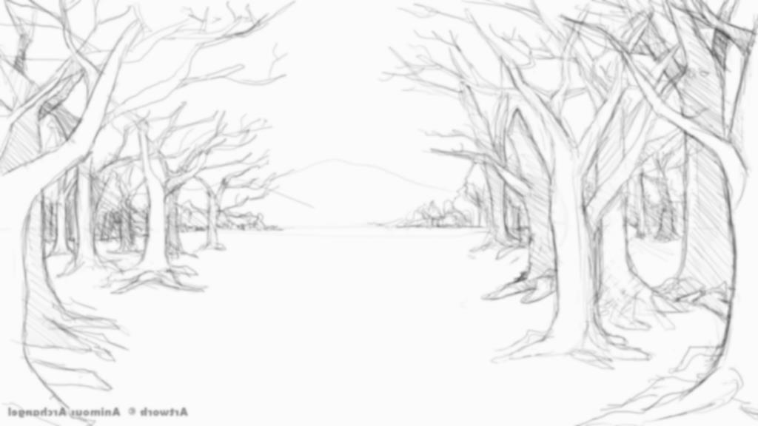](http://www.google.co.uk/url?sa=i&rct=j&q=&esrc=s&source=images&cd=&cad=rja&uact=8&ved=0ahUKEwj7rqncxdLYAhUFvRQKHQ0hAcUQjRwIBw&url=http%3A%2F%2Fdrawingpencilarts.com%2Fsimple-forest-drawing%2F&psig=AOvVaw3xWXgWQUQfICg4lANKzYee&ust=1515850602992836)

**Maths**Recall and use division facts for the 2, 5 and 10 times tables .and calculate mathematical statements for division.   
Solve problems involving division.

Interpret and draw pictograms, tally charts, block diagrams and tables and ask and answer questions about data.

Identify, compare and describe the properties of 2-D shapes and 3-D shapes,

Identify 2-D shapes on the surface of 3-D shapes.

Recognise, find, name and write fractions of a length, shape, set of objects or quantity.

Choose and use appropriate standard units to estimate and measure length/height in any direction (m/cm); mass (kg/g); temperature (°C); capacity (litres/ml) to the nearest appropriate unit.

**EXPLORE**

Fantastic Forests

Year 2 Spring Term 2022

Please find the learning and skills that we hope to cover this term.

**RHE**

Keeping safe online (including Safer Internet Day on 8/2/22)

Respecting others and making healthy friendships

Keeping healthy by understanding how diseases are spread and what we can do to stop them.

**Computing**Program a simple floor turtle.  
Creating and debugging simple programs.

Using PowerPoint to present information.

**Music**Playing tuned and un-tuned instruments

Experimenting with percussion

Using voices as instruments

**Art/DT**Making rubbings and using textures to create pictures.

Use clay to make leaf print bowl.

Joining materials to make own stick man.

Sketching leaves and natural objects.

Collage using found materials  
Artists: Max Ernst, Jeanie Baker, Andy Goldsworthy

**RE**

Identifying things that are important in our own lives through the Islamic Creation story and the Christian Creation story

The basic teachings of another main religion: Sikhism

The Christian Bible story of Easter.

**PE**Ball skills, including…

sending and receiving and playing simple games.

Team Building, including…

Following instructions, fair play, working co-operatively.

**Science** (Living Things and their Habitats)Explore and compare the differences between things that are living, that are dead and that have never been alive.

Identify that most living things live in habitats to which they are suited and describe how different habitats provide for the basic needs of different kinds of animals and plants, and how they depend on each other.

Identify and name a variety of plants and animals in their habitats, including micro-habitats.

Classify and identify a range of living things.

Observe closely using a range of equipment.

Gather and record data to help answer a question.

**English**

Key Texts (Stickman, Little Red Riding Hood, Where the Forest Meets the Sea, Tidy)

Retell a story and plan then write own adapted story

Use expanded noun phrases and time conjunctions to develop story writing

Plan and write a story with beginning middle and end.

Write about real events in the form of a chronological report.

Write own guide book or information page.

Write a letter.

Read and recite poems.  
Compare stories and draw conclusions.

Discuss the stories that they can read and those that are read to them.

Use the four sentence types.

Use full stops, capital letters, exclamation marks and question marks.

Continue to learn to read and spell the Year 2 Common exception words

Continue learning the Year 2 spelling patterns.

Continue to learn the grammar for Year 2.

**Geography**

Learn about seasonal weather patterns in UK and hot and cold locations around the world

Compare local area to a non-European country

Use simple fieldwork and observation skills to study the immediate environment.   
Use basic geographical vocabulary and refer to local and familiar features.

Draw own maps and use directional language.

Name, locate and identify characteristics of the four countries and capital cities of the UK using maps, atlases and globes.

Name and locate the seven continents and five oceans of the world using maps, atlases and globes.